Water Accounting

Water Supplied to Treatment
Enter values in gallons.
Click on the box to the right to see what part of the water system is being addressed.

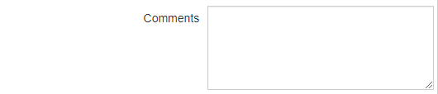

Finished Imported Water

Enter values in gallons

Water Supplied to Distribution
Enter values in gallons.
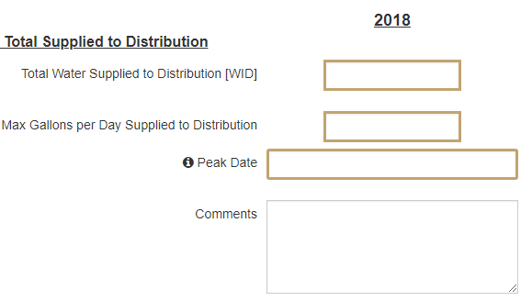

Authorized Consumption
Enter values in gallons.
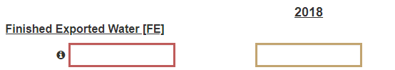

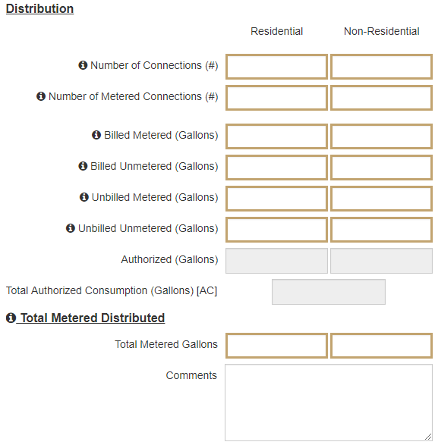

Water Losses
Enter values in gallons.
Water Loss - is the difference between Total System Input and Authorized Consumption.

Losses are made up of Apparent Losses (meter errors and unauthorized consumption) and Real Losses. Real Losses are equivalent to leakage.

Real Losses- Volume of water lost through all types of leaks, breaks and overflows on mains, service reservoirs and service connections, up to the point of users metering.

Apparent Losses - apparent losses, which are also called commercial losses, include all types of inaccuracies associated with customer metering as well as data handling errors (meter reading and billing), plus unauthorized consumption (theft or illegal use).

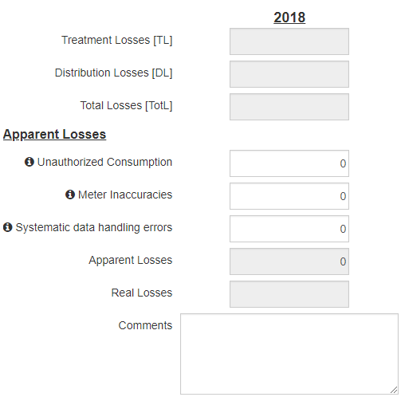

Demographic Data
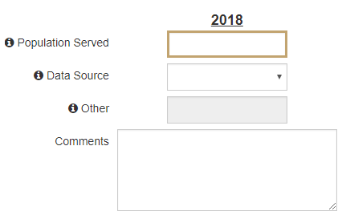

Meter Technology
Water meter technology is changing rapidly. Unmeasured or inaccurate flow results in significant revenue loss for the Utility. Regardless of the type of meter, regular testing is needed to insure accuracy and optimize revenue.
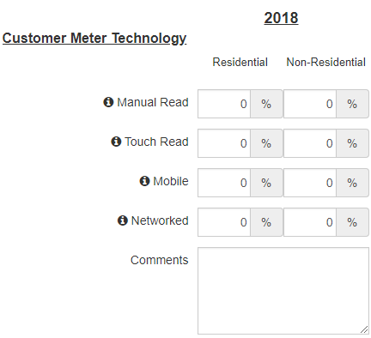

Other System Impacts
Enter any expected large changes to your water system. Examples: New large industrial park, cities merging or splitting water systems, significant increase or decrease in population, new water treatment plant.
