Conservation – Indirect

Ordinances/Policy/Codes In Effect
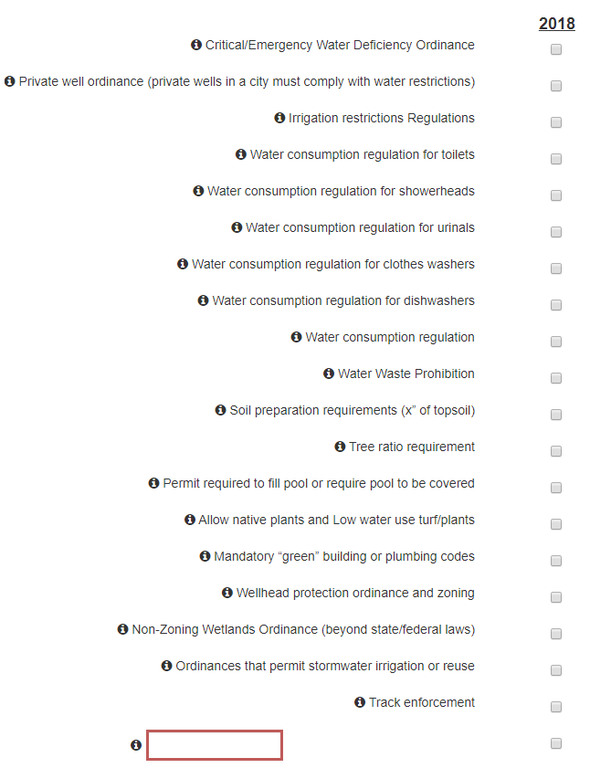

Education & Outreach
Because there are many factors that influence the actual number of people that may receive your water conservation education and outreach message, simply list the number of efforts, not individuals. For example, you do not need to count everyone that came to a water festival, simply list 1 Community Event.

If your city would like to keep record of the number of individual contacts, you may enter that data for your own use in the "other" tabs.
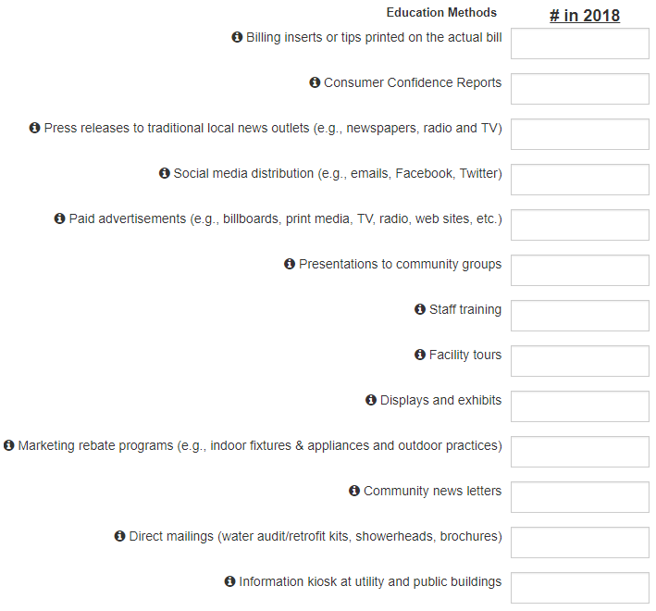
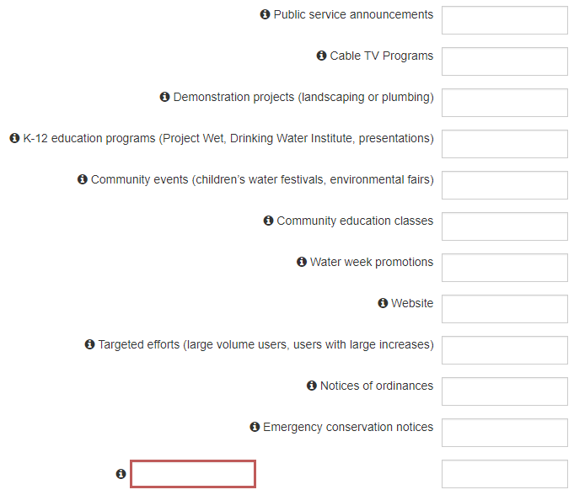

What collaborative efforts has your city participated in to manage groundwater or surface water withdrawals? (Check all that apply)
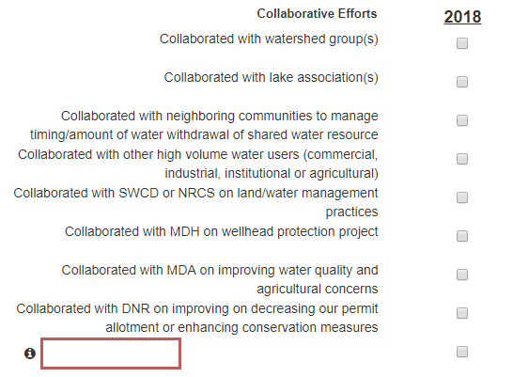

Billing Rates
