Conservation - Direct

Conservation Projects – Water Supply System (Before the Customer Meter)
Enter savings for each system project type in Gallons and costs in US dollars. In future reports you will be able to view the previous years data. Add any project types needed to enter your savings activities.

Leak detection and repair is a key water efficiency strategy. Age of pipes and storage facilities, the pipe materials and construction quality, the valves, meter accuracy and pumps all matter. Soil types also affect system efficiency, as corrosive soils reduce pipe life. High operational pressure and variations in hilly areas can further strain distribution system components.

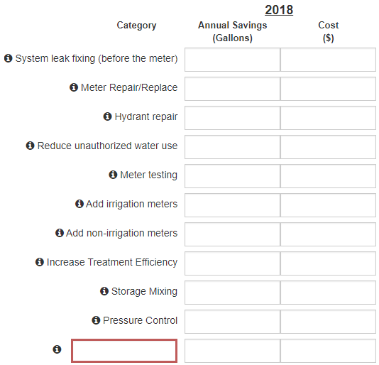

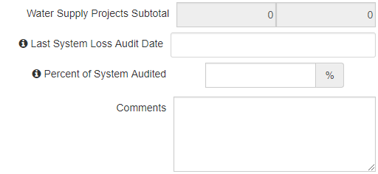

Conservation Measures – Customer (After the Customer Meter)
In this section, list the quantity of water saving devises funded or partially funded by the city. For example a cost-share program for 200 rain barrels. Other city-sponsored incentive program may also qualify as well as cooperative projects with energy utility companies, SWCDs or other organizations.

An excellent resource for water suppliers is the Saving Watts & Drops program. This program allows you to get multiple bids on bulk purchases for no charge and no obligation. See www.quantityquotes.net.

For many of the categories a water savings in gallons is already provided. These savings are based on research by the AWWA, EPA WaterSense and/or the Alliance for Water Efficiency.

If no gallons of savings is provided please insert your best estimate based on the product purchased and the item that is being replaced.
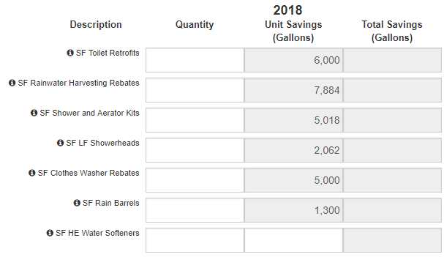
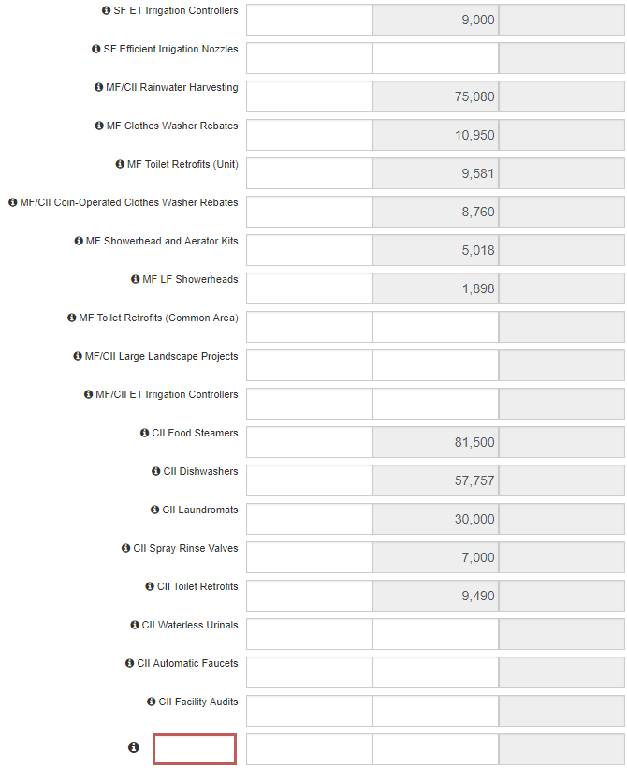

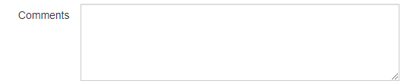

Conservation Projects – Customer (After the Customer Meter)
Enter savings for each project. Do not duplicate measure savings above.
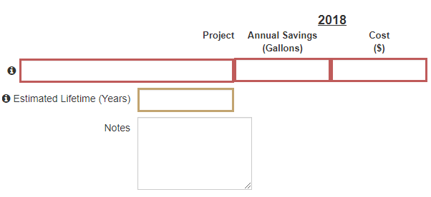

Conservation Projects – Water Reuse
