
Shoreland Management Model Ordinance

Introduction
This model is intended to help local governments develop new shoreland ordinances and amend existing ordinances. This model ordinance is consistent with Minnesota’s shoreland management rules (6120.2500 – 6120.3800). The model ordinance includes some provisions that differ from those in rule. This is because the model is periodically updated to be consistent with changes made to statute and other agency rules since the rules were published in 1989. The model also contains administrative language not in rule to help clarify and administer provisions in the ordinance.

Clarifications & Higher Standards
Blue bold text in the “Ordinance Language” column indicates any language that provides clarity on topics not sufficiently addressed in rule, or reflects a higher standard than the minimum in rule. This text is optional and is identified as such in the “Commentary” column. (Note that higher standards may be additions to or deletions from the rules.) There are many higher standards that communities can consider besides those mentioned in this model. Please see the Innovative Standards Webpage for examples of what other communities are doing.

Implementation Flexibility
Some shoreland ordinance provisions provide greater levels of shoreland protection than other provisions. Many of these provisions deal with dimensional standards such as lot area/width, setbacks, impervious surface, etc. In general, they must be as strict as the model language, otherwise deviations must be approved by the DNR consistent with the implementation flexibility criteria in rule (6120.2800 Subp. 3). Approval to deviate from these provisions usually requires some type of offsetting higher standard on another provision in the ordinance, and must be negotiated and documented in an agreement with the DNR before the DNR will provide conditional approval of the ordinance or ordinance amendment.

Contents
1.0 STATUTORY AUTHORIZATION AND POLICY 1
2.0 GENERAL PROVISIONS AND DEFINITIONS 1
3.0 ADMINISTRATION 9
4.0 SHORELAND CLASSIFICATION SYSTEM AND LAND USES 11
5.0 SPECIAL LAND USE PROVISIONS 15
6.0 DIMENSIONAL AND GENERAL PERFORMANCE STANDARDS 17
7.0 PERFORMANCE STANDARDS FOR PUBLIC AND PRIVATE FACILITIES 25
8.0 VEGETATION AND LAND ALTERATIONS 27
9.0 SUBDIVISION/PLATTING PROVISIONS 30
10.0 PLANNED UNIT DEVELOPMENTS (PUDs) 31

Ordinance Language | Commentary in Public Version of Model
1.0 STATUTORY AUTHORIZATION AND POLICY  1.1 Statutory Authorization. This shoreland ordinance is adopted pursuant to the authorization and policies contained in Minnesota Statutes, Chapter 103F, Minnesota Rules, Parts 6120.2500 - 6120.3900, and the planning and zoning enabling legislation in Minnesota Statutes, Chapter 394 (for counties) or Chapter 462 (for municipalities).  1.2 Policy. The Legislature of Minnesota has delegated responsibility to local governments of the state to regulate the subdivision, use and development of the shorelands of public waters and thus preserve and enhance the quality of surface waters, conserve the economic and natural environmental values of shorelands, and provide for the wise use of waters and related land resources. This responsibility is hereby recognized by (insert name of Community).  2.0 GENERAL PROVISIONS AND DEFINITIONS  2.1 Jurisdiction. The provisions of this ordinance apply to the shorelands of the public water bodies as classified in Section 4.1 of this ordinance, and to the shorelands of public water bodies greater than 10 acres in unincorporated areas in which the city has, by ordinance, extended the application of its zoning regulations as provided by Minnesota Statute, Chapter 462.357 Subd 1. Pursuant to Minnesota Rules, Parts 6120.2500 - 6120.3900, no lake, pond, or flowage less than 10 acres in size in municipalities or 25 acres in size in unincorporated areas need be regulated in a local government’s shoreland regulations. A body of water created by a private user where there was no previous shoreland may, at the discretion of the governing body, be exempt from this ordinance.  2.2 Enforcement. The (insert name of local government or designated official) is responsible for the administration and enforcement of this ordinance. Any violation of the provisions of this ordinance or failure to comply with any of its requirements (including violations of conditions and safeguards established in connection with grants of variances or conditional uses constitutes a misdemeanor and is punishable as defined by law. Violations of this ordinance can occur regardless of whether or not a permit is required for a regulated activity listed in Section 3.2 of this ordinance.  2.3 Severability. If any section, clause, provision, or portion of this ordinance is adjudged unconstitutional or invalid by a court of competent jurisdiction, the remainder of this ordinance shall not be affected thereby.  2.4 Abrogation and Greater Restrictions. It is not intended by this ordinance to repeal, abrogate, or impair any existing easements, covenants, or deed restrictions. However, where this ordinance imposes greater restrictions, the provisions of this ordinance shall prevail. All other ordinances inconsistent with this ordinance are hereby repealed to the extent of the inconsistency only.  2.5 Definitions. Unless specifically defined below, words or phrases used in this ordinance shall be interpreted to give them the same meaning they have in common usage and to give this ordinance its most reasonable application. For the purpose of this ordinance, the words “must” and “shall” are mandatory and not permissive. All distances, unless otherwise specified, are measured horizontally.  2.511 Accessory structure or facility. Any building or improvement subordinate to a principal use which, because of the nature of its use, can reasonably be located at or greater than normal structure setbacks. Examples include: swimming pools, saunas, detached garages, and storage sheds.  2.512 Animal feedlot. A facility as defined by Minnesota Rules, part 7020.0300.  2.513 Bluff. A topographic feature such as a hill, cliff, or embankment having the following characteristics:  - Part or all of the feature is located in a shoreland area;  - The slope must drain toward the waterbody;  - The slope rises at least 25 feet above the ordinary high water level; and  - The grade of the slope from the toe of the bluff to a point 25 feet or more above the ordinary high water level averages 30 percent or greater (see Figure 1), except that an area with an average slope of less than 18 percent over a distance of at least 50 feet shall not be considered part of the bluff (see Figure 2).  Figure 1. Illustration of Bluff  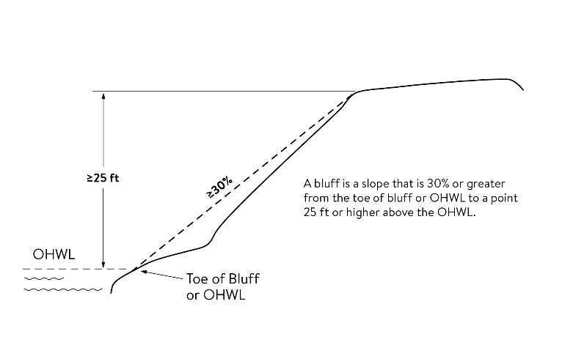  Figure 2. Exception to Bluff  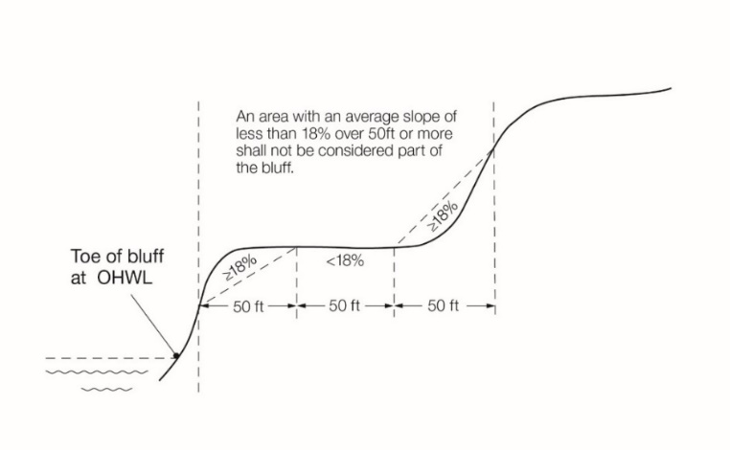  2.514 Bluff impact zone. A bluff and land located within 20 feet of the top of a bluff. See Figure 3  Figure 3. Bluff Impact Zone and Top of Bluff  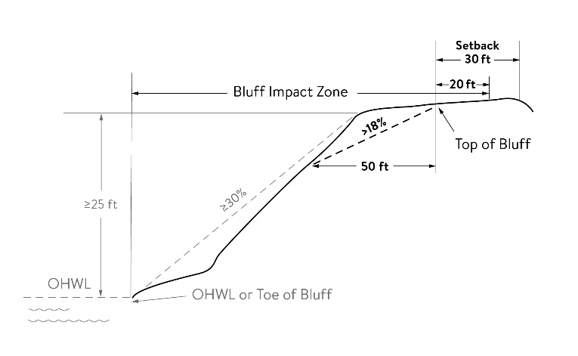  2.515 Bluff, Toe of. The lower point of a 50-foot segment with an average slope exceeding 18 percent or the ordinary high water level, whichever is higher.  2.516 Bluff, Top of. For the purposes of measuring setbacks, bluff impact zone, and administering vegetation management standards, the higher point of a 50-foot segment with an average slope exceeding 18 percent. See Figure 3.  2.517 Boathouse. A facility as defined by Minnesota Statutes, Section 103G.245.  2.518 Buffer. A vegetative feature as defined by Minnesota Statutes, Section 103F.48.  2.519 Building line. A line parallel to a lot line or the ordinary high water level at the required setback beyond which a structure may not extend.  2.520 Controlled access lot. A lot used to access public waters or as a recreation area for owners of nonriparian lots within the same subdivision containing the controlled access lot.  2.521 Commercial planned unit developments. Developments that provide transient, short-term lodging spaces, rooms, or parcels and their operations are essentially service-oriented. For example, hotel/motel accommodations, resorts, recreational vehicle and camping parks, and other primarily service-oriented activities are commercial planned unit developments.  2.522 Commercial use. The principal use of land or buildings for the sale, lease, rental, or trade of products, goods, and services.  2.523 Commissioner. The commissioner of the Department of Natural Resources.  2.524 Conditional use. A land use or development as defined by ordinance that would not be appropriate generally but may be allowed with appropriate restrictions upon a finding that certain conditions as detailed in the zoning ordinance exist, the use or development conforms to the comprehensive land use plan of the community, and the use is compatible with the existing neighborhood.  2.525 Deck. A horizontal, unenclosed platform with or without attached railings, seats, trellises, or other features, attached or functionally related to a principal use or site and at any point extending more than three feet above ground.  2.526 Duplex, triplex, and quad. A dwelling structure on a single lot, having two, three, and four units, respectively, attached by common walls and each unit equipped with separate sleeping, cooking, eating, living, and sanitation facilities.  2.527 Dwelling site. A designated location for residential use by one or more persons using temporary or movable shelter, including camping and recreational vehicle sites.  2.528 Dwelling unit. Any structure or portion of a structure, or other shelter designed as short- or long-term living quarters for one or more persons, including rental or timeshare accommodations such as motel, hotel, and resort rooms and cabins.  2.529 Expansion. Any increase in a dimension such as number of units or size, area, volume, or height of an existing structure or accessory structure or facility.  2.530 Extractive use. The use of land for surface or subsurface removal of sand, gravel, rock, industrial minerals, other nonmetallic minerals, and peat not regulated under Minnesota Statutes, Sections 93.44 to 93.51.  2.531 Forest land conversion. The clear cutting of forested lands to prepare for a new land use other than reestablishment of a subsequent forest stand.  2.532 Guest cottage. A structure used as a dwelling unit that may contain sleeping spaces and kitchen and bathroom facilities in addition to those provided in the primary dwelling unit on a lot.  2.533 Height of building. The vertical distance between the highest adjoining ground level at the building or ten feet above the lowest adjoining ground level, whichever is lower, and the highest point of a flat roof or average height of the highest gable of a pitched or hipped roof (see Figure 3).  Figure 3. Height of Building  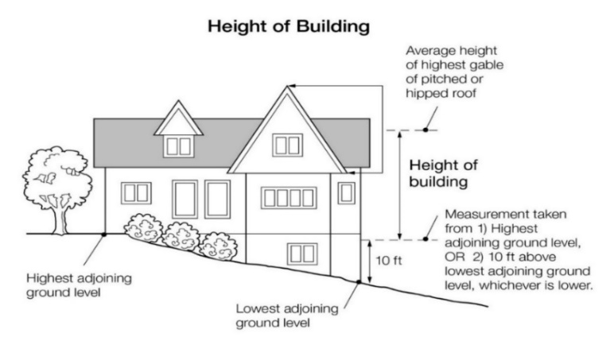  2.534 Impervious surface. A constructed hard surface that prevents or retards entry of water into the soil and causes water to run off the surface in greater quantities and at an increased rate of flow than prior to development, including rooftops; decks; sidewalks; patios; swimming pools; parking lots; concrete, asphalt, gravel driveways, or permeable pavers; and other similar surfaces.  2.535 Improvement. Making an existing structure or accessory structure or facility of better quality, more efficient, or more aesthetically pleasing, that does not replicate what pre-existed, but does not include an expansion, enlargement, or intensification.  2.536 Industrial use. The use of land or buildings for the production, manufacture, warehousing, storage, or transfer of goods, products, commodities, or other wholesale items.  2.537 Intensive vegetation clearing. The complete removal of trees or shrubs in a contiguous patch, strip, row, or block.  2.538 Lot. A parcel of land designated by plat, metes and bounds, registered land survey, auditors plot, or other accepted means and separated from other parcels or portions by said description for the purpose of sale, lease, or separation.  2.539 Lot width. The minimum distance between:  - Side lot lines measured at the midpoint of the building line; and  - Side lot lines at the ordinary high water level, if applicable (see Figure 4).  Figure 4. Lot Width  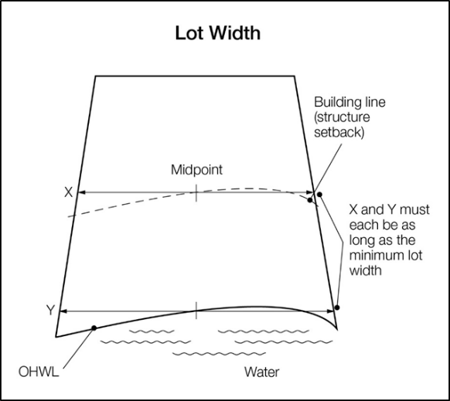  2.540 Maintenance and repair. Upkeep or preservation of an existing structure or accessory structure or facility against normal wear and tear or degradation over time that does not change exterior dimensions. Examples include the rehabilitation or replacement of windows, siding, a roof, or exterior finishes such as paint or stain.  2.541 Metallic minerals and peat. “Metallic minerals and peat” has the meaning given under Minnesota Statutes, Sections 93.44 to 93.51.  2.542 Nonconformity. Any legal use, structure or parcel of land already in existence, recorded, or authorized before the adoption of official controls or amendments to those controls that would not have been permitted to become established under the terms of the official controls as now written.  2.543 Ordinary high water level. The boundary of public waters and wetlands, and shall be an elevation delineating the highest water level which has been maintained for a sufficient period of time to leave evidence upon the landscape, commonly that point where the natural vegetation changes from predominantly aquatic to predominantly terrestrial. For watercourses, the ordinary high water level is the elevation of the top of the bank of the channel. For reservoirs and flowages, the ordinary high water level is the operating elevation of the normal summer pool.  2.544 Planned unit development. A type of development characterized by a unified site design for a number of dwelling units or dwelling sites on a parcel, whether for sale, rent, or lease, and also usually involving clustering of these units or sites to provide areas of common open space, density increases, and a mix of structure types and land uses. These developments may be organized and operated as condominiums, time-share condominiums, cooperatives, full fee ownership, commercial enterprises, or any combination of these, or cluster subdivisions of dwelling units, residential condominiums, townhouses, apartment buildings, dwelling grounds, recreational vehicle parks, resorts, hotels, motels, and conversions of structures and land uses to these uses.  2.545 Public waters. Any water as defined in Minnesota Statutes, Section 103G.005, Subd. 15, 15a.  2.546 Replacement and restoration. Reconstruction of part or all of an existing structure or accessory structure or facility that closely matches or replicates the preexisting structure or facility.  2.547 Residential planned unit development. A use where the nature of residency is nontransient and the major or primary focus of the development is not service-oriented. For example, residential apartments, manufactured home parks, time-share condominiums, townhouses, cooperatives, and full fee ownership residences would be considered as residential planned unit developments. To qualify as a residential planned unit development, a development must contain at least five dwelling units or sites.  2.548 Resort. “Resort” has the meaning in Minnesota Statute, Section 103F.227.  2.549 Semipublic use. The use of land by a private, nonprofit organization to provide a public service that is ordinarily open to some persons outside the regular constituency of the organization.  2.550 Setback. The minimum horizontal distance between a structure, sewage treatment system, or other facility and an ordinary high water level, sewage treatment system, top of a bluff, road, highway, property line, or other facility.  2.551 Sewage treatment system. “Sewage treatment system” has the meaning given under Minnesota Rules, part 7080.1100, Subp. 82.  2.552 Sewer system. Pipelines or conduits, pumping stations, and force main, and all other construction, devices, appliances, or appurtenances used for conducting sewage or industrial waste or other wastes to a point of ultimate disposal.  2.553 Shore impact zone. Land located between the ordinary high water level of a public water and a line parallel to it at a setback of 50 percent of the structure setback (see Figure 5).  Figure 5. Shore Impact Zone  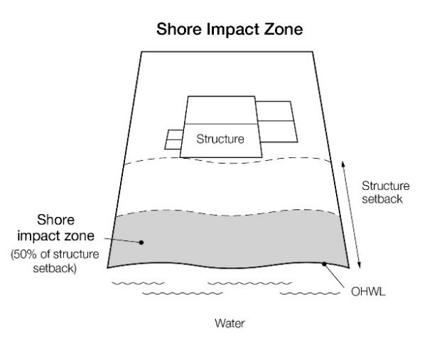  2.554 Shoreland. “Shoreland” means land located within the following distances from public waters:  - 1,000 feet from the ordinary high water level of a lake, pond, or flowage; and  - 300 feet from a river or stream, or the landward extent of a floodplain designated by ordinance on a river or stream, whichever is greater (see Figure 6).  Figure 6. Definition of Shoreland  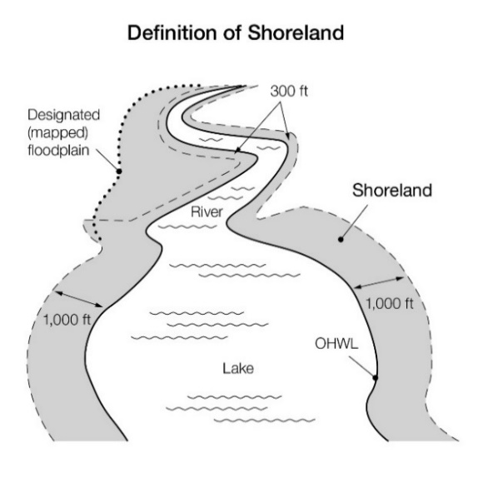  2.555 Shore recreation facilities. Swimming areas, docks, watercraft mooring areas and launching ramps and other water recreation facilities.  2.556 Significant historic site. Any archaeological site, standing structure, or other property that meets the criteria for eligibility to the National Register of Historic Places or is listed in the State Register of Historic Sites, or is determined to be an unplatted cemetery that falls under the provisions of Minnesota Statutes, Section 307.08. A historic site meets these criteria if it is presently listed on either register or if it is determined to meet the qualifications for listing after review by the Minnesota state archaeologist or the director of the Minnesota Historical Society. All unplatted cemeteries are automatically considered to be significant historic sites.  2.557 Steep slope. Land where agricultural activity or development is either not recommended or described as poorly suited due to slope steepness and the site’s soil characteristics, as mapped and described in available county soil surveys or other technical reports, unless appropriate design and construction techniques and farming practices are used in accordance with the provisions of this ordinance. Where specific information is not available, steep slopes are lLands having average slopes over 12 percent, as measured over horizontal distances of 50 feet or more, which are not bluffs.  2.558 Structure. Any building or appurtenance, including decks, except aerial or underground utility lines, such as sewer, electric, telephone, telegraph, gas lines, towers, poles, and other supporting facilities.  2.559 Subdivision. Land that is divided for the purpose of sale, rent, or lease, including planned unit developments.  2.560 Suitability analysis. An evaluation of land to determine if it is appropriate for the proposed use. The analysis considers factors relevant to the proposed use and may include the following features: susceptibility to flooding; existence of wetlands; soils, erosion potential; slope steepness; water supply, sewage treatment capabilities; water depth, depth to groundwater and bedrock, vegetation, near-shore aquatic conditions unsuitable for water-based recreation; fish and wildlife habitat; presence of significant historic sites; or any other relevant feature of the natural land.  2.561 Variance. “Variance” means the same as that defined in Minnesota Statutes, Section 394.27 Subd. 7 (for counties) or Section 462.357 Subd. 6 (2) (for municipalities).  2.562 Water-oriented accessory structure or facility. A small, above ground building or other improvement, except stairways, fences, docks, and retaining walls, which, because of the relationship of its use to surface water, reasonably needs to be located closer to public waters than the normal structure setback. Examples of such structures and facilities include, watercraft and watercraft equipment storage structures, gazebos, screen houses, fish houses, pump houses, patios, and detached decks. Boathouses and boat storage structures given the meaning under Minnesota Statutes, Section 103G.245 are not a water-oriented accessory structures.  2.563 Water-dependent use. The use of land for commercial, industrial, public or semi-public purposes, where access to and use of a public water is an integral part of the normal conduct of operation. Marinas, resorts, and restaurants with transient docking facilities are examples of uses typically found in shoreland areas.  2.564 Wetland. “Wetland” has the meaning given under Minnesota Rule, part 8420.0111.  3.0 ADMINISTRATION  3.1 Purpose. The purpose of this Section is to identify administrative provisions to ensure the ordinance is administered consistent with its purpose.  3.2 Permits.  3.21 A permit is required for the construction of buildings or building additions (including construction of decks and signs), the installation and/or alteration of sewage treatment systems, and those grading and filling activities not exempted by Section 8.3 of this ordinance.  3.22 A certificate of compliance, consistent with Minnesota Rules Chapter 7082.0700 Subp. 3, is required whenever a permit or variance of any type is required for any improvement on or use of the property. A sewage treatment system shall be considered compliant if the only deficiency is the system’s improper setback from the ordinary high water level.  3.3 Application materials. Application for permits and other zoning applications such as variances shall be made to the (insert designated official) on the forms provided. The application shall include the necessary information so that the (insert designated official) can evaluate how the application complies with the provisions of this ordinance.  3.4 Certificate of Zoning Compliance. The (insert designated official) shall issue a certificate of zoning compliance for each activity requiring a permit as specified in Section 3.2 of this ordinance. This certificate will specify that the use of land conforms to the requirements of this ordinance. Any use, arrangement, or construction at variance with that authorized by permit shall be deemed a violation of this ordinance and shall be punishable as provided in Section 2.2 of this ordinance.  3.5 Variances. Variances may only be granted in accordance with Minnesota Statutes, Section 394.27 (for counties) or Section 462.357 (for municipalities) and are subject to the following:  3.51 A variance may not circumvent the general purposes and intent of this ordinance; and  3.52 For properties with existing sewage treatment systems, a certificate of compliance, consistent with Minnesota Rules Chapter 7082.0700 Subp. 3, is required for variance approval. A sewage treatment system shall be considered compliant if the only deficiency is the system’s improper setback from the ordinary high water level.  3.6 Conditional Uses. All conditional uses in the shoreland area are subject to a thorough evaluation of the waterbody and the topographic, vegetation, and soil conditions to ensure:  3.61 The prevention of soil erosion or other possible pollution of public waters, both during and after construction;  3.62 The visibility of structures and other facilities as viewed from public waters is limited;  3.63 There is adequate water supply and on-site sewage treatment; and  3.64 The types, uses, and numbers of watercraft that the project will generate are compatible in relation to the suitability of public waters to safely accommodate these watercrafts.  3.7 Mitigation.  3.71 In evaluating all variances, conditional uses, zoning and building permit applications, the zoning authority shall require the property owner to address, when appropriate, the following conditions, when related to and proportional to the impact, to meet the purpose of this ordinance, to protect adjacent properties, and the public interest:  - Advanced storm water runoff management treatment;  - Reducing impervious surfaces;  - Increasing setbacks from the ordinary high water level;  - Restoration of wetlands;  - Limiting vegetation removal and/or riparian vegetation restoration;  - Provisions for the location, design, and use of structures, sewage treatment systems, water supply systems, watercraft launching and docking areas, and parking areas; and  - Other conditions the zoning authority deems necessary.  3.72 In evaluating plans to construct sewage treatment systems, roads, driveways, structures, or other improvements on steep slopes, conditions to prevent erosion and to preserve existing vegetation screening of structures, vehicles, and other facilities as viewed from the surface of public waters assuming summer, leaf-on vegetation shall be attached to permits.  3.8 Nonconformities.  3.81 All legally established nonconformities as of the date of this ordinance may continue, but will be managed according to Minnesota Statutes, Sections 394.36 Subd. 5 (for counties) and 462.357 Subd. 1e (for cities) and other regulations of this community for alterations and additions; repair after damage; discontinuance of use; and intensification of use.  3.82 All additions or expansions to the outside dimensions of an existing nonconforming structure must meet the setback, height, lowest floor elevations, and other requirements of Sections 5.0 to 8.0 of this ordinance. Any deviation from these requirements must be authorized by a variance.  3.9 Notifications to the Department of Natural Resources.  3.91 All amendments to this shoreland ordinance must be submitted to the Department of Natural Resources for review and approval for compliance with the statewide shoreland management rules. The (insert local government name) will submit the proposed ordinance amendments to the commissioner or the commissioner’s designated representative at least 30 days before any scheduled public hearings.  3.92 All notices of public hearings to consider variances, ordinance amendments, or conditional uses under shoreland management controls must be sent to the commissioner or the commissioner’s designated representative at least ten (10) days before the hearings. Notices of hearings to consider proposed subdivisions/plats must include copies of the subdivision/plat.  3.93 All approved ordinance amendments and subdivisions/plats, and final decisions approving variances or conditional uses under local shoreland management controls must be sent to the commissioner or the commissioner’s designated representative and postmarked within ten days of final action. When a variance is approved after the Department of Natural Resources has formally recommended denial in the hearing record, the notification of the approved variance shall also include the summary of the public record/testimony and the findings of facts and conclusions which supported the issuance of the variance.  3.94 Any request to change the shoreland management classification of public waters within (insert local government name) must be sent to the commissioner or the commissioner’s designated representative for approval, and must include a resolution and supporting data as required by Minnesota Rules, part 6120.3000, subp.4.  3.95 Any request to reduce the boundaries of shorelands of public waters within (insert local government name) must be sent to the commissioner or the commissioner’s designated representative for approval and must include a resolution and supporting data The boundaries of shorelands may be reduced when the shoreland of water bodies with different classifications overlap. In these cases, the topographic divide between the water bodies shall be used for adjusting the boundaries.  3.10 Mandatory EAW. An Environmental Assessment Worksheet consistent with Minnesota Rules, Chapter 4410 must be prepared for projects meeting the thresholds of Minnesota Rules, part 4410.4300, Subparts 19a, 20a, 25, 27, 28, 29, and 36a.  4.0 SHORELAND CLASSIFICATION SYSTEM AND LAND USES  4.1 Shoreland Classification System.  4.11 Purpose. To ensure that shoreland development on the public waters of (insert local government name) is regulated consistent with the classifications assigned by the commissioner under Minnesota Rules, part 6120.3300.  4.12 The shoreland area for the waterbodies listed in Sections 4.13 to 4.15 are defined in Section 2.550 and are shown on the Official Zoning Map.  4.13 Lakes are classified as follows:  - General development (GD);  - Recreational development (RD); and  - Natural environment (NE).  4.14 Rivers and Streams are classified as follows:  - Urban;  Agriculture;  - Transition;  - Forested; and  - Remote.  4.15 All public rivers and streams shown on the Public Waters Inventory Map for (insert name of county), a copy of which is adopted by reference, not given a classification in Section 4.14 shall be considered “Tributary.”  4.2 Land Uses.  4.21 Purpose. To identify land uses that are compatible with the protection and preservation of shoreline resources in order to conserve the economic and environmental values of shoreland and sustain water quality.  4.22 Shoreland district land uses listed in Sections 4.23 and 4.24 are regulated as:  - Permitted uses (P). These uses are allowed, provided all standards in this ordinance are followed;  - Conditional uses (C). These uses are allowed through a conditional use permit. The use must be evaluated according to the criteria in Section 3.6 of this ordinance and any additional conditions listed in this ordinance; and  - Not permitted uses (N). These uses are prohibited.  4.23 Land uses for lake classifications:  4.24 Land uses for river and stream classifications:  5.0 SPECIAL LAND USE PROVISIONS  5.1 Commercial, Industrial, Public, and Semipublic Use Standards.  5.11 Water-dependent uses may be located on parcels or lots with frontage on public waters provided that:  - The use complies with provisions of Section 7.0;  - The use is designed to incorporate topographic and vegetative screening of parking areas and structures;  - Uses that require short-term watercraft mooring for patrons must centralize these facilities and design them to avoid obstructions of navigation and to be the minimum size necessary to meet the need; and  - Uses that depend on patrons arriving by watercraft may use signs and lighting, provided that:  - Signs placed in or on public waters must only convey directional information or safety messages and may only be placed by a public authority or under a permit issued by the county sheriff; and  - Signs placed within the shore impact zone are:  - No higher than ten feet above the ground, and no greater than 32 square feet in size; and  - If illuminated by artificial lights, the lights must be shielded or directed to prevent illumination across public waters; and  - Other lighting may be located within the shore impact zone or over public waters if it is used to illuminate potential safety hazards and is shielded or otherwise directed to prevent direct illumination across public waters. This does not preclude use of navigational lights.  5.12 Commercial, industrial, public, and semi-public uses that are not water-dependent must be located on lots or parcels without public waters frontage, or, if located on lots or parcels with public waters frontage, must either be set back double the ordinary high water level setback or be substantially screened from view from the water by vegetation or topography, assuming summer, leaf-on conditions.  5.2 Agriculture Use Standards.  5.21 Buffers.  - The shore impact zone for parcels with permitted agricultural land uses is equal to a line parallel to and 50 feet from the ordinary high water level.  - General cultivation farming, grazing, nurseries, horticulture, truck farming, sod farming, and wild crop harvesting are permitted uses if steep slopes and shore and bluff impact zones are maintained in perennial vegetation or operated under an approved conservation plan that includes alternative riparian water quality practices consistent with the field office technical guides of the local soil and water conservation district or the Natural Resource Conservation Service, and as approved by the local soil and water conservation district.  5.22 New animal feedlots are not allowed in shoreland. Modifications or expansions to existing feedlots or resumption of old feedlots are conditional uses and must meet the following standards:  - Feedlots must be designed consistent with Minnesota Rules, Chapter 7020;  - Feedlots must not further encroach into the existing ordinary high water level setback or the bluff impact zone and must not expand to a capacity of 1,000 animal units or more; and,  - Old feedlots not currently in operation may resume operation consistent with Minnesota Statutes, Section 116.0711.  5.3 Forest Management Standards.  5.31 The harvesting of timber and associated reforestation must be conducted consistent with the applicable provisions of the Sustaining Minnesota Forest Resources: Voluntary Site-Level Forest Management Guidelines for Landowners, Loggers and Resource Managers.  5.32 Intensive vegetation clearing for forest land conversion to another use is a conditional use subject to an erosion control and sedimentation plan developed and approved by the soil and water conservation district.  5.4 Extractive Use Standards. Extractive uses are conditional uses and must meet the following standards:  5.41. Site Development and Restoration Plan. A site development and restoration plan must be developed, approved, and followed over the course of operation. The plan must:  - Address dust, noise, possible pollutant discharges, hours and duration of operation, and anticipated vegetation and topographic alterations;  - Identify actions to be taken during operation to mitigate adverse environmental impacts, particularly erosion; and  - Clearly explain how the site will be rehabilitated after extractive activities end.  5.42 Setbacks for Processing Machinery. Processing machinery must meet structure setback standards from ordinary high water levels and from bluffs.  5.5 Metallic and Peat Mining Standards. Mining of metallic minerals and peat is a permitted use provided the provisions of Minnesota Statutes, Sections 93.44 to 93.51, are satisfied.  6.0 DIMENSIONAL AND GENERAL PERFORMANCE STANDARDS  6.1 Purpose. To establish dimensional and performance standards that protect shoreland resources from impacts of development.  6.2 Lot Area and Width Standards. After the effective date of this ordinance, all new lots must meet the minimum lot area and lot width requirements in Sections 6.25 and 6.26, subject to the following standards:  6.21 Only lands above the ordinary high water level and excluding right-of-way can be used to meet lot area and width standards;  6.22 Lot width standards must be met at both the ordinary high water level and at the building line;  6.23 The sewer lot area dimensions can only be used if publicly owned sewer system service is available to the property;  6.24 Residential subdivisions with dwelling unit densities exceeding those in Sections 6.25 and 6.26 are allowed only if designed and approved as residential PUDs under Section 10.0 of this ordinance; and  6.25 Lake Minimum Lot Area and Width Standards:  - General development lake – No sewer.  - General development lake – Sewer  - Recreational development lake – No sewer  - Recreational development lake – Sewer  - Natural environment lake – No sewer  - Natural environment lake – Sewer  6.26 River/Stream Minimum Lot Width Standards. There are no minimum lot area requirements for rivers and streams. The lot width standards in feet are:  6.3 Special Residential Lot Provisions.  6.31 Subdivisions of duplexes, triplexes, and quads are conditional uses on Natural Environment Lakes and must also meet the following standards:  - Each building must be set back at least 200 feet from the ordinary high water level;  - Each building must have common sewage treatment and water systems in one location and serve all dwelling units in the building;  - Watercraft docking facilities for each lot must be centralized in one location and serve all dwelling units in the building; and  - No more than 25 percent of a lake’s shoreline can be in duplex, triplex, or quad developments.  6.32. One guest cottage may be allowed on lots meeting or exceeding the duplex lot area and width dimensions presented in Sections 6.25 and 6.26, provided the following standards are met:  - For lots exceeding the minimum lot dimensions of duplex lots, the guest cottage must be located within an area equal to the smallest duplex-sized lot that could be created including the principal dwelling unit;  - A guest cottage must not cover more than 700 square feet of land surface and must not exceed 15 feet in height; and  - A guest cottage must be located or designed to reduce its visibility as viewed from public waters and adjacent shorelands by vegetation, topography, increased setbacks or color, assuming summer leaf-on conditions.  6.33 Controlled access lots are permissible if created as part of a subdivision and in compliance with the following standards:  - The lot must meet the area and width requirements for residential lots, and be suitable for the intended uses of controlled access lots as provided in item D;  - If docking, mooring, or over-water storage of more than six (6) watercraft is to be allowed at a controlled access lot, then the width of the lot (keeping the same lot depth) must be increased by a percentage of the requirements for riparian residential lots for each watercraft beyond six, consistent with the following table:  - The lot must be jointly owned by all purchasers of lots in the subdivision or by all purchasers of nonriparian lots in the subdivision who are provided riparian access rights on the access lot; and  - Covenants or other equally effective legal instruments must be developed that:  - Specify which lot owners have authority to use the access lot;  - Identify what activities are allowed. The activities may include watercraft launching, loading, storage, beaching, mooring, docking, swimming, sunbathing, or picnicking;  - Limit the total number of vehicles allowed to be parked and the total number of watercraft allowed to be continuously moored, docked, or stored over water;  - Require centralization of all common facilities and activities in the most suitable locations on the lot to minimize topographic and vegetation alterations; and  - Require all parking areas, storage buildings, and other facilities to be screened by vegetation or topography as much as practical from view from the public water, assuming summer, leaf-on conditions.  6.34 Access Easements. Easements providing access to boat docking and mooring facilities to non-riparian property owners are prohibited.  6.4 Placement, Height, and Design of Structures.  6.41 OHWL Setback for Structures and Sewage Treatment Systems. When more than one setback applies to a site, structures and facilities must be located to meet all setbacks, and comply with the following OHWL setback provisions. The structure setback standards for sewered properties can only be used if publicly owned sewer system service is available.  - OHWL Setbacks. Structures, impervious surfaces, and sewage treatment systems must meet setbacks from the Ordinary High Water Level (OHWL), except that one water-oriented accessory structure or facility, designed in accordance with Section 7.3 of this ordinance, may be set back a minimum distance of ten (10) feet from the OHWL:  - Setback averaging. Where principal structures exist on the adjoining lots on both sides of a proposed building site, structure setbacks may be altered without a variance to conform to the adjoining principal structure setbacks from the OHWL, provided the proposed structure is not located in a shore impact zone or in a bluff impact zone (see Figure 7);  Figure. 7 Structure Setback Averaging  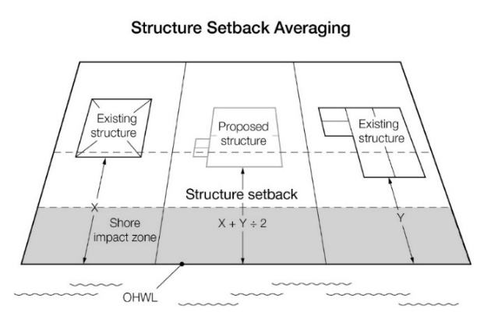  - Setbacks of decks. Deck additions may be allowed without a variance to a structure not meeting the required setback from the ordinary high water level if all of the following criteria are met:  - The structure existed on the date the structure setbacks were established;  - A thorough evaluation of the property and structure reveals no reasonable location for a deck meeting or exceeding the existing ordinary high water level setback of the structure;  - The deck encroachment toward the ordinary high water level does not exceed 15 percent of the existing setback of the structure from the ordinary high water level or is no closer than 30 feet from the OHWL, whichever is more restrictive; and  - The deck is constructed primarily of wood, and is not roofed or screened (see Figure 8).  Figure 8. Deck Encroachment  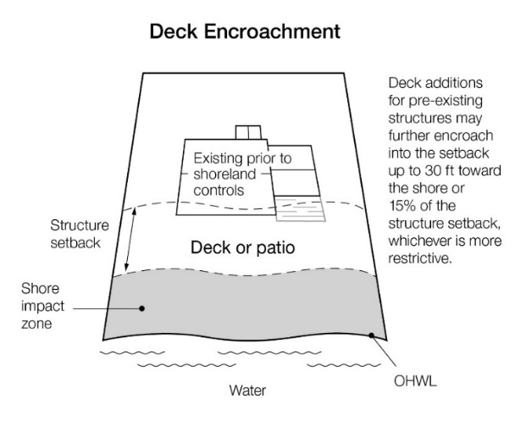  - Additional structure setbacks. Structures must also meet the following setbacks, regardless of the waterbody classification:  - Bluff Impact Zones. Structures, impervious surfaces, and accessory facilities, except stairways and landings, must not be placed within bluff impact zones.  6.42 Height of Structures. All structures in residential districts in cities, except churches and nonresidential agricultural structures, must not exceed 25 feet in height.  6.43 Lowest Floor Elevation.  - Determining elevations. Structures must be placed at an elevation consistent with the applicable floodplain regulatory elevations. Where these elevations are not known, the lowest floor, including basement, must be placed or flood-proofed at an elevation determined using the following methodology:  - For lakes, by placing the lowest floor at a level at least three feet above the highest known water level, or three feet above the ordinary high water level, whichever is higher (see Figure 9);  - For rivers and streams, by placing the lowest floor at least three feet above the highest known flood elevation. If highest known flood elevation is not available, by placing the lowest floor at least three feet above the ordinary high water level (see Figure 9), or by conducting a technical evaluation to establish a flood protection elevation. Technical evaluations must be done by a qualified engineer or hydrologist consistent with Minnesota Rules, parts 6120.5000 to 6120.6200.  - Methods for placement.  - In addition to the lowest floor, all service utilities must be elevated or water-tight to the elevation determined in part A.  - If elevation methods involving fill would result in filling in the SIZ, then structures must instead be elevated through floodproofing methods in accordance with 6.43(B)(3) below;  - If the structure is floodproofed, then it must be built to resist hydrostatic pressure through elevation methods such as blocks, pilings, filled stem walls, elevated concrete pad, internally flooded enclosed areas, or through other accepted engineering practices consistent with FEMA technical bulletins 1, 2 and 3.  Figure 9. Lowest Floor Elevation  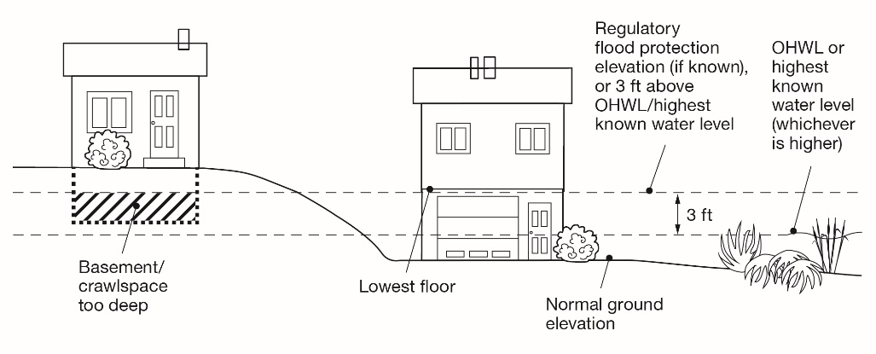  6.44 Significant Historic Sites. No structure may be placed on a significant historic site in a manner that affects the values of the site unless adequate information about the site has been removed and documented in a public repository.  6.5 Water Supply and Sewage Treatment.  6.51 Water supply. Any public or private supply of water for domestic purposes must meet or exceed standards for water quality of the Minnesota Department of Health and the Minnesota Pollution Control Agency.  6.52 Sewage treatment. Any premises used for human occupancy must be connected to a publicly-owned sewer system, where available or comply with Minnesota Rules, Chapters 7080 – 7081.  7.0 PERFORMANCE STANDARDS FOR PUBLIC AND PRIVATE FACILITIES  7.1 Placement and Design of Roads, Driveways, and Parking Areas. These facilities must be designed to take advantage of natural vegetation and topography to achieve maximum screening as viewed from public waters. They must be constructed to minimize and control erosion to public waters consistent with the field office technical guides of the local SWCD and comply with the following standards:  7.11 Roads, driveways, and parking areas must meet structure setbacks and must not be placed within bluff and shore impact zones, when other reasonable and feasible placement alternatives exist. If no alternatives exist, they may be placed within these areas, and must be designed to minimize adverse impacts;  7.12 Watercraft access ramps, approach roads, and access-related parking areas may be placed within shore impact zones provided the vegetative screening and erosion control conditions of this subpart are met;  7.13 Private watercraft access ramps, approach roads, and access-related parking areas are prohibited.  7.13 Private facilities must comply with the grading and filling provisions of Section 8.3 of this ordinance; and  7.14 For public roads, driveways and parking areas, documentation must be provided by a qualified individual that they are designed and constructed to minimize and control erosion to public waters consistent with the field office technical guides of the local soil and water conservation district, or other applicable technical materials.  7.2 Stairways, Lifts, and Landings. Stairways and lifts are the preferred alternative to major topographic alterations for achieving access up and down bluffs and steep slopes to shore areas. Stairways, lifts, and landings must meet the following design requirements:  7.21 Stairways and lifts must not exceed four feet in width on residential lots. Wider stairways may be used for commercial properties, public recreational uses, and planned unit developments;  7.22 Landings for stairways and lifts on residential lots must not exceed 32 square feet in area. Landings larger than 32 square feet may be used for commercial properties, public-space recreational uses, and planned unit developments;  7.23 Canopies or roofs are not allowed on stairways, lifts, or landings;  7.24 Stairways, lifts, and landings may be either constructed above the ground on posts or pilings, or placed into the ground, provided they are designed and built in a manner that ensures control of soil erosion;  7.25 Stairways, lifts, and landings must be located in the most visually inconspicuous portions of lots, as viewed from the surface of the public water assuming summer, leaf-on conditions, whenever practical; and  7.26 Facilities such as ramps, lifts, or mobility paths for physically handicapped persons are also allowed for achieving access to shore areas, if they are consistent with the dimensional and performance standards of sub items 7.21 to 7.25 and the requirements of Minnesota Rules, Chapter 1341.  7.3 Water-oriented Accessory Structures or Facilities. Each residential lot may have one water-oriented accessory structure or facility if it complies with the following provisions:  7.31 The structure or facility must not exceed ten feet in height, exclusive of safety rails, and cannot occupy an area greater than 250 square feet. The structure or facility may include detached decks not exceeding eight feet above grade at any point or at-grade patios;  7.32 The structure or facility is not in the Bluff Impact Zone;  7.33 The setback of the structure or facility from the ordinary high water level must be at least ten feet;  7.34 The structure is not a boathouse or boat storage structure as defined under Minnesota Statutes, Section 103G.245;  7.35 The structure or facility must be treated to reduce visibility as viewed from public waters and adjacent shorelands by vegetation, topography, increased setbacks or color, assuming summer, leaf-on conditions;  7.36 The roof may be used as an open-air deck with safety rails, but must not be enclosed with a roof or sidewalls or used as a storage area;  7.37 The structure or facility must not be designed or used for human habitation and must not contain water supply or sewage treatment facilities;  7.38 As an alternative for general development and recreational development waterbodies, water-oriented accessory structures used solely for storage of watercraft and boating-related equipment may occupy an area up to 400 square feet provided the maximum width of the structure is 20 feet as measured parallel to the shoreline; and  7.39 Water-oriented accessory structures may have the lowest floor placed lower than the elevation specified in Section 6.43 if the structure is designed to accommodate internal flooding, constructed of flood-resistant materials to the elevation, electrical and mechanical equipment is placed above the elevation and, if long duration flooding is anticipated, the structure is built to withstand ice action and wind-driven waves and debris.  7.4. Fences. Fences between principal structures and the waterbody are allowed if fences are:  7.41 Not higher than six feet.  7.42 Not located within the SIZ and BIZ, except for farm fences.  7.43 Not located in the regulatory floodplain, except for farm fences.  7.5 Lighting. Within the OHWL setback:  7.51 Lighting shall be fully shielded and directed away from the water.  7.52 Uplighting viewable from the water is prohibited.  8.0 VEGETATION AND LAND ALTERATIONS  8.1 Purpose. Alterations of vegetation and topography are regulated to prevent erosion into public waters, fix nutrients, preserve shoreland aesthetics, preserve historic values, prevent bank slumping, sustain water quality, and protect fish and wildlife habitat.  8.2 Vegetation Management.  8.21 A vegetation permit is required prior to to vegetative clearing in the shore impact zone and bluff impact zone and on steep slopes. No clearing is allowed until a plan is submitted and approved consistent with these vegetation management provisions.  8.22 Removal or alteration of vegetation must comply with the provisions of this subsection except for:  - Vegetation alteration necessary for the construction of structures and sewage treatment systems under validly issued permits for these facilities;  - The construction of public roads and parking areas if consistent with Section 7.1 of this ordinance;  - Forest management uses consistent with Section 5.3 of this ordinance; and  - Agricultural uses consistent with Section 5.2 of this ordinance.  8.23 Intensive vegetation clearing in the shore and bluff impact zones and on steep slopes is prohibited. Intensive clearing outside of these areas is allowed if consistent with the forest management standards in Section 5.3 of this ordinance.  8.24 Limited clearing and trimming of trees and shrubs in the shore and bluff impact zones and on steep slopes, is allowed to provide a view to the water from the principal dwelling and to accommodate the placement of stairways and landings, picnic areas, access paths, livestock watering areas, beach and watercraft access areas, and permitted water-oriented accessory structures or facilities, provided that:  - Vegetation be maintained to Thescreening of structures, vehicles, or other facilities by at least 50% as viewed from the water, assuming summer, leaf-on conditions, is not substantially reduced. The maximum view corridor shall be less than 50 feet or one-third of the parcel width, whichever is less;  - Existing shading of water surfaces along rivers is preserved;  - Cutting debris or slash shall be scattered and not mounded on the ground; and  - Perennial ground cover is retained.  - Picnic areas, access paths, livestock watering areas, beaches and watercraft access areas are prohibited in bluff impact zones.  8.25 Removal of trees, limbs, or branches that are dead, diseased, dying, or pose safety hazards is allowed without a permit.  8.26 Fertilizer and pesticide runoff into surface waters must be minimized through use of vegetation, topography or both.  8.27 Violations of the vegetation standards shall be subject to a Restoration Order including vegetation restoration plan and a three-year maintenance plan prepared by the land owner and approved by the zoning administrator. Near shore or highly erodible locations are to be restored with a mix of deep-rooted woody and herbaceous vegetation with high stem-density, suitable for the location.  8.3 Grading and Filling.  8.31 Grading and filling activities must comply with the provisions of this subsection except for the construction of public roads and parking areas if consistent with Section 7.1 of this ordinance.  8.32 Permit Requirements.  - Grading, filling and excavations necessary for the construction of structures, sewage treatment systems, and driveways, if part of an approved permit, do not require a separate grading and filling permit. However, the standards in Section 8.33 of this ordinance must be incorporated into the permit.  - For all other work, including driveways not part of another permit, a grading and filling permit is required for:  - the movement of more than 10 cubic yards of material on steep slopes or within shore or bluff impact zones; and  - the movement of more than 50 cubic yards of material outside of steep slopes and shore and bluff impact zones.  - placement of retaining walls, including boulder walls within the SIZ and BIZ provided that:  - if the project includes work at or below the OHWL, the commissioner has already approved or permitted the project.  - the structures are used only to correct a documented existing erosion problem and not for aesthetic reasons.  - the height and length are the minimum necessary to control the erosion problem and are not higher than 4 feet or longer than 10 feet, unless the zoning administrator determines that a larger wall is necessary to correct the erosion problem; and  - walls are screened by vegetation to not be visible from the waterbody.  - Placement of natural rock rip rap, including associated grading of the shoreline and placement of a filter blanket is permitted if:  - if the project includes work at or below the OHWL, the commissioner has already approved or permitted the project;  - the finished slope does not exceed three feet horizontal to one-foot vertical;  - the landward extent of the riprap is within ten feet of the ordinary high water level; and  - the height of the riprap above the ordinary high water level does not exceed three feet (see Figure 10).  - A vegetative buffer, consisting of deep rooted and woody vegetation, is to be established at a distance no less than ten feet from the landward extent of the riprap.  - Figure 10. Riprap Guidelines  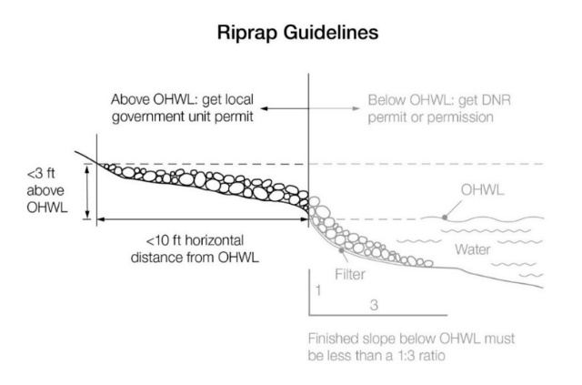  8.33 Grading, filling and excavation activities must meet the following standards:  - Grading or filling of any wetland must meet or exceed the wetland protection standards under Minnesota Rules, Chapter 8420 and any other permits, reviews, or approvals by other local state, or federal agencies such as watershed districts, the DNR or US Army Corps of Engineers;  - Land alterations must be designed and implemented to minimize the amount of erosion and sediment from entering surface waters during and after construction consistently by:  - Limiting the amount and time of bare ground exposure;  - Using temporary ground covers such as mulches or similar materials;  - Establishing permanent, deep-rooted and dense vegetation cover as soon as possible;  - Using sediment traps, vegetated buffer strips or other appropriate techniques;  - Stabilizing altered areas to acceptable erosion control standards consistent with the field office technical guides of the soil and water conservation district;  - Not placing fill or excavated material in a manner that creates unstable slopes. Plans to place fill or excavated material on steep slopes must be reviewed by qualified professionals for continued slope stability and must not create finished slopes of 30 percent or greater;  - Fill or excavated material must not be placed in bluff impact zones;  - Any alterations below the ordinary high water level of public waters must first be authorized by the commissioner under Minnesota Statutes, Section 103G; and  - Alterations of topography are only allowed if they are accessory to permitted or conditional uses and do not adversely affect adjacent or nearby properties  8.34 Connections to public waters. Excavations to connect boat slips, canals, lagoons, and harbors to public waters require a public waters permit and must comply with Minnesota Rules, Chapter 6115.  8.4 Stormwater Management.  8.41 General Standards:  - When possible, existing natural drainageways, and vegetated soil surfaces must be used to convey, store, filter, and retain stormwater runoff before discharge to public waters.  - Development must be planned and conducted in a manner that will minimize the extent of disturbed areas, runoff velocities, erosion potential, and reduce and delay runoff volumes. Disturbed areas must be stabilized as soon as possible and appropriate facilities or methods used to retain sediment on the site.  - When development density, topography, soils, and vegetation are not sufficient to adequately handle stormwater runoff, constructed facilities such as settling basins, skimming devices, dikes, waterways, ponds and infiltration may be used. Preference must be given to surface drainage, vegetation, and infiltration rather than buried pipes and man-made materials and facilities.  8.42 Specific Standards:  - Impervious surfaces of lots must not exceed 25 percent of the lot area.  - When constructed facilities are used for stormwater management, documentation must be provided by a qualified individual that they are designed and installed consistent with the field office technical guide of the local soil and water conservation district or the Minnesota Stormwater Manual, as applicable.  - New constructed stormwater outfalls to public waters must be consistent with Minnesota Rules, part 6115.0231.  9.0 SUBDIVISION/PLATTING PROVISIONS  9.1 Purpose. To ensure that new development minimizes impacts to shoreland resources and is safe and functional.  9.2 Land suitability. Each lot created through subdivision, including planned unit developments authorized under Section 10.0 of this ordinance, must be suitable in its natural state for the proposed use with minimal alteration A suitability analysis must be conducted for each proposed subdivision, including planned unit developments, to determine if the subdivision is suitable in its natural state for the proposed use with minimal alteration and whether any feature of the land is likely to be harmful to the health, safety, or welfare of future residents of the proposed subdivision or of the community.  9.3 Consistency with other controls. Subdivisions and each lot in a subdivision shall meet all official controls so that a variance is not needed later to use the lots for their intended purpose.  9.4 Water and Sewer Design Standards.  9.41 A potable water supply and a sewage treatment system consistent with Minnesota Rules, Chapters 7080 – 7081 must be provided for every lot.  9.42 Each lot must include at least two soil treatment and dispersal areas that support systems described in Minnesota Rules, parts 7080.2200 to 7080.223 or site conditions described in part 7081.0270, subparts 3 to 7, as applicable.  9.43 Lots that would require use of holding tanks are prohibited.  9.5 Information requirements.  9.51 Topographic contours at ten-foot intervals or less from United States Geological Survey maps or more current sources, showing limiting site characteristics;  9.52 The surface water features required in Minnesota Statutes, section 505.021, Subd. 1, to be shown on plats, obtained from United States Geological Survey quadrangle topographic maps or more current sources;  9.53 Adequate soils information to determine suitability for building and sewage treatment capabilities for every lot from the most current existing sources or from field investigations such as soil borings, percolation tests, or other methods;  9.54 Information regarding adequacy of domestic water supply; extent of anticipated vegetation and topographic alterations; near-shore aquatic conditions, including depths, types of bottom sediments, and aquatic vegetation; and proposed methods for controlling stormwater runoff and erosion, both during and after construction activities;  9.55 Location of 100-year flood plain areas and floodway districts from existing adopted maps or data; and  9.56 A line or contour representing the ordinary high water level, the “toe” and the “top” of bluffs, and the minimum building setback distances from the top of the bluff and the lake or stream.  9.6 Dedications. When a land or easement dedication is a condition of subdivision approval, the approval must provide easements over natural drainage or ponding areas for management of stormwater and significant wetlands.  9.7 Platting. All subdivisions that cumulatively create five or more lots or parcels that are 2-1/2 acres or less in size shall be processed as a plat in accordance with Minnesota Statutes, Chapters 462.358 Subd. 3a (cities) and 505. No permit for construction of buildings or sewage treatment systems shall be issued for lots created after the adoption of this ordinance unless the lot was previously approved as part of a formal subdivision.  9.8 Controlled Access Lots. Controlled access lots within a subdivision must meet or exceed the lot size criteria in Section 6.33 of this ordinance.  10.0 PLANNED UNIT DEVELOPMENTS (PUDs)  10.1 Purpose. To protect and enhance the natural and scenic qualities of shoreland areas during and after development and redevelopment of high density residential and commercial uses.  10.2 Types of PUDs Permissible. Planned unit developments (PUDs) are allowed for new projects on undeveloped land, redevelopment of previously built sites, or conversions of existing buildings and land. Deviation from the minimum lot size standards of Section 6.2 of this ordinance is allowed if the standards in this Section are met.  10.3 Processing of PUDs. Planned unit developments in the shoreland district must be processed as a conditional use and comply with the provisions of this section in addition to those standards outlined elsewhere in the zoning and subdivision regulations. When there is a conflict in requirements, the more stringent of the requirements shall be applied. An expansion to an existing commercial PUD involving 6 or less new dwelling units or sites since the date this ordinance was adopted is permissible as a permitted use provided the total project density does not exceed the allowable densities calculated in the project density evaluation procedures in Section 10.5. Approval cannot occur until all applicable environmental reviews are complete.  10.4 Application for a PUD. The applicant for a PUD must submit the following documents prior to final action on the application request:  10.41 Site plan and/or plat showing:  - Locations of property boundaries;  - Surface water features;  - Existing and proposed structures and other facilities;  - Land alterations;  - Sewage treatment and water supply systems (where public systems will not be provided);  - Topographic contours at ten-foot intervals or less; and  - Identification of buildings and portions of the project that are residential, commercial, or a combination of the two (if project combines commercial and residential elements).  10.42 A property owner’s association agreement (for residential PUD’s) with mandatory membership, and consistent with Section 10.6 of this ordinance.  10.43 Deed restrictions, covenants, permanent easements or other instruments that:  - Address future vegetative and topographic alterations, construction of additional buildings, beaching of watercraft, and construction of commercial buildings in residential PUDs; and  - Ensure the long-term preservation and maintenance of open space in accordance with the criteria and analysis specified in Section 10.6 of this ordinance.  10.44 A master plan/site plan describing the project and showing floor plans for all commercial structures.  10.45 Additional documents necessary to explain how the PUD will be designed and will function.  10.5 Density Determination. Proposed new or expansions to existing planned unit developments must be evaluated using the following procedures.  10.51 Step 1. Identify Density Analysis Tiers. Divide the project parcel into tiers by drawing one or more lines parallel to the ordinary high water level at the following intervals, proceeding landward:  10.52 Step 2. Calculate Suitable Area for Development. Calculate the suitable area within each tier by excluding all road rights-of way or easements,wetlands, bluffs, or land below the ordinary high water level of public waters.  10.53 Step 3. Determine Base Density:  - For residential PUDs, divide the suitable area within each tier by the minimum single residential lot area for lakes to determine the allowable number of dwelling units, or base density, for each tier. For rivers, if a minimum lot area is not specified, divide the tier width or river frontage by the minimum single residential lot width.  - For commercial PUDs:  - Determine the average area for each dwelling unit or dwelling site within each tier. Include both existing and proposed dwelling units and sites in the calculation.  - For dwelling units, determine the average inside living floor area of dwelling units in each tier. Do not include decks, patios, garages, or porches and basements, unless they are habitable space.  - For dwelling sites (campgrounds), determine the area of each dwelling site as follows:  For manufactured homes, use the area of the manufactured home, if known, otherwise use 1,000 sf.  For recreational vehicles, campers or tents, use 400 sf.  - Select the appropriate floor area/dwelling site area ratio from the following table for the floor area or dwelling site area determined in Section 10.53 B. 1.  - Multiply the suitable area within each tier determined in Section 10.52 by the floor area or dwelling site area ratio to yield the total floor area or dwelling site area for each tier to be used for dwelling units or dwelling sites.  - Divide the total floor area or dwelling site area for each tier calculated in Section 10.53 B. 3 by the average inside living floor area for dwelling units or dwelling site area determined in 10.53 B 1. This yields the allowable number of dwelling units or dwelling sites, or base density, for each tier.  - Allowable densities may be transferred from any tier to any other tier further from the waterbody, but must not be transferred to any tier closer to the waterbody.  - All PUDs with densities at or below the base density must meet the design standards in Section 10.6  10.54 Step 4. Determine if the Site can Accommodate Increased Density:  - The following increases to the dwelling unit or dwelling site base densities determined in Section 10.53 are allowed if the design criteria in Section 10.6 of this ordinance are satisfied as well as the standards in Section 10.54, item B:  - Structure setbacks from the ordinary high water level:  - Are increased to at least 50 percent greater than the minimum setback; or  - The impact on the waterbody is reduced an equivalent amount through vegetative management, topography, or additional acceptable means and the setback is at least 25 percent greater than the minimum setback.  10.6 Design Criteria. All PUDs must meet the following design criteria.  10.61 General Design Standards.  - All residential planned unit developments must contain at least five dwelling units or sites.  - On-site water supply and sewage treatment systems must be centralized and meet the standards in Section 6.5 of this ordinance. Sewage treatment systems must meet the setback standards of Section 6.41, item A of this ordinance.  - Dwelling units or dwelling sites must be clustered into one or more groups and located on suitable areas of the development.  - Dwelling units or dwelling sites must be designed and located to meet the dimensional standards in Sections 6.41, 6.42, and 6.43:  - Shore recreation facilities:  - Must be centralized and located in areas suitable for them based on a suitability analysis.  - The number of spaces provided for continuous beaching, mooring, or docking of watercraft must not exceed one for each allowable dwelling unit or site in the first tier (notwithstanding existing mooring sites in an existing commercially used harbor).  - Launching ramp facilities, including a small dock for loading and unloading equipment, may be provided for use by occupants of dwelling units or sites located in other tiers.  - Structures, parking areas, and other facilities must be treated to reduce visibility as viewed from public waters and adjacent shorelands by vegetation, topography, increased setbacks, color, or other means acceptable to the local unit of government, assuming summer, leaf-on conditions. Vegetative and topographic screening must be preserved, if existing, or may be required to be provided.  - Accessory structures and facilities, except water oriented accessory structures, must meet the required structure setback and must be centralized.  - Water-oriented accessory structures and facilities may be allowed if they meet or exceed design standards contained in Section 7.3 of this ordinance and are centralized.  10.62 Open Space Requirements.  - Open space must constitute at least 50 percent of the total project area and must include:  - Areas with physical characteristics unsuitable for development in their natural state;  - Areas containing significant historic sites or unplatted cemeteries;  - Portions of the shore impact zone preserved in its natural or existing state as follows:  - For existing residential PUD’s, at least 50 percent of the shore impact zone  - For new residential PUDs, at least 70 percent of the shore impact zone.  - For all commercial PUD’s, at least 50 percent of the shore impact zone.  - Open space may include:  - Outdoor recreational facilities for use by owners of dwelling units or sites, by guests staying in commercial dwelling units or sites, and by the general public;  - Subsurface sewage treatment systems if the use of the space is restricted to avoid adverse impacts on the systems; and  - Non-public water wetlands.  - Open space shall not include:  - Dwelling sites or lots, unless owned in common by an owners association;  - Dwelling units or structures, except water-oriented accessory structures or facilities;  - Road rights-of-way or land covered by road surfaces and parking areas;  - Land below the OHWL of public waters; and  - Commercial facilities or uses.  10.63 Open Space Maintenance and Administration Requirements.  - Open space preservation. The appearance of open space areas, including topography, vegetation, and allowable uses, must be preserved and maintained by use of deed restrictions, covenants, permanent easements, public dedication, or other equally effective and permanent means. The instruments must prohibit:  - Commercial uses (for residential PUD’s);  - Vegetation and topographic alterations other than routine maintenance;  - Construction of additional buildings or storage of vehicles and other materials; and  - Uncontrolled beaching of watercraft.  - Development organization and functioning. Unless an equally effective alternative community framework is established, all residential planned unit developments must use an owners association with the following features:  - Membership must be mandatory for each dwelling unit or dwelling site owner and any successive owner;  - Each member must pay a pro rata share of the association’s expenses, and unpaid assessments can become liens on units or dwelling sites;  - Assessments must be adjustable to accommodate changing conditions; and  - The association must be responsible for insurance, taxes, and maintenance of all commonly owned property and facilities.  10.64 Erosion Control and Stormwater Management.  - Erosion control plans must be developed and must be consistent with the provisions of Section 8.3 of this ordinance. Erosion control plans approved by a soil and water conservation district may be required if project size and site physical characteristics warrant.  - Stormwater management facilities must be designed and constructed to manage expected quantities and qualities of stormwater runoff.  - For residential PUDs, impervious surface for the entire project site must not exceed 25%.  - For commercial PUDs, impervious surfaces within any tier must not exceed 25 percent of the tier area, except that 35 percent impervious surface coverage may be allowed in the first tier of general development lakes with an approved stormwater management plan and consistency with Section 8.0 of this ordinance.  10.7 Conversions. Local governments may allow existing resorts or other land uses and facilities to be converted to residential PUDs if all of the following standards are met:  10.71 Proposed conversions must be evaluated using the same procedures for residential PUDs involving new construction. Inconsistencies between existing features of the development and these standards must be identified;  10.72 Deficiencies involving water supply and sewage treatment, structure color, impervious coverage, open space, and shore recreation facilities must be corrected as part of the conversion or as specified in the conditional use permit;  10.73 Shore and bluff impact zone deficiencies must be evaluated and reasonable improvements made as part of the conversion. These improvements must include, where applicable, the following:  - Removal of extraneous buildings, docks, or other facilities that no longer need to be located in shore or bluff impact zones;  - Remedial measures to correct erosion, improve vegetative cover and improve screening of buildings and other facilities as viewed from the water; and  - Conditions attached to existing dwelling units located in shore or bluff impact zones that preclude exterior expansions in any dimension or substantial alterations. The conditions must also provide for future relocation of dwelling units, where feasible, to other locations, meeting all setback and elevation requirements when they are rebuilt or replaced.  10.74 Existing dwelling unit or dwelling site densities that exceed standards in Section 10.5 of this ordinance may be allowed to continue but must not be allowed to be increased, either at the time of conversion or in the future. Efforts must be made during the conversion to limit impacts of high densities by requiring seasonal use, improving vegetative screening, centralizing shore recreation facilities, installing new sewage treatment systems, or other means. | 1.1. Ensures that LGU authority to administer and enforce the ordinance is connected to state regulatory policy.  1.2. Reinforces the responsibility of local governments to regulate shorelands in their jurisdiction.  2.1. Identifies the size of waterbodies that must be included in the ordinance as directed by rule. Water bodies meeting these thresholds must be listed in Section 4.0. Optional provision for cities that have extra-territorial zoning authority.  2.2 – 2.4. If these provisions are already included in the zoning ordinance, they are not needed.  2.5. These definitions are the minimum necessary for a compliant ordinance. Some definitions may not be needed if a given feature or land use is not present or not allowed in the community.  2.511. Optional. Adding examples helps communicate what accessory structures or facilities are.  2.513. The DNR’s bluff mapping tool, a GIS script, is available for download from the Minnesota Geospatial Commons. This tool is helpful for identifying bluffs for general mapping and planning purposes.  2.513.D. The phrase “except that an area with an average slope of less than 18 percent over a distance of at least 50 feet shall not be considered part of the bluff,” identifies terraces or large relatively flat areas that separate bluff features above and below the terrace. According to the Shoreland Rules SONAR, these areas are buildable if setback standards can be met. This phrase is not to be used in conjunction with the top of bluff definition to reduce the size of the bluff.  2.515. This optional text is added to improve clarity.  2.516 Optional language helps to clarify that the top of bluff is used for administering other provisions in addition to bluff setbacks.  2.517. Boathouses are prohibited by statute, and are different than water-oriented accessory structures (2.562) which are allowed in the rules.  2.525. Any feature meeting this definition is also a structure (see structure definition) and must meet structure setbacks. Decks must meet floodplain standards. Decks that are accessory to a residential use are prohibited in floodways. Optional language. Make all decks a structure subject to permitting by eliminating the “three-feet above ground” language.  2.529. Optional. New definition to clarify nonconformity terms used in MS 462.357 and 394.36.  2.534. Optional definition. An impervious surface definition is not in rule, but is very helpful for administering the required impervious surface standards in Section 8.4 of this model. Gravel driveways are defined as impervious since soils become compacted after use and impair infiltration of water, and they are often eventually paved over by property owners and such work doesn’t usually require a permit. Permeable pavers are also included to eliminate their use as a “work around” to meeting impervious coverage standards in Section 8.4. Permeable pavement can reduce stormwater runoff, if maintained, but as a hard surface they remove habitat/vegetation and thus also impact shoreland aesthetics, both of which are shoreland protection goals.  2.535. Optional. New definition to clarify nonconformity terms used in MS 462.357 and 394.36.  2.540. Optional. New definition to clarify nonconformity terms used in MN 462.357 and 394.36.  2.543. This is the same definition as 103G.005 Subd. 14.  2.546. Optional. New definition to clarify nonconformity terms used in MS 462.357 and 394.36.  2.557. Optional deletion. This is a difficult definition to administer. Simplifying this definition to include only average slopes over 12% will make administration easier and improve resource protection.  2.562. Optional addition. Local governments may consider, decks and patios as water-oriented accessory structures (WOAS)to help clarify administration. The treatment of patios, specifically, in the shore impact zone (SIZ) is a common source of confusion. As a WOAS, patios could be allowed in the SIZ and counted towards the size limitation of WOAS in Section 7.3.  2.563. “Water-dependent use” is used instead of the term “surface water-oriented commercial use” and is expanded to include industrial, public, and semi-public uses with similar needs to have access to and use of public waters.This helped to streamline the standards in Section 6.1 of the model..  3.1. All purpose statements in the model are optional but strongly encouraged. They help explain the intent of zoning provisions, which is useful to local governments for explaining provisions to property owners and developing findings for variance decisions.  3.5. The statutory criteria for evaluating variance applications are broad, one-size-fits-all, for use with all variances. Variances to shoreland protection standards affect public waters, resources to be protected for all state residents. Because of the special status of these waters, communities may want to establish special criteria for evaluating shoreland variances to ensure variances do not adversely affect public water resources.  3.71. This language is consistent with Minnesota Statute, sections 394.36 Subd. 5(f) (counties) and 462.357 Subd. 1e(i)(municipalities). Conditions come verbatim from statute or are a slight modification of statutory conditions and those from 6120.3900 Subp. 3A (b). Optional deletion provides stronger authority to apply conditions. The phrase “when related to and proportional to the impact” makes clear that conditions will be appropriately applied.  3.81. Variances to statutory requirements (394.36 Subd. 5 (d) or 462.357 Subd. 1e (g)) to combine contiguous nonconforming lots under common ownership are prohibited. See “Considerations in Managing Nonconforming Lots in Shoreland Areas.”  3.82. Consistent with Minnesota Statutes, sections 394.36, Subd. 4 (counties) and 462.357, Subd. 1e (municipalities).  3.9. DNR’s preferred notification method is via email to the appropriate DNR Area Hydrologist.  3.91. Submittal of ordinances and amendments to the DNR is required under statute. The optional language provides for submittal of amendments earlier than the 10-day notification required of public hearings (Section 3.92). Submittal of amendments 30 days prior to public hearing is mutually beneficial; it provides DNR with sufficient time to complete a review and make an approval decision in time for public hearings, thus minimizing delays in the local government’s adoption schedule. Amendments involving rezonings or zoning map changes that affect shorelands (e.g. changes to underlying zoning when shoreland provisions refer to underlying zoning) also require DNR review and approval.  3.94. Reclassifications require a formal request, and are usually only approved to correct an error in the original classification. Provisions for implementation flexibility (6120.2800, Subp. 3), rather than reclassification, may be used for requesting changes in standards for certain areas. Local governments may also adopt special protection classifications, a useful approach for applying higher standards around waters in need of greater protection.  3.10. Mandatory EAWs are required for many projects in shorelands. In most cases, the local government is the Responsible Government Unit (RGU) for completing the EAW.  4.1. The ordinance must list all public water shoreland within the community’s jurisdiction including public waters not in the jurisdiction but with surrounding shoreland that is in the jurisdiction.  4.12. Optional provision. It is helpful to show the shoreland areas for lakes and rivers on the zoning map along with their classifications.  4.13. Cities must list lakes that are 10 or more acres, and counties 25 or more acres (Minnesota Rules, part 6120.2500, Subp. 13). Cities that annex land or townships that incorporate with lakes that are 10 acres or more must amend their ordinances to include those lakes. List lakes along with the DNR public waters ID number.  4.14. List river names here along with township, range and section number of the river reach.  Optional. Communities with sensitive shorelines or waters that are at risk to degradation due to nonpoint source nutrient pollution may designate those waters (lakes and rivers) with a special protection classification and regulate the shoreland of those waters with more restrictive development standards such as lot area, setback, riparian buffers, etc.  4.15. Instead of this provision, local governments may list all tributaries in the table in Section 4.14, and/or provide a map of all watercourses subject to the tributary class. This is a practical alternative if the number of tributaries is relatively small.  4.22. Land uses in the shoreland district are listed as permitted, not permitted, or conditional for each water body classification. Land uses for each lake classification are in Section 4.23, and uses for each river classification are in 4.24. The allowed land uses in these two tables were consolidated from the “land use district” tables in MR 6120.3200. In situations where the allowable use classification (P, C, N) varied for a given land use in different districts, the most restrictive allowable use classification was used for these two tables. There may be some situations where the less restrictive standard may be relevant for a specific community. If so, please explain why when you submit your ordinance to the DNR  Local governments may further clarify if the listed “permitted” uses are allowed with or without a permit. Uses listed as “conditional” require a Conditional Use Permit (CUP). Underlying zoning should be consistent with these uses to alleviate potential conflicts.  Optional. Add solar power as a conditional use including criteria or conditions of approval. See “Consideration in Siting Solar Power Facilities in Shoreland Areas” for ideas for conditions.  New feedlots are prohibited in shorelands per Minnesota Rules, part 7020. Minnesota statute 116.0711 allows the resumption of existing feedlots.  Optional. Add solar power as a conditional use including criteria or conditions of approval. See “Consideration in Siting Solar Power Facilities in Shoreland Areas” for ideas for conditions.  New feedlots are prohibited in shorelands per Minnesota Rules, part 7020. Minnesota statute 116.0711 allows the resumption of existing feedlots.  5.0. The uses and their special conditions in this section must be in the shoreland ordinance if the use is allowed. If not, the provision may be excluded from this section, however, it should be added to the land use tables in 4.23 and 4.24 and listed as “N.” Note that some of these uses are conditional uses and must be identified as such in use tables 4.23 and 4.24.  5.11.D. This provision was modified from rules for consistency with the Supreme Court decision in Reed vs Town of Gilbert regarding the first amendment and signage.  5.21. The DNR will consider a 50-foot average, 30-foot minimum buffer and language defining alternative water quality practices consistent with Minnesota Statutes, section 103F.48 as being consistent with 6120.3300, Subp. 7. Please see guidance and model language for acceptable language.  5.21.B. Optional deletion. Eliminating the option to use alternative practices instead of the required buffer will reduce nutrient runoff and improve surface water quality.  6.21. Optional. Ensures there is sufficient lot area that meets minimum area and construction of impervious surfaces without need of a variance  6.25. Local governments may want to require larger lot area and width standards than those listed. Larger lots reduce density and risk of surface water use overcrowding and preserve lakeshore character. Larger lots also reduce the amount of development and impervious surfaces along sensitive shorelines providing protection to waters sensitive to nutrient pollution.  6.26. Local governments may want to establish minimum lot area requirements and require larger lot width and area standards than those listed.  6.31. If a community does not have NE lakes this provision may be omitted. If a community has NE lakes but prohibits duplex, triplex or quads on NE lakes, this provision may be omitted. However, duplex, triplex or quad structures must be listed in the land use tables 4.23 and 4.24 as “N.”  6.32. If a community does not allow guest cottages or secondary dwelling units, this provision may be omitted. However, guest cottages must be listed in the land use tables 4.23 and 4.24 as “N.”  6.33. Controlled access lots are the only method to allow riparian access for non-riparian property and are only allowed at the time of subdivision. Communities concerned about overcrowding of surface waters may choose to prohibit controlled access lots. If a community does not allow controlled access lots, this provision may be omitted. However, controlled access lots must be listed in the land use tables in 4.23 and 4.24 as “N.”  6.34. Optional. Communities concerned about crowding of surface waters may want to prohibit access easements and the additional boats that result from their use.  6.4. Local governments may apply stricter standards than those listed here. Increasing structure setbacks can help reduce the risk of erosion in near shore areas and enhance the aesthetic character of lakes and shorelands. Larger setbacks also allow room for larger riparian buffers. Increasing septic system setbacks increases reduces the risk of subsurface effluent reaching surface waters.  6.41 Optional addition. This language clarifies that the ”sewer” standards only apply if a publicly owned sewer system is available to the property to be consistent with similar language in Section 6.23 which is specified in rule.  6.41.A. Optional language. Keeping impervious surfaces away from the riparian edge is important for reducing the risk of erosion in the near shore area and nutrient loading into surface waters due to runoff. Section 7.3 of this ordinance allows for some exceptions for impervious surfaces in the near shore area. ALL accessory structures must meet floodplain standards and are prohibited in floodways.  6.41.B. Local governments may choose to exclude this provision from their ordinance or only apply it to nonconforming lots. Optional addition of “principal” is helpful to ensure that new structures are not sited based on location of nonconforming accessory structures.  6.41.C. Local governments may choose to exclude this provision from their ordinance.  6.41.D. Local governments may apply stricter standards than those listed. The presence of permeable soils on top of bedrock, combined with steep slopes or bluffs, can increase risk of septic effluent leakage out the sides of slopes or bluffs. Establishing septic system setbacks from the top of bluffs can reduce this risk.  6.41.E. Optional. Keeping impervious surfaces out of the bluff impact zone is important for reducing the risk of slope erosion and failure and nutrient loading into surface waters due to runoff.  6.42. Height standards only apply to residential districts in cities (MR 6120.3300 Subp. 3.G.).  6.43.A. If flood elevations are known along all public waters and stream reaches in the community, everything in part A after the first sentence can be deleted (this would only typically apply to small cities with few waterbodies).  6.43.B(2) Optional. Elevation on fill can often lead to significant alterations and vegetation removal in the highly sensitive shore impact zone. The addition of this standard would help to minimize near shore impacts.  7.13. Optional higher standard to minimize spread of Aquatic Invasive Species (AIS). If this optional standard used, old provision 7.13 MUST be deleted. Alternatively, private facilities could be prohibited only on lakes with existing public access. If this approach used, old provision 7.13 should be kept and renumbered.  7.3. If a community does not allow water-oriented accessory structures or facilities (WOAS), this provision may be omitted. However, such structures and facilities must be listed in the land use tables in 4.23 and 4.24 as “N.”  7.31. Optional addition. Including “patios” as a water-oriented accessory structure (WOAS) or facility makes patios subject to the limitations of this provision. This helps to simplify administration and limit the amount of impervious surfaces within the shore impact zone. “Patios” should only be included here if they are also included in the definition of WOAS in Section 2.562. It’s acceptable to allocate the 250 SF limit between multiple structures and facilities.  7.36. Optional addition. The additional language helps to clarify structure design and keep such structures smaller and less noticeable. Rules don’t specifically prohibit roofs but they do say “must not be enclosed” A reasonable interpretation is that roofs constitute and enclosure.  7.4. Optional. Fence regulation can help eliminate conflicts between property owners and minimize impacts to shoreland and floodplain resources.  7.5. Optional. Lighting regulation can help eliminate conflicts between property owners and minimize impacts to shoreland resources, especially waterfowl.  8.0. These standards prohibit or limit vegetation removal in specified areas. These are difficult to administer and enforce, and once vegetation has been removed there are no requirements to restore it. Communities concerned about the loss of riparian vegetation and habit, erosion control and aesthetics may consider establishing a requirement to maintain a riparian buffer and restoration to the required standard as a condition of any permit approval. This is one of the most important actions any community can take – See the Innovative Standards Webpage .  8.21. Optional higher standard. Requiring a permit for vegetation clearance in sensitive areas provides opportunity for LGU staff to guide the clearing activities and ensure activites are consistent with regulations. See Section 9.0 of the DNR MRCCA model ordinance for specific ideas on permitting vegetation management activities.  8.24 A. Optional. Having quantitative measures helps to communicate standards to property owners as well as enforce the ordinance.  8.23 C, D, and E. Optional. These standards provide additional protection for vegetation and reduce land disturbance in bluff impact areas that enhance habitat and protect water quality.  8.26. Optional. Requiring restoration and maintenance for violations of vegetation standards communicates that there are consequences for cutting vegetation. These provisions may be modified to address local concerns.  8.3. Note that Minnesota Rules, part 4410.4300, Subp. 36a provides thresholds for mandatory EAWs for certain land conversions and alterations in shoreland. The local government is the Responsible Government Unit (RGU) unless otherwise specified.  8.32.A. The 1999 model ordinance included driveways in this provision even though they are not included in rule. If ordinances include driveways in this provision they should also include the driveway language in 8.32.B. to communicate that driveways, as a stand-alone project, do need a permit if they meet the stated disturbance thresholds.  8.32.B. Optional. In addition to a cubic yard threshold for permitting, also include a square footage threshold. Most property owners can visualize square footage better than cubic yards and will thus aid in permitting compliance. An area that is 270 square feet (16.43 ft. X 16.43 ft.) by 1 foot deep is 270 cubic feet or 10 cubic yards.An area that is 1,350 square feet (36.74 ft. X 36.74 ft.) by 1 foot deep is 1,350 cubic feet or 50 cubic yards.  8.32.B.(1).Optional. Consider prohibiting filling in the SIZ or if filling is allowed, require conditions of approval that, at a minimum, require vegetation restoration.  8.32 B. (3). Optional.The SL rules and SONAR are not clear on how to address retaining walls in the SIZ/BIZ. LGUs may prohibit them or require a permit subject to conditions (as provided in this example). These conditions may be modified to address local concerns.  8.32. B. (4). This provision and items b. – d. are required under the SL rules. By locating this provision here, a permit is always required for placing rip rap. Under the rules, a permit is only needed for placing rip rap if it disburbs more than 10 cubic yards. To keep the rule based-approach, 8.32 B (4) and items b. – d. can be located as item (10) under 8.33 B (its original location).  8.32.B.(4).a. Optional. It is good practice to coordinate rip rap installation with the DNR – may avoid violations of public water rules and restorations.  8.32.B.(4)e. Optional. This provision provides replacement habitat and aestethic screening, as well as enhanced protection against erosion.  8.33.B.(3). Optional addition of deep-rooted and dense vegetation to improve soil stability.  8.34. DNR permits for public water excavations require that the local government have a DNR-approved shoreland zoning ordinance (Minnesota Statute, Section 103G.245, Subd. 8(1)) as a condition of a public water permit approval. The DNR may deny a permit for public waters excavations if there is no shoreland ordinance or if the current ordinance is not consistent with the ordinance the DNR has approved.  8.41. These are common stormwater management BMPs. If any of these specific provisions exist elsewhere in a local ordinance and are similar, they may be omitted here.  8.42.A. Local governments may reduce the maximum amount of impervious surface allowed. Reducing the amount of allowed impervious surface will reduce the runoff volume and rate reducing the risk of erosion and nutrient loading into surface waters. Requiring a lower minimum (15% or 20%) only on new lots avoids the creation of nonconformities.  9.51. In addition to paper based topographic information, MnTOPO is a web-based application for viewing, printing and downloading high-resolution elevation data. It can also be used to generate elevation profiles for locating bluffs, watershed boundaries or other topographical features of interest.  9.7. Optional. “Cumulatively” is recommended to close a loophole where a parcel is subdivided at different times, each time creating fewer than 5 parcels to avoid the requirement to plat. Both Minnesota Statutes, sections 462 and 394 say official controls are to provide for “orderly” development. Applying this provision cumulatively to parcels supports this purpose.  10.0 Shoreland PUDs require a conditional use permit (CUP) and are best thought of as a conditional use to allow higher density in shoreland areas. Provisions in this section are conditions of approval that are required to approve a Shoreland PUD (CUP) and cannot be weakened through the negotiation process of a local government’s general PUD ordinance.  10.3. Optional addition to ensure that a community’s “general PUD” ordinance isn’t used to undermine the shoreland standards in theses shoreland PUD provisions. If a community does not allow PUDs in shoreland, Section 10.0 should be omitted. However, PUDs must be listed in the land use tables in 4.23 and 4.24 as “N.”  If the local government does not have DNR-approved shoreland PUD provisions in its ordinance but still allows PUDs in shoreland, Minnesota Rules, part 6120.3800, Subp. 1 gives the DNR authority to review PUDs in shoreland for compliance with state rules. In this case, the ordinance must have a provision that states “The DNR must approve all PUDs located in shorelands.”  10.5. Determining and evaluating proposed project density may be complex depending on the project. Please review the Residential PUD Guidance Document for determining density and/or contact your Area Hydrologist for assistance.  10.52. Optional. Road rights-of-way or easements are not developable and should thus not be included in area considered suitable for development on which allowable density is calculated.  10.53.A. For LGUs that have specified a minimum lot area for river lots, the process for determining base density for lakes and rivers will be the same – tier area divided by lot area. Note that tier width is the same thing as the river frontage along a given parcel.  10.54. This provision allows very high densities leading to overcrowding of surface waters and increases the risk to phosphorus sensitive lakes and sensitive shoreline areas. Even without this density bonus provision, the Shoreland PUD allows for significantly greater density over standard lot and block subdivisions due to design flexibility of not requiring a minimum lot size. Local governments concerned about overuse of surface waters, degradation of water quality, compatibility with adjacent development, and overall community character should omit or reduce this density bonus provision.  10.61.D MR 6120.3800 Subp. 5.B.3.(b) states that dwelling units must be designed to meet/exceed the dimensional standards for OHWL setback, elevation, height.  10.62. Open space provides significant ecological, recreational, and economic benefits. Local governments may want to add additional specifications for its design and maintenance. This could include specifying the amount and type of native vegetation, its long-term maintenance, and connectivity to adjacent natural areas. Other options include limiting the amount of open space that may be used for high intensity recreational areas (trails, playgrounds, etc.), stormwater and sewage treatment, etc.  10.62.B.(3). WCA or other non-public water wetlands may be included in open space. Public waters, including public water wetlands, are already public open space and cannot be counted as open space.  10.62.C.(1). Optional. “Dwelling sites” are not the same as lots (see definition in Section 2). Dwelling sites in a residential subdivision is the area within a lot not covered by a dwelling unit or structure (plus a buffer area around the sites or structures) that can be included as open space. Privately owned residential “open space” is very difficult to manage and maintain for ecological benefits, even with the required conservation easements. Communities concerned about developing and maintaining valuable habitat and water quality through open space preservation or about the ability to “administer” protection of open space on residential lots, may choose to add “lots, unless owned in common by an owner’s association.”  10.62.C.(4) clarifies that open space cannot include land below the OHWL of public waters. Use of the water above this land is already a “public” open space. The purpose of the open space is to set-aside and permanently protect private land for recreation, habitat, and water quality purposes and to offset higher development densities allowed.  10.64.B.(1) Optional higher standard to ensure that the impervious surface for the entire development does not exceed 25%  10.64.B.(2) Optional deletion. Local governments may choose to require a 25% impervious surface limit in all tiers for commercial PUDs by deleting the provisions that allows a 35% impervious surface limit. This spreads out the impervious surface and limits it in near shore areas thus preserving habitat and shoreland aesthetics.
  General Development Lake Name | DNR Public Waters I.D. #
  (Insert lake name) | (Insert DNR Public Waters I.D. #)
  (Insert lake name) | (Insert DNR Public Waters I.D. #)
  Recreational Development Lake Name | DNR Public Waters I.D. #
  (Insert lake name) | (Insert DNR Public Waters I.D. #)
  (Insert lake name) | (Insert DNR Public Waters I.D. #)
  Natural Environment Lake Name | DNR Public Waters I.D. #
  (Insert lake name) | (Insert DNR Public Waters I.D. #)
  (Insert lake name) | (Insert DNR Public Waters I.D. #)
  Urban River Name | Legal Description
  (Insert river name) | (Insert legal description)
  (Insert river name) | (Insert legal description)
  Agriculture River Name | Legal Description
  (Insert river name) | (Insert legal description)
  (Insert river name) | (Insert legal description)
  Transition River Name | Legal Description
  (Insert river name) | (Insert legal description)
  (Insert river name) | (Insert legal description)
  Forested River Name | Legal Description
  (Insert river name) | (Insert legal description)
  (Insert river name) | (Insert legal description)
  Remote River Name | Legal Description
  (Insert river name) | (Insert legal description)
  (Insert river name) | (Insert legal description)
  Land Uses | General Development | Recreational Development | Natural Environment
  Single residential | P | P | P
  Duplex, triplex, quad residential | P | P | C
  Residential PUD | C | C | C
  Water-dependent (Resorts are also Commercial PUDs) | C | C | C
  Commercial | P | P | C
  Commercial PUD (Expansion of PUD involving up to six additional units or sites allowed as a permitted use provided the provisions of Section 10.0 are satisfied.) | C | C | C
  Solar Power Facilities (principal land use) | C | C | C
  Parks & historic sites | C | C | C
  Public, semipublic | P | P | C
  Industrial | C | C | N
  Agricultural: cropland and pasture | P | P | P
  Agricultural feedlots: New | N | N | N
  Agricultural feedlots: Expansion or resumption of existing | C | C | C
  Forest management | P | P | P
  Forest land conversion | C | C | C
  Extractive use | C | C | C
  Mining of metallic minerals and peat | P | P | P
  Land Uses | Remote | Forested | Transition | Agriculture | Urban | Tributary
  Single residential | P | P | P | P | P | P
  Duplex, triplex, quad residential | C | P | P | P | P | P
  Residential PUD | C | C | C | C | C | C
  Water-dependent commercial - Accessory to residential PUD | C | C | C | C | C | C
  Commercial | C | C | C | C | P | P
  Commercial PUD - Expansion of PUD involving up to six additional units or sites allowed as a permitted use provided the provisions of Section 10.0 are satisfied. | C | C | C | C | C | C
  Solar Power Facilities (principal land use) | C | C | C | C | C | C
  Parks & historic sites | C | C | C | C | C | C
  Public, semipublic | C | C | C | C | P | P
  Industrial | N | C | N | N | C | C
  Agricultural: cropland and pasture | P | P | P | P | P | P
  Agricultural feedlots: New | N | N | N | N | N | N
  Agricultural feedlots: Expansion or resumption of existing | C | C | C | C | C | C
  Forest management | P | P | P | P | P | P
  Forest land conversion | C | C | C | C | C | C
  Extractive use | C | C | C | C | C | C
  Mining of metallic minerals and peat | P | P | P | P | P | P
  Lot Type | Riparian Lot Area (sf) | Riparian Lot Width (ft) | Nonriparian Lot Area (sf) | Nonriparian Lot Width (ft)
  Single | 20,000 | 100 | 40,000 | 150
  Duplex | 40,000 | 180 | 80,000 | 265
  Triplex | 60,000 | 260 | 120,000 | 375
  Quad | 80,000 | 340 | 160,000 | 490
  Lot Type | Riparian Lot Area (sf) | Riparian Lot Width (ft) | Nonriparian Lot Area (sf) | Nonriparian Lot Width (ft)
  Single | 15,000 | 75 | 10,000 | 75
  Duplex | 26,000 | 135 | 17,500 | 135
  Triplex | 38,000 | 195 | 25,000 | 190
  Quad | 49,000 | 255 | 32,500 | 245
  Lot Type | Riparian Lot Area (sf) | Riparian Lot Width (ft) | Nonriparian Lot Area (sf) | Nonriparian Lot Width (ft)
  Single | 40,000 | 150 | 40,000 | 150
  Duplex | 80,000 | 225 | 80,000 | 265
  Triplex | 120,000 | 300 | 120,000 | 375
  Quad | 160,000 | 375 | 160,000 | 490
  Lot Type | Riparian Lot Area (sf) | Riparian Lot Width (ft) | Nonriparian Lot Area (sf) | Nonriparian Lot Width (ft)
  Single | 20,000 | 75 | 15,000 | 75
  Duplex | 35,000 | 135 | 26,000 | 135
  Triplex | 50,000 | 195 | 38,000 | 190
  Quad | 65,000 | 255 | 49,000 | 245
  Lot Type | Riparian Lot Area (sf) | Riparian Lot Width (ft) | Nonriparian Lot Area (sf) | Nonriparian Lot Width (ft)
  Single | 80,000 | 200 | 80,000 | 200
  Duplex | 120,000 | 300 | 160,000 | 400
  Triplex | 160,000 | 400 | 240,000 | 600
  Quad | 200,000 | 500 | 320,000 | 800
  Lot Type | Riparian Lot Area (sf) | Riparian Lot Width (ft) | Nonriparian Lot Area (sf) | Nonriparian Lot Width (ft)
  Single | 40,000 | 125 | 20,000 | 125
  Duplex | 70,000 | 225 | 35,000 | 220
  Triplex | 100,000 | 325 | 52,000 | 315
  Quad | 130,000 | 425 | 65,000 | 410
  Lot Type | Remote | Forested | Transition | Agriculture | Urban & Tributary No Sewer | Urban & Tributary Sewer
  Single | 300 | 200 | 250 | 150 | 100 | 75
  Duplex | 450 | 300 | 375 | 225 | 150 | 115
  Triplex | 600 | 400 | 500 | 300 | 200 | 150
  Quad | 750 | 500 | 625 | 375 | 250 | 190
  Ratio of lake size to shore length (acres/mile) | Required percent increase in frontage
  Less than 100 | 25%
  100 – 200 | 20%
  201 – 300 | 15%
  301 – 400 | 10%
  Greater than 400 | 5%
  Waterbody Classification | Structures with No Sewer | Structures with Sewer | Sewage Treatment Systems
  Natural Environment Lakes | 150 | 150 | 150
  Recreational Development Lakes | 100 | 75 | 75
  General Development Lakes | 75 | 50 | 50
  Remote Rivers | 200 | 200 | 150
  Forested and Transition Rivers | 150 | 150 | 100
  Agriculture, Urban, & Tributary Rivers | 100 | 50 | 75
  Setback from: | Setback (ft)
  Top of bluff | 30
  Unplatted cemetery | 50
  Right-of-way line of federal, state, or county highway | 50
  Right-of-way line of town road, public street, or other roads not classified | 20
  Waterbody Classification | No Sewer (ft) |  | Sewer (ft)
  General Development Lakes – 1st tier | 200 |  | 200
  General Development Lakes – all other tiers | 267 |  | 200
  Recreational Development Lakes | 267 |  | 267
  Natural Environment Lakes | 400 |  | 320
  All Rivers | 300 |  | 300
  Inside Living Floor Area or Dwelling Site Area (sf) | General Development Lakes w/Sewer – all tiers  General Development Lakes w/no sewer – 1st tier  Agricultural, Urban and Tributary Rivers | General Development Lakes w/no sewer – all other tiers  Recreational Development Lakes  Forested and Transition Rivers | Natural Environment Lakes  Remote Rivers
  < 200 | .040 | .020 | .010
  300 | .048 | .024 | .012
  400 | .056 | .028 | .014
  500 | .065 | .032 | .016
  600 | .072 | .038 | .019
  700 | .082 | .042 | .021
  800 | .091 | .046 | .023
  900 | .099 | .050 | .025
  1,000 | .108 | .054 | .027
  1,100 | .116 | .058 | .029
  1,200 | .125 | .064 | .032
  1,300 | .133 | .068 | .034
  1,400 | .142 | .072 | .036
  > 1,500 | .150 | .075 | .038
  Shoreland Tier | Maximum density increase within each tier (percent)
  1st | 50
  2nd | 100
  3rd | 200
  4th | 200
  5th | 200

