Mississippi River Corridor Critical Area (MRCCA) Model Ordinance
Use this MS Word document with the model ordinance document containing commentary (PDF). The commentary document explains many provisions including guidance for ordinance administration and considerations for determining whether certain provisions are needed. The commentary document also includes optional language reflecting higher standards than those in rule. Optional language is shown as blue bold additions or deletions in the commentary document and this document.

1.0 AUTHORITY, INTENT AND PURPOSE
1.1 Statutory Authorization. This Mississippi River Corridor Critical Area (MRCCA) (section, chapter or article) is adopted pursuant to the authorization and policies contained in Minnesota Statutes, Chapter 116G, Minnesota Rules, Parts 6106.0010 - 6106.0180, and the planning and zoning enabling legislation in Minnesota Statutes, Chapter 462 and 473.
1.2 Policy. The Legislature of Minnesota has delegated responsibility to local governments of the state to regulate the subdivision, use and development of designated critical areas and thus preserve and enhance the quality of important historic, cultural, aesthetic values, and natural systems and provide for the wise use of these areas.

2.0 GENERAL PROVISIONS AND DEFINITIONS
2.1 Jurisdiction. The provisions of this (section, chapter or article) apply to land within the river corridor boundary as described in the State Register, volume 43, pages 508 to 519 and shown on the zoning map (insert reference citation).
2.2 Enforcement. The (insert name of local government or designated official) is responsible for the administration and enforcement of this (section, chapter or article). Any violation of its provisions or failure to comply with any of its requirements including violations of conditions and safeguards established in connection with grants of variances or conditional uses constitutes a misdemeanor and is punishable as defined by law. Violations of this (section, chapter or article) can occur regardless of whether or not a permit is required for a regulated activity listed in Section 3.2.
2.3 Severability. If any section, clause, provision, or portion of this (section, chapter or article) is judged unconstitutional or invalid by a court of competent jurisdiction, the remainder of this (section, chapter or article) shall not be affected thereby.
2.4 Abrogation and Greater Restrictions. It is not intended by this (section, chapter or article) to repeal, abrogate, or impair any existing easements, covenants, or deed restrictions. However, where this (section, chapter or article) imposes greater restrictions, the provisions of this (section, chapter or article) shall prevail. All other (sections, chapters or articles) inconsistent with this (section, chapter or article) are hereby repealed to the extent of the inconsistency only.
2.5 Underlying Zoning. Uses and standards of underlying zoning districts apply except where standards of this overlay district are more restrictive.
2.6 Definitions. Unless specifically defined below, words or phrases used in this (section, chapter or article) shall be interpreted to give them the same meaning they have in common usage and to give this (section, chapter or article) its most reasonable application. For the purpose of this (section, chapter or article), the words “must” and “shall” are mandatory and not permissive. All distances, unless otherwise specified, are measured horizontally.
2.611 Access path. An area designated to provide ingress and egress to public waters.
2.612 Adjacent. Having a boundary that physically touches or adjoins.
2.613 Agricultural use. A use having the meaning given under Minnesota Statutes, section 40A.02.
2.614 Alternative design. Subdivision design methods such as conservation design, transfer of development density, or similar zoning and site design techniques that protect open space and natural areas.
2.615 Biological and ecological functions. The functions of vegetation in stabilizing soils and slopes, retaining and filtering runoff, providing habitat, and recharging groundwater.
2.616 Bluff. A natural topographic feature having:
- A slope that rises at least 25 feet and the grade of the slope averages 18 percent or greater, measured over a horizontal distance of 25 feet, as follows:
- Where the slope begins above the ordinary high water level, from the toe of the slope to the top of the slope; or
- Where the slope begins below the ordinary high water level, from the ordinary high water level to the top of the slope. See Figure 1; or
- A natural escarpment or cliff with a slope that rises at least ten feet above the ordinary high water level or toe of the slope, whichever is applicable, to the top of the slope, with a slope of 75 degrees or greater. See Figure 2.
OR
2.616 Bluff. A natural topographic feature having:
- A slope that rises at least 25 feet where the grade of the slope averages 18 percent or greater, from the toe of the bluff to the top of the bluff, or from the OHWL to the top of bluff, whichever is more restrictive. See Figure 1; or
Figure 1. Bluff
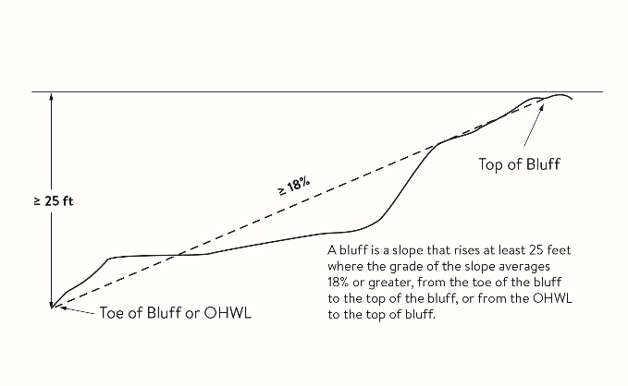
- A natural escarpment or cliff with a slope that rises at least ten feet above the ordinary high water level or toe of the bluff, whichever is applicable, to the top of the bluff, with a slope of 75 degrees or greater. See Figure 2.
Figure 2. Natural Escarpment Bluff and Bluff Impact Zone
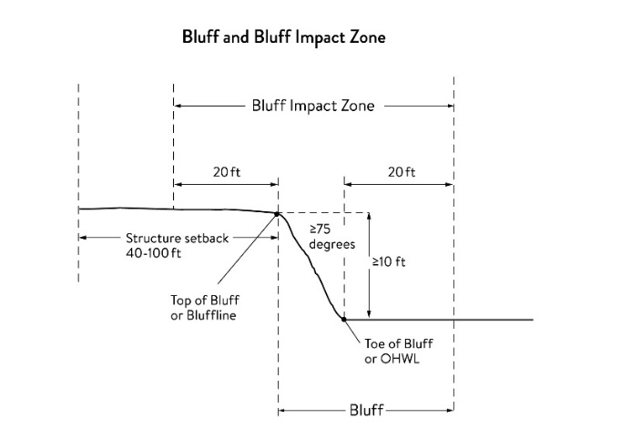
2.617 Bluff impact zone (BIZ). A bluff and land located within 20 feet of the bluff. See Figure 2 for natural escarpment or cliff example and Figure 3 for more common bluff example.

Figure 3. Bluff Impact Zone, Bluffline, Toe of bluff, and Top of Bluff
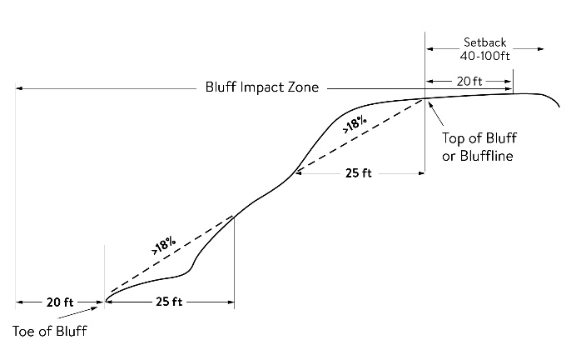
2.618 Bluffline. A line delineating the top of the bluff. More than one bluffline may be encountered proceeding landward from the river. See Figures 2 for natural escarpment or cliff example and Figure 3 for more common bluff example.
2.619 Bluff, Toe of. The lower point of a 25-foot horizontal segment with an average slope exceeding 18 percent A line along the bottom of a bluff, requiring field verification. such that the slope above the line exceeds 18 percent and the slope below the line is 18 percent or less, measured over a horizontal distance of 25 feet. See Figure 3.
2.620 Bluff, Top of. The higher point of a 25-foot horizontal segment with an average slope exceeding 18 percent A line along the top of a bluff, requiring field verification. such that the slope below the line exceeds 18 percent and the slope above the line is 18 percent or less, measured over a horizontal distance of 25 feet. See Figure 3 .
2.621 Buildable area. The area upon which structures may be placed on a lot or parcel of land and excludes areas needed to meet requirements for setback, rights-of-way, bluff impact zones, historic properties, wetlands, designated floodways, land below the ordinary high water level of public waters, and other unbuildable areas.
2.622 Building. A structure with two or more outside rigid walls and a fully secured roof and affixed to a permanent site.
2.623 Certificate of compliance. A document written after a compliance inspection, certifying that the development complies with applicable requirements at the time of the inspection.
2.624 Commissioner. The commissioner of the Minnesota Department of Natural Resources.
2.625 Conditional use. A use having the meaning given under Minnesota Statutes, chapters 394 and 462.
2.626 Conservation design. A pattern of subdivision that is characterized by grouping lots within a portion of a parcel, where the remaining portion of the parcel is permanently protected as open space.
2.627 Conventional subdivision. A pattern of subdivision that is characterized by lots that are spread regularly throughout a parcel in a lot and block design.
2.628 Deck. A horizontal, unenclosed, aboveground level structure open to the sky, with or without attached railings, seats, trellises, or other features, attached or functionally related to a principal use or site.
2.629 Developer. Having the meaning given under Minnesota Statutes, section 116G.03.
2.630 Development. Having the meaning given under Minnesota Statutes, section 116G.03.
2.631 Discretionary action. An action under this chapter related to land use that requires a public hearing by local ordinance or statute, such as preliminary plats, final subdivision plats, planned unit developments, conditional use permits, interim use permits, variances, appeals, and rezonings.
2.632 Dock. Having the meaning given under Minnesota Rules, chapter 6115.
2.633 Electric power facilities. Equipment and associated facilities for generating electric power or devices for converting wind energy to electrical energy as identified and defined under Minnesota Statutes, section 216E.
2.634 Essential services. Underground or overhead gas, electrical, communications, steam, or water distribution, collection, supply, or disposal systems, including storm water. Essential services include poles, wires, mains, drains, pipes, conduits, cables, fire alarm boxes, traffic signals, hydrants, navigational structures, aviation safety facilities or other similar equipment and accessories in conjunction with the systems. Essential services does not include buildings, treatment works as defined in Minnesota Statutes, section 115.01, electric power facilities or transmission services.
2.635 Feedlot. Having the meaning given for animal feedlots under Minnesota Rules chapter 7020.
2.636 Floodplain. Having the meaning given the meaning given under Minnesota Rules chapter 6120.
2.637 Fully reconstructs. The reconstruction of an existing impervious surface that involves site grading and subsurface excavation so that soil is exposed. Mill and overlay and other resurfacing activities are not considered fully reconstructed.
2.638 Hard-surface trail. A trail surfaced in asphalt, crushed aggregate, or other hard surface, for multi-purpose use, as determined by local, regional, or state agency plans.
2.639 Historic property. An archaeological site, standing structure, site, district, or other property that is:
- Listed in the National Register of Historic Places or the State Register of Historic Places or locally designated as a historic site under Minnesota Statutes, chapter 471;
- determined to meet the criteria for eligibility to the National Register of Historic Places or the State Register of Historic Places as determined by the director of the Minnesota Historical Society; or
- An unplatted cemetery that falls under the provisions of Minnesota Statutes, chapter 307, in consultation with the Office of the State Archaeologist.
2.640 Impervious surface. A constructed hard surface that either prevents or retards the entry of water into the soil and causes water to run off the surface in greater quantities and at an increased rate of flow than prior to development. Examples include rooftops, decks, sidewalks, patios, parking lots, storage areas, and driveways, including those with concrete, asphalt, or gravel surfaces.
2.641 Intensive vegetation clearing. The removal of all or a majority of the trees or shrubs in a contiguous patch, strip, row, or block.
2.642 Interim use. A use having the meaning given under Minnesota Statutes, chapters 394 and 462.
2.643 Land alteration. An activity that exposes the soil or changes the topography, drainage, or cross section of the land, excluding gardening or similar minor soil disturbances.
2.644 Local government. Counties, cities, and townships.
2.645 Lot. Having the meaning given under Minnesota Rules chapter 6120.
2.646 Lot width. The shortest distance between lot lines measured at both the ordinary high water level and at the required structure setback from the ordinary high water level. See Figure 4.
Figure 4. Lot Width
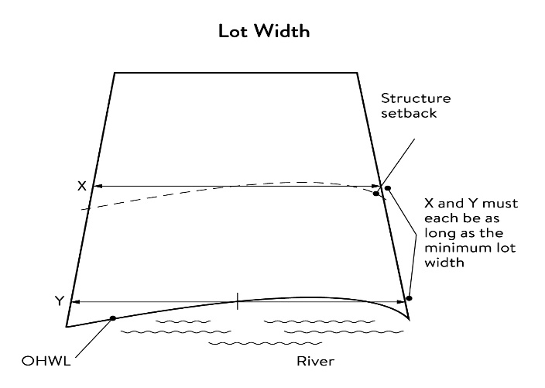
2.647 Marina. Having the meaning given under Minnesota Rules chapter 6115.
2.648 Mississippi River Corridor Critical Area (MRCCA). The area within the River Corridor Boundary (See Section 2.678).
2.649 Mississippi River Corridor Critical Area (MRCCA) Plan. A chapter or other element in the (insert name of jurisdiction) comprehensive plan.
2.650 Mooring facility. Having the meaning given under Minnesota Rules part 6115.0170.
2.651 Native plant community. A plant community identified by the Minnesota Biological Survey or biological survey issued or adopted by a local, state, or federal agency.
2.652 Natural-surface trail. A trail composed of native soil and rock or compacted granular stone, primarily intended for hiking, equestrian, or mountain bike use, as determined by local, regional, or state agency plans.
2.653 Natural vegetation. Any combination of ground cover, understory, and tree canopy that, while it may have been altered by human activity, continues to stabilize soils, retain and filter runoff, provide habitat, and recharge groundwater.
2.654 Nonconformity. Having the meaning given under Minnesota Statutes, section 394.22.
2.655 Nonmetallic mining. Construction, reconstruction, repair, relocation, expansion, or removal of any facility for the extraction, stockpiling, storage, disposal, or reclamation of nonmetallic minerals such a stone, sand, and gravel. Nonmetallic mining does not include ancillary facilities such as access roads, bridges, culverts, and water level control structures. For purposes of this subpart, “facility” includes all mine pits, quarries, stockpiles, basins, processing structures and equipment, and any structures that drain or divert public waters to allow mining.
2.656 Off-premise advertising signs. Those signs that direct attention to a product, service, business, or entertainment venue that is not exclusively related to the premises where the sign is located.
2.657 Ordinary high water level (OHWL). Having the meaning given under Minnesota Statutes, section 103G.005.
2.658 Overlay district. A zoning district applied over one or more previously established zoning districts, establishing additional or stricter standards and criteria for covered properties in addition to those of the underlying zoning district. Overlay districts are often used to protect historic features and natural resources such as shoreland or floodplain.
2.659 Parcel. Having the meaning given under Minnesota Statutes, section 116G.03.
2.660 Patio. A constructed hard surface located at ground level with no railings and open to the sky.
2.661 Picnic shelter. A roofed structure open on all sides, accessory to a recreational use.
2.662 Planned unit development (PUD). A method of land development that merges zoning and subdivision controls, allowing developers to plan and develop a large area as a single entity, characterized by a unified site design, a mix of structure types and land uses, and phasing of development over a number of years. Planned unit development includes any conversion of existing structures and land uses that utilize this method of development.
2.663 Plat. Having the meaning given under Minnesota Statutes, sections 505 and 515B.
2.664 Port. A water transportation complex established and operated under the jurisdiction of a port authority according to Minnesota Statutes, chapter 458.
2.665 Primary conservation areas (PCAs). Key resources and features, including shore impact zones, bluff impact zones, floodplains, wetlands, gorges, areas of confluence with tributaries, natural drainage routes, unstable soils and bedrock, native plant communities, cultural and historic properties, and significant existing vegetative stands, tree canopies, and other resources identified in local government plans.
2.666 Private facilities. Private roads, driveways, and parking areas, private water access and viewing facilities, decks and patios in setback areas, and private signs.
2.667 Professional engineer. An engineer licensed to practice in Minnesota.
2.668 Public facilities. Public utilities, public transportation facilities, and public recreational facilities.
2.669 Public recreational facilities. Recreational facilities provided by the state or a local government and dedicated to public use, including parks, scenic overlooks, observation platforms, trails, docks, fishing piers, picnic shelters, water access ramps, and other similar water-oriented public facilities used for recreation.
2.670 Public river corridor views (PRCVs). Views toward the river from public parkland, historic properties, and public overlooks, as well as views toward bluffs from the ordinary high water level of the opposite shore, as seen during the summer months and documented in the MRCCA plan/chapter of the comprehensive plan.
2.671 Public transportation facilities. All transportation facilities provided by federal, state, or local government and dedicated to public use, such as roadways, transit facilities, railroads, and bikeways.
2.672 Public utilities. Electric power facilities, essential services, and transmission services.
2.673 Public waters. Having the meaning given under Minnesota Statutes, section 103G.005.
2.674 Readily visible. Land and development that are easily seen from the ordinary high water level of the opposite shore during summer months.
2.675 Resource agency. A federal, state, regional, or local agency that engages in environmental, natural, or cultural resource protection or restoration activities, including planning, implementation, and monitoring.
2.676 Retaining wall. A vertical or nearly vertical structures constructed of mortar and rubble masonry, rock, or stone regardless of size, vertical timber pilings, horizontal timber planks with piling supports, sheet pilings, poured concrete, concrete blocks, or other durable materials.
2.677 Rock riprap. Natural coarse rock placed or constructed to armor shorelines, streambeds, bridge abutments, pilings and other shoreline structures against scour, or water or ice erosion.
2.678 River corridor boundary. The boundary approved and adopted by the Metropolitan Council under Minnesota Statutes, section 116G.06, as approved and adopted by the legislature in Minnesota Statutes, section 116G.15, and as legally described in the State Register, volume 43, pages 508 to 518.
2.679 River-dependent use. The use of land for commercial, industrial, or utility purposes, where access to and use of a public water feature is an integral part of the normal conduct of business and where the use is dependent on shoreline facilities.
2.680 Selective vegetation removal. The removal of isolated individual trees or shrubs that are not in a contiguous patch, strip, row, or block and that does not substantially reduce the tree canopy or understory cover.
2.681 Setback. A separation distance measured horizontally.
2.682 Shore impact zone (SIZ). Land located between the ordinary high water level of public waters and a line parallel to it at a setback of 50 percent of the required structure setback or, for agricultural use, 50 feet landward of the ordinary high water level. See Figure 5.
Figure 5. Shore Impact Zone
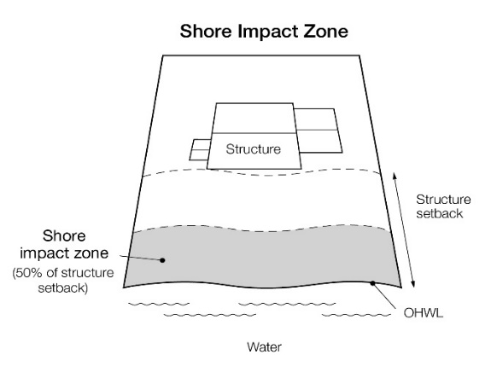
2.683 Shoreline facilities. Facilities that require a location adjoining public waters for ingress and egress, loading and unloading, and public water intake and outflow, such as barge facilities, port facilities, commodity loading and unloading equipment, watercraft lifts, marinas, short-term watercraft mooring facilities for patrons, and water access ramps. Structures that would be enhanced by a shoreline location, but do not require a location adjoining public waters as part of their function, are not shoreline facilities, such as restaurants, bait shops, and boat dealerships.
2.684 Significant existing vegetative stands. Vegetation that is largely intact and connected and contains a sufficient representation of the original native plant community. It contributes to the scenic value of the MRCCA and provides high ecological and water quality values.
2.685 Steep slope. A natural topographic feature with an average slope of 12 to 18 percent, measured over a horizontal distance equal to or greater than 50 feet, and any slopes greater than 18 percent that are not bluffs.
2.686 Storm water management facilities. Facilities for the collection, conveyance, treatment, or disposal of storm water.
2.687 Structure. A building, sign, or appurtenance thereto, except for aerial or underground utility lines, such as sewer, electric, telephone, or gas lines, and utility line towers, poles, and other supporting appurtenances.
2.688 Subdivision. Having the meaning given under Minnesota Statutes, section 462.352.
2.689 Subsurface sewage treatment system. Having the meaning given under Minnesota Rules, part 7080.1100.
2.690 Transmission services.
- Electric power lines, cables, pipelines, or conduits that are:
- used to transport power between two points, as identified and defined under Minnesota Statutes, section 216E.01, Subd. 4; or
- For mains or pipelines for gas, liquids, or solids in suspension, used to transport gas, liquids, or solids in suspension between two points; and
- Telecommunication lines, cables, pipelines, or conduits.
2.691 Treeline. The more or less continuous line formed by the tops of trees in a wooded area when viewed from a particular point. The treeline is determined during all seasons as if under full foliage.
2.692 Variance. Having the meaning given under Minnesota Statutes, section 394.22.
2.693 Water access ramp. A boat ramp, carry-down site, boarding dock, and approach road, or other access that allows launching and removal of a boat, canoe, or other watercraft with or without a vehicle and trailer.
2.694 Water-oriented accessory structure. A small building or other improvement, except stairways, fences, docks, and retaining walls, that, because of the relationship of its use to public waters, needs to be located closer to public waters than the normal structure setback. Examples include gazebos, screen houses, fish houses, pump houses, and detached decks and patios.
2.695 Water quality impact zone. Land within the shore impact zone or within 50 feet of the OHWL of the river, whichever is greater, AND land within 50 feet boundary of a public water, wetland, or natural drainage route, whichever is greater.
2.696 Wetland. Having the meaning given under Minnesota Statutes, section 103G.005.
2.697 Wharf. Having the meaning given under Minnesota Rules, part 6115.0170.

3.0 ADMINISTRATION
3.1 Purpose. The purpose of this Section is to identify administrative provisions to ensure this (section, chapter, or article) is administered consistent with its purpose.
3.2 Permits. A permit is required for the construction of buildings or building additions (including construction of decks and signs), the installation and/or alteration of sewage treatment systems, vegetation removal consistent with Section 9.0 and land alterations consistent with Section 10.0.
3.3 Variances. Variances to the requirements under this (section, chapter, or article) may only be granted in accordance with Minnesota Statutes, Section 462.357 and must consider the potential impacts of variances on primary conservation areas, public river corridor views, and other resources identified in the MRCCA plan. In reviewing the variance application, the (zoning authority, governing body, or other appropriate term) shall:
3.31 Evaluate the impacts to these resources. If negative impacts are found, require conditions to mitigate the impacts that are related to and proportional to the impacts, consistent with Section 3.5 and
3.32 Make written findings that the variance is consistent with the purpose of this (section, chapter, or article), as follows.
- The extent, location and intensity of the variance will be in substantial compliance with the MRCCA Plan;
- The variance is consistent with the character and management purpose of the MRCCA district in which it is located;
- The variance will not be detrimental to PCAs and PRCVs nor will it contribute to negative incremental impacts to PCAs and PRCVs when considered in the context of past, present and reasonable future actions; and
- The variance will not negatively impact (insert other MRCCA plan-identified resources).
3.4 Conditional and interim use permits. All conditional and interim uses, required under this (section, chapter or article), must comply with Minnesota Statutes, section 462.3595 and must consider the potential impacts on primary conservation areas, public river corridor views, and other resources identified in the MRCCA plan. In reviewing the application, the (zoning authority, governing body, or other appropriate term) shall:
3.41 Evaluate the impacts to these resources and if negative impacts are found, require conditions to mitigate the impacts that are related to and proportional to the impacts, consistent with Section 3.5; and
3.42 Make written findings that the conditional use is consistent with the purpose of this (section, chapter, or article), as follows.
- The extent, location and intensity of the conditional use will be in substantial compliance with the MRCCA Plan;
- The conditional use is consistent with the character and management purpose of the MRCCA district in which it is located;
- The conditional use will not be detrimental to PCAs and PRCVs nor will it contribute to negative incremental impacts to PCAs and PRCVs when considered in the context of past, present and reasonable future actions; and
- The conditional use will not negatively impact (insert other MRCCA plan-identified resources).
3.5 Conditions of Approval. The (zoning authority, governing body, or other appropriate term) shall evaluate the impacts to PCAs, PRCVs, and other resources identified in the MRCCA Plan, and if negative impacts are found, require conditions to mitigate the impacts that are related to and proportional to the impacts. Mitigation may include:
3.51 Restoration of vegetation identified as “vegetation restoration priorities” identified in the MRCCA plan.
3.52 Preservation of existing vegetation;
3.53 Stormwater runoff management;
3.54 Reducing impervious surface;
3.55 Increasing structure setbacks;
3.56 Wetland and drainage route restoration and/or preservation;
3.57 Limiting the height of structures
3.58 Modifying structure design to limit visual impacts on PRCVs; and
3.59 Other conservation measures.
3.6 Application materials. Applications for permits and discretionary actions required under this (section, chapter or article) must submit the following information unless the (insert designated official) determines that the information is not needed.
3.61 A detailed project description; and
3.62 Scaled maps and plans, dimensional renderings, maintenance agreements, and other materials that identify and describe:
- Primary conservation areas;
- Public river corridor views;
- Buildable area;
- Existing and proposed topography and drainage patterns;
- Proposed storm water and erosion and sediment control practices;
- Existing and proposed vegetation to be removed and established;
- Ordinary high water level, blufflines, and all required setbacks;
- Existing and proposed structures;
- Existing and proposed impervious surfaces; and
- Existing and proposed subsurface sewage treatment systems.
3.7 Nonconformities.
3.71 All legally established nonconformities as of the date of this ordinance may continue consistent with Minnesota Statutes, section 462.357, Subd. 1e .
3.72 New structures erected in conformance with the setback averaging provisions of Section 6.34 are conforming structures.
3.73 Site alterations and expansion of site alterations that were legally made prior to the effective date of this ordinance are conforming. Site alterations include vegetation, erosion control, storm water control measures, and other nonstructural site improvements.
3.74 Legally nonconforming principal structures that do not meet the setback requirements of Section 6.3 may be expanded laterally provided that:
- The expansion does not extend into the shore or bluff impact zone or further into the required setback than the building line of the existing principal structure (See Figure 6); and
- The expanded structure’s scale and bulk is consistent with that of the original structure and existing surrounding development.
Figure 6. Expansion of Nonconforming Structure
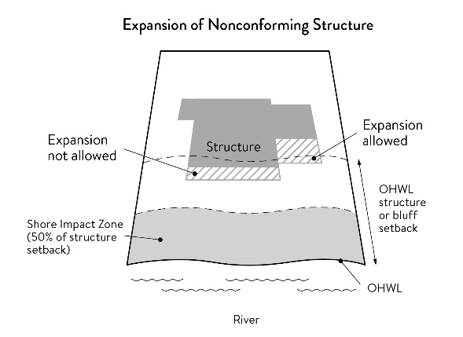
3.8 Notifications.
3.81 Amendments to this (section, chapter, or article) and to the MRCCA plan must be submitted to the Commissioner as provided in Minnesota Rules, part 6106.0070, Subp. 3, Items B – I.
3.82 Notice of public hearings for discretionary actions, including conditional and interim use permits, variances, appeals, rezonings, preliminary plats, final subdivision plats, master plans, and PUDs, must be sent to the following entities at least thirty (30) ten (10) days prior to the hearing:
- The Commissioner in a format prescribed by the DNR;
- National Park Service; and
- Where building heights exceed the height limits specified in Section 6.2 as part of the conditional use or variance process, adjoining local governments within the MRCCA, including those with overlapping jurisdiction and those across the river.
3.83 Notice of final decisions for actions in Section 3.82, including findings of fact, must be sent to the Commissioner, the National Park Service, and adjoining local governments within the MRCCA within ten (10) days of the final decision.
3.84 Requests to amend district boundaries must follow the provisions in Minnesota Rules, part 6106.0100, Subp. 9, Item C.
3.85 The DNR will be notified at time of application submittal of master plans, PUDs, preliminary, and final plats.
3.9 Accommodating disabilities. Reasonable accommodations for ramps or other facilities to provide persons with disabilities access to the persons’ property, as required by the federal Americans with Disabilities Act and the federal Fair Housing Act and as provided by Minnesota Rules, chapter 1341, must:
3.91 Comply with Sections 6.0 to 12.0; or
3.92 If Sections 6.0 to 12.0 cannot be complied with, ramps or other facilities are allowed with an administrative permit provided:
- The permit terminates on either a specific date or upon occurrence of a particular event related to the person requiring accommodation; and
- Upon expiration of the permit, the ramp or other facilities must be removed.

4.0 MRCCA DISTRICTS
4.1 Purpose. The purpose of this Section is to establish districts under which building height and structure placement are regulated to protect and enhance the Mississippi River’s resources and features consistent with the natural and built character of each district.
4.2 District description and management purpose. The MRCCA within the (City or Town) is divided into the following MRCCA Districts:
4.21 Rural and Open Space (ROS).
- Description. The ROS District is characterized by rural and low-density development patterns and land uses, and includes land that is riparian or visible from the river, as well as large, undeveloped tracts of high ecological and scenic value, floodplain, and undeveloped islands. Many primary conservation areas exist in the district.
- Management purpose. The ROS District must be managed to sustain and restore the rural and natural character of the corridor and to protect and enhance habitat, parks and open space, public river corridor views, and scenic, natural, and historic areas.
4.22 River Neighborhood (RN).
- Description. The RN District is characterized by primarily residential neighborhoods that are riparian or readily visible from the river or that abut riparian parkland. The district includes parks and open space, limited commercial development, marinas, and related land uses.
- Management purpose. The RN District must be managed to maintain the character of the river corridor within the context of existing residential and related neighborhood development, and to protect and enhance habitat, parks and open space, public river corridor views, and scenic, natural, and historic areas. Minimizing erosion and the flow of untreated storm water into the river and enhancing habitat and shoreline vegetation are priorities in the district.
4.23 River Towns and Crossings (RTC).
- Description. The RTC District is characterized by historic downtown areas and limited nodes of intense development at specific river crossings, as well as institutional campuses that predate designation of the MRCCA, and that include taller buildings.
- Management purpose. The RTC district must be managed in a manner that allows continued growth and redevelopment in historic downtowns and more intensive redevelopment in limited areas at river crossings to accommodate compact walkable development patterns and connections to the river. Minimizing erosion and the flow of untreated storm water into the river, providing public access to and public views of the river, and restoring natural vegetation in riparian areas and tree canopy are priorities in the district.
4.24 Separated from River (SR).
- Description. The SR District is characterized by its physical and visual distance from the Mississippi River. The district includes land separated from the river by distance, topography, development, or a transportation corridor. The land in this district is not readily visible from the Mississippi River.
- Management purpose. The SR district provides flexibility in managing development without negatively affecting the key resources and features of the river corridor. Minimizing negative impacts to primary conservation areas and minimizing erosion and flow of untreated storm water into the Mississippi River are priorities in the district. The RTC district must be managed in a manner that allows continued growth and redevelopment in historic downtowns and more intensive redevelopment in limited areas at river crossings to accommodate compact walkable development patterns and connections to the river. Minimizing erosion and the flow of untreated storm water into the river, providing public access to and public views of the river, and restoring natural vegetation in riparian areas and tree canopy are priorities in the district.
4.25 Urban Mixed (UM).
- Description. The UM District includes large areas of highly urbanized mixed use that are a part of the urban fabric of the river corridor, including institutional, commercial, industrial, and residential areas and parks and open space.
- Management purpose. The UM District must be managed in a manner that allows for future growth and potential transition of intensely developed areas that does not negatively affect public river corridor views and that protects bluffs and floodplains. Restoring and enhancing bluff and shoreline habitat, minimizing erosion and flow of untreated storm water into the river, and providing public access to and public views of the river are priorities in the district.
4.26 Urban Core (UC).
- Description. The UC District includes downtown.
- Management purpose. The UC District must be managed with the greatest flexibility to protect commercial, industrial, and other high-intensity urban uses, while minimizing negative impacts to primary conservation areas and minimizing erosion and flow of untreated storm water into the river. Providing public access to and public views of the river are priorities in the district.
4.3 MRCCA district map. The locations and boundaries of the MRCCA districts established by this (section, chapter, or article) are shown on (insert name of MRCCA Overlay District map) which is incorporated herein by reference. The district boundary lines are intended to follow the centerlines of rivers and streams, highways, streets, lot lines, and municipal boundaries, unless a boundary line is otherwise indicated on the map. Where district boundaries cross unsubdivided property, the district boundary line is determined by use of dimensions or the scale appearing on the map.

5.0 SPECIAL LAND USE PROVISIONS
5.1 Purpose. To identify development standards and considerations for land uses that have potential to negatively impact primary conservation areas and public river corridor views.
5.2 Underlying zoning. Uses within the MRCCA are generally determined by underlying zoning, with additional provisions for the following land uses:
5.21 Agricultural use. Perennial ground cover is required within 50 feet of the ordinary high water level and within the bluff impact zone.
5.22 Feedlots. New animal feedlots and manure storage areas are prohibited. Existing animal feedlots and manure storage areas must conform with Minnesota Rules, chapter 7020.
5.23 Forestry. Tree harvesting and biomass harvesting within woodlands, and associated reforestation, must be consistent with recommended practices in Conserving Wooded Areas in Developing Communities: Best Management Practices in Minnesota.
5.24 Nonmetallic mining. Nonmetallic mining requires a conditional use permit or interim use permit issued by the local government, subject to the following:
- New nonmetallic mining is prohibited within the shore impact zone and bluff impact zone and within the required structure setback from the bluffline and OHWL;
- Processing machinery must be located consistent with setback standards for structures as provided in Section 6.3;
- Only one barge loading area, which must be limited to the minimum size practicable, is permitted for each mining operation;
- New and, where practicable, existing nonmetallic mining operations must not be readily visible and must be screened by establishing and maintaining natural vegetation. The unscreened boundaries of nonmetallic mining areas are limited to only the barge loading area;
- A site management plan must be developed by the operator and approved by the local government before new nonmetallic mining commences. Operations must be consistent with the site plan throughout the duration of operations at the site. The site management plan must:
- Describe how the site will be developed over time with an emphasis on minimizing environmental risk to public waters;
- Explain where staged reclamation may occur at certain points during the life of the site;
- Address dust, noise, storm water management, possible pollutant discharges, days and hours of operation, and duration of operations; and
- Describe any anticipated vegetation and topographic alterations outside the pit, and reclamation plans consistent with the stated end use for the land; and;
- Existing and new nonmetallic mining operations must submit land reclamation plans to the local government compatible with the purposes of this ordinance.
5.25 River-dependent uses. River-dependent uses must comply with the following design standards:
- Structures and parking areas, except shoreline facilities and private roads and conveyances serving river-dependent uses as provided in Section 12.0, must meet the dimensional and performance standards in this (section, chapter, or article), must be designed so that they are not readily visible, and must be screened by establishing and maintaining natural vegetation;
- Shoreline facilities must comply with Minnesota Rules, chapter 6115 and must:
- Be designed in a compact fashion so as to minimize the shoreline area affected; and
- Minimize the surface area of land occupied in relation to the number of watercraft or barges to be served; and
- Dredging and placement of dredged material are subject to existing federal and state permit requirements and agreements.
5.26 Wireless communication towers. Wireless communication towers require a conditional or interim use permit and are subject to the following design standards:
- The applicant must demonstrate that functional coverage cannot be provided through co-location, a tower at a lower height, or a tower at a location outside of the MRCCA;
- The tower must not be located in a bluff or shore impact zone; and
- Placement of the tower must minimize impacts on public river corridor views.
- Comply with the general design standards in Section 8.2.

6.0 STRUCTURE HEIGHT AND PLACEMENT AND LOT SIZE
6.1 Purpose. To establish standards that protect primary conservation areas and public river corridor views from development impacts and ensure that new development is sited consistent with the purpose of the MRCCA.
6.2 Structure height. Structures and facilities must comply with the following standards unless identified as exempt in Section 12.0.
6.21 Structures and facilities must comply with the following standards unless identified as exempt in Section 12.0.
- ROS District: 35 feet (or lower).
- RN District: 35 feet.
- RTC District: 48 feet (or lower), provided tiering of structures away from the Mississippi River and from blufflines is given priority, with lower structure heights closer to the river and blufflines, and that structure design and placement minimizes interference with public river corridor views. Structures over 48 feet (or lower) and up to (fill in a max. height) are allowed as a conditional use according to Section 6.23.
- SR District: Height is determined by underlying zoning, provided the allowed height is consistent with that of the mature treeline, where present, and existing surrounding development, as viewed from the OWHL of the opposite shore.
- UM District: 65 feet, provided tiering of structures away from the Mississippi River and from blufflines is given priority, with lower structure heights closer to the river and blufflines, and that structure design and placement minimize interference with public river corridor views. Structures over 65 feet (or lower) and up to (fill in a max. height) are allowed as a conditional use according to Section 6.23.
- UC District: Height is determined by underlying zoning, provided tiering of structures away from the Mississippi River and blufflines be given priority, with lower structure heights closer to the river and blufflines, and structure design and placement minimize interference with public river corridor views.
6.22 Height is measured on the side of the structure facing the Mississippi River.
6.23 In addition to the conditional use permit requirements of Section 3.4, criteria for considering whether to grant a conditional use permit for structures exceeding the height limits must include:
- Assessment of the visual impact of the proposed structure on public river corridor views, including views from other communities;
- Determination that the proposed structure meets the required bluff and OHWL setbacks;
- Identification and application of techniques to minimize the perceived bulk of the proposed structure, such as:
- Placing the long axis of the building perpendicular to the river;
- Stepping back of portions of the facade;
- Lowering the roof pitch or use of a flat roof;
- Using building materials or mitigation techniques that will blend in with the natural surroundings such as green roofs, green walls, or other green and brown building materials;
- Narrowing the profile of upper floors of the building; or
- Increasing the setbacks of the building from the Mississippi River or blufflines;
- Identification of techniques for preservation of those view corridors identified in the MRCCA Plan; and
- Opportunities for creation or enhancement of public river corridor views.
6.3 Structure and impervious surface placement.
6.31 Structures and impervious surface must not be placed in the shore or bluff impact zones unless identified as an exemption in Section 12.0.
6.32 Structures, impervious surfaces, and facilities must comply with the following OHWL setback provisions unless identified as exempt in Section 12.0.
- ROS District: 200 feet from the Mississippi River and 150 feet from the Minnesota and Vermillion Rivers.
- RN District: 100 feet from the Mississippi River and 75 feet from the Rum and Vermillion Rivers.
- RTC District: 75 feet from the Mississippi, Crow, and Rum Rivers.
- SR District: 75 feet from the Vermillion River.
- UM District: 50 feet from the Mississippi River.
- UC District: Setbacks are determined by underlying zoning.
6.33 Structures, impervious surfaces, and facilities must comply with the following bluffline setback provisions unless identified as exempt in Section 12.0:
- ROS District: 100 feet.
- RN District: 40 feet.
- RTC District: 40 feet.
- SR District: 40 feet.
- UM District: 40 feet.
- UC District: 40 feet.
6.34 Where principal structures exist on the adjoining lots on both sides of a proposed building site, the minimum setback may be altered to conform to the average of the adjoining setbacks, if the new structure's scale and bulk riverward or bluffward of the setbacks required under Sections 6.32 and 6.33 are consistent with adjoining development. See Figure 7.
Figure 7. Structure Setback Averaging
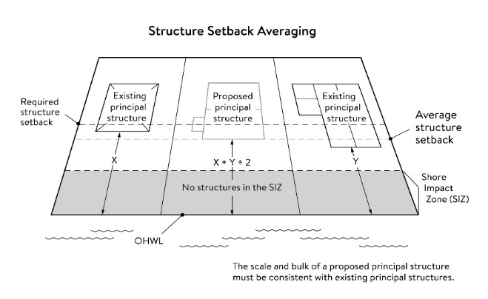
6.35 Subsurface sewage treatment systems, including the septic tank and absorption area, must be located at least 75 feet from the ordinary high water level of the Mississippi River and all other public waters.
6.4 Lot size and buildable area.
6.41 The width of lots abutting the Mississippi River in the ROS District must be at least 200 feet, unless alternative design methods are used that provide greater protection of the riparian area.
6.42 All new lots must have adequate buildable area to comply with the setback requirements of Sections 6.32 and 6.33 so as to not require variances to use the lots for their intended purpose.

7.0 PERFORMANCE STANDARDS FOR PRIVATE FACILITIES
7.1 Purpose. To establish design standards for private facilities that are consistent with best management practices and that minimize impacts to primary conservation areas, public river corridor views and other resources identified in the MRCCA plan.
7.2 General design standards. All private facilities must be developed in accordance with the vegetation management and land alteration requirements in Sections 9.0 and 10.0.
7.3 Private roads, driveways, and parking areas. Except as provided in Section 12.0, private roads, driveways and parking areas must:
7.31 Be designed to take advantage of natural vegetation and topography so that they are not readily visible;
7.32 Comply with structure setback requirements according to Section 6.3; and
7.33 Not be placed within the bluff impact zone or shore impact zone, unless exempt under Section 12.0 and designed consistent with Section 8.2.
7.4 Private water access and viewing facilities.
7.41 Private access paths must be no more than:
- Eight feet wide, if placed within the shore impact zone; and
- Four feet wide, if placed within the bluff impact zone.
7.42 Private water access ramps must:
- Comply with Minnesota Rules, parts 6115.0210 and 6280.0250; and
- Be designed and constructed consistent with the applicable standards in Design Handbook for Recreational Boating and Fishing Facilities.
7.43 Design and construction of private stairways, lifts, and landings are subject to the following standards:
- Stairways and lifts must not exceed four feet in width on residential lots. Wider stairways may be used for commercial properties and residential facilities held in common, if approved by (insert name of LGU permit or approval type);
- Landings for stairways and lifts on residential lots must not exceed 32 square feet in area. Landings larger than 32 square feet area allowed for commercial properties and residential facilities held in common, if approved by (insert name of LGU permit or approval type);
- Canopies or roofs are prohibited on stairways, lifts, or landings;
- Stairways, lifts, and landings must be located in the least visible portion of the lot whenever practical; and
- Ramps, lifts, mobility paths, or other facilities for persons with physical disabilities are allowed for achieving access to shore areas according to Section 7.43 A. – D, and as provided under Section 3.9.
7.45 One water-oriented accessory structure is allowed for each riparian lot or parcel less than 300 feet in width at the ordinary high water level, with one additional water-oriented accessory structure allowed for each additional 300 feet of shoreline on the same lot or parcel. Water-oriented accessory structures are prohibited in the bluff impact zone and must:
- Not exceed 12 feet in height;
- Not exceed 120 square feet in area; and
- Be placed a minimum of 10 feet from the ordinary high water level.
7.5 Decks and patios in setback areas. Decks and at-grade patios may encroach into the required setbacks from the ordinary high water level and blufflines without a variance, when consistent with Sections 9.0 and 10.0, provided that:
7.51 The encroachment of the deck or patio into the required setback area does not exceed 15 percent of the required structure setback;
7.52 The area of the deck or patio that extends into the required setback area occupies no more than 25 percent of the total area between the required setback and the 15 percent using the formula:
[Required setback depth (feet) x 0.15 x lot width at setback (feet) x 0.25 = maximum total area]
7.53 The deck or patio does not extend into the bluff impact zone. See Figure 8.
Figure 8. Deck and Patio Encroachment
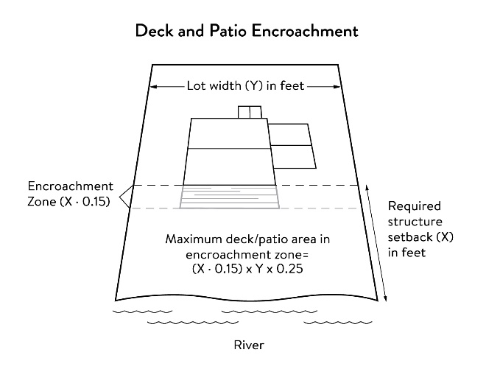
7.6 Off-premise and directional signs.
7.61 Off-premise advertising signs must:
- Meet required structure placement and height standards in Sections 6.2 and 6.3.
- Not be readily visible
7.62 Directional signs for patrons arriving at a business by watercraft must comply with the following standards:
- They must be consistent with Minnesota Statutes, section 86B.115.
- Only convey the location and name of the establishment and the general types of goods and services available, if located in a shore impact zone.
- Be no greater than ten feet in height and 32 square feet in surface area; and
- If illuminated, the lighting must be fully shielded and directed downward to prevent illumination out across the river or to the sky.
7.7 Fences. Fences between principal structures and the river are allowed if fences are:
7.71 Not higher than six feet.
7.72 Not located within the SIZ and BIZ
7.73 Not located in the regulatory floodplain.
7.8 Lighting. Within the OHWL setback:
7.81 Lighting shall be fully shielded and directed away from the river.
7.82 Uplighting is prohibited.

8.0 PERFORMANCE STANDARDS FOR PUBLIC FACILITIES
8.1 Purpose. To establish design standards for public facilities that are consistent with best management practices and that minimize impacts to primary conservation areas, public river corridor views and other resources identified in the MRCCA plan. Public facilities serve the public interest by providing public access to the Mississippi River corridor or require locations in or adjacent to the river corridor and therefore require some degree of flexibility.
8.2 General design standards. All public facilities must be designed and constructed to:
8.21 Minimize visibility of the facility from the river to the extent consistent with the purpose of the facility;
8.22 Comply with the structure placement and height standards in Section 6.0, except as provided in Section 12.0;
8.23 Be consistent with the vegetation management standards in Section 9.0 and the land alteration and storm water management standards in Section 10.0, including use of practices identified in Best Practices for Meeting DNR General Public Waters Work Permit GP 2004-0001, where applicable;
8.24 Avoid primary conservation areas, unless no alternative exists. If no alternative exists, then disturbance to primary conservation areas must be avoided to the greatest extent practicable, and design and construction must minimize impacts; and
8.25 Minimize disturbance of spawning and nesting times by scheduling construction at times when local fish and wildlife are not spawning or nesting.
8.26 Minimize disturbance during bird migration and nesting times by scheduling construction at times when birds are not migrating or nesting.
8.3 Right-of-way maintenance standards. Right-of-way maintenance must comply with the following standards:
8.31 Vegetation currently in a natural state must be maintained to the extent feasible;
8.32 Where vegetation in a natural state has been removed, native plants must be planted and maintained on the right-of-way; and
8.33 Chemical control of vegetation must be avoided when practicable, but when chemical control is necessary, chemicals used must be in accordance with the regulations and other requirements of all state and federal agencies with authority over the chemical’s use.
8.4 Crossings of public water or public land. Crossings of public waters or land controlled by the commissioner are subject to approval by the commissioner according to Minnesota Statutes, sections 84.415 and 103G.245.
8.5 Public utilities. Public utilities must comply with the following standards:
8.51 High-voltage transmission lines, wind energy conversion systems greater than five megawatts, and pipelines are regulated according to Minnesota Statutes, chapter 216E, 216F, and 216G respectively; and
8.52 If overhead placement is necessary, utility facility crossings must minimize visibility of the facility from the river be hidden from view and follow other existing right of ways as much as practicable.
8.53 The appearance of structures must be as compatible as practicable with the surrounding area in a natural state with regard to height and width, materials used, and color.
8.54 Wireless communication facilities, according to Section 5.26.
8.6 Public transportation facilities. Public transportation facilities shall comply with structure placement and height standards in Section 6.0. Where such facilities intersect or about two or more MRCCA districts, the least restrictive standards apply. Public transportation facilities must be designed and constructed to give priority to:
8.61 Providing scenic overlooks for motorists, bicyclists, and pedestrians;
8.62 Providing safe pedestrian crossings and facilities along the river corridor;
8.63 Providing access to the riverfront in public ownership; and
8.64 Allowing for use of the land between the river and the transportation facility.
8.7 Public recreational facilities. Public recreational facilities must comply with the following standards:
8.71 Buildings and parking associated with public recreational facilities must comply with the structure placement and height standards in Section 6.0, except as provided in Section 12.0;
8.72 Roads and driveways associated with public recreational facilities must not be placed in the bluff or shore impact zones unless no other placement alternative exists. If no alternative exists, then design and construction must minimize impacts to shoreline vegetation, erodible soils and slopes, and other sensitive resources.
8.73 Trails, access paths, and viewing areas associated with public recreational facilities and providing access to or views of the Mississippi River are allowed within the bluff and shore impact zones if design, construction, and maintenance methods are consistent with the best management practice guidelines in Trail Planning, Design, and Development Guidelines.
- Hard-surface trails are not allowed on the face of bluffs with a slope exceeding 30 percent. Natural surface trails are allowed, provided they do not exceed eight feet in width.
- Trails, paths, and viewing areas must be designed and constructed to minimize:
- Visibility from the river;
- Visual impacts on public river corridor views; and
- Disturbance to and fragmentation of primary conservation areas.
8.74 Public water access facilities must comply with the following requirements:
- Watercraft access ramps must comply with Minnesota Rules chapters 6115.0210 and 6280.0250; and
- Facilities must be designed and constructed consistent with the standards in Design Handbook for Recreational Boating and Fishing Facilities.
8.75 Public signs and kiosks for interpretive or directional purposes are allowed in the bluff or shore impact zones, provided they are placed and constructed to minimize disturbance to these areas and avoid visual impacts on public river corridor views. If illuminated, the lighting must be fully shielded and be directed downward.
8.76 Public stairways, lifts, and landings must be designed as provided in Section 7.43.

9.0 VEGETATION MANAGEMENT
9.1 Purpose. To establish standards that sustain and enhance the biological and ecological functions of vegetation; preserve the natural character and topography of the MRCCA; and maintain stability of bluffs and steep slopes and ensure stability of other erosion-prone areas.
9.2 Applicability. This section applies to:
9.21 Shore impact zones;
9.22 Areas within 50 feet of a wetland or natural drainage route;
9.23 Bluff impact zones;
9.24 Areas of native plant communities; and
9.25 Significant existing vegetative stands identified in the MRCCA plan.
9.3 Activities allowed without a vegetation permit.
9.31 Maintenance of existing lawns, landscaping and gardens;
9.32 Removal of vegetation in emergency situations as determined by (insert name of LGU);
9.33 Right-of-way maintenance for public facilities meeting the standards Section 8.3;
9.34 Agricultural and forestry activities meeting the standards of Sections 5.21 and 5.23;
9.35 Selective vegetation removal, provided that vegetative cover remains consistent with the management purpose of the MRCCA District, including removal of:
- Vegetation that is dead, diseased, dying, or hazardous;
- Vegetation to prevent the spread of diseases or insect pests;
- Individual trees and shrubs; and
- Invasive non-native species.
9.4 Activities allowed with a vegetation permit.
9.41 Only the following intensive vegetation clearing activities are allowed with a vegetation permit:
- Clearing of vegetation that is dead, diseased, dying, or hazardous;
- Clearing to prevent the spread of diseases or insect pests;
- Clearing to remove invasive non-native species.
- Clearing to prepare for restoration and erosion control management activities consistent with a plan approved by (insert name of LGU or name of resource agency).
- The minimum necessary for development that is allowed with a building permit or as an exemption under Section 12.0.
9.42 General Performance Standards. The following standards must be met, in addition to a restoration plan under Section 9.6, in order to approve a vegetation permit:
- Development is sited to minimize removal of or disturbance to natural vegetation;
- Soil, slope stability, and hydrologic conditions are suitable for the proposed work as determined by a professional engineer or (insert name of resource agency, if someone other than professional engineer is desired);
- Clearing is the minimum necessary and designed to blend with the natural terrain and minimize visual impacts to public river corridor views and other scenic views;
- Vegetation removal activities are conducted so as to expose the smallest practical area of soil to erosion for the least possible time, and to avoid bird migration and nesting seasons; and
- Any other condition determined necessary to achieve the purpose of this section.
9.5 Prohibited activities. All other intensive vegetation clearing is prohibited.
9.6 Vegetation restoration plan.
9.61 Development of a vegetation restoration plan and reestablishment of natural vegetation is required:
- For any vegetation removed with a permit under Section 9.41;
- Upon failure to comply with any provisions in this section; or
- As part of the planning process for subdivisions as provided in Section 11.0.
9.62 Restoration Plan Performance Standards. The vegetation restoration plan must satisfy the application submittal requirements in 3.6, and:
- Vegetation must be restored in one or more of the following restoration priority areas:
- Stabilization of erodible soilsAreas with soils showing signs of erosion, especially on or near the top and bottom of steep slopes and bluffs;
- Restoration or enhancement of shoreline vegetationShoreline areas within 25 feet of the water with no natural vegetation, degraded vegetation, or planted with turf grass;
- Revegetation of bluffs or steep slopes visible from the riverAreas on steep slopes and bluffs that are visible from the river with no natural vegetation, degraded vegetation, or planted with turf grass; or
- Other approved priority opportunity area, including priorities identified in the MRCCA plan, if none of the above exist.
- Include vegetation that provides suitable habitat and effective soil stability, runoff retention, and infiltration capability. Vegetation species, composition, density, and diversity must be guided by nearby patches of native plant communities and by Native Vegetation Establishment and Enhancement Guidelines;
- Any highly erodible soils disturbed during removal and/or restoration must be stabilized with deep-rooted vegetation with a high stem density;
- Vegetation removed must be restored with natural native vegetation to the greatest extent practicable. The area (square feet) of the restored vegetation should be similar to that removed to the greatest extent practicable.
- For restoration of removed native plant communities, restored vegetation must also provide biological and ecological function equivalent to the removed native plant communities. The area (square feet) of the restored vegetation should be equivalent to that removed;
- Be prepared by a qualified individual; and
- Include a maintenance plan that includes management provisions for controlling invasive species and replacement of plant loss for three years.
9. 63 A certificate of compliance will be issued after the vegetation restoration plan requirements have been satisfied.

10.0 LAND ALTERATION STANDARDS AND STORMWATER MANAGEMENT
10.1 Purpose. To establish standards that protect water quality from pollutant loadings of sediment, nutrients, bacteria, and other contaminants; and maintain stability of bluffs, shorelines, and other areas prone to erosion.
10.2 Land alteration.
10.21 Within the bluff impact zone, land alteration is prohibited, except for the following, which are allowed by permit.
- Erosion control consistent with a plan approved by the local government or resource agency and consistent with Section 10.6;
- The minimum necessary for development that is allowed as an exception under Section 12; and
- Repair and maintenance of existing buildings and facilities.
10.22 Within the water quality impact zone, land alteration that involves more than ten cubic yards of material or affects an area greater than 1,000 square feet requires a permit.
10.3 Rock riprap, retaining walls, and other erosion control structures.
10.31 Construction, repair, or replacement of rock riprap, retaining walls, and other erosion control structures located at or below the OHWL must comply with Minnesota Rules, part 6115.0215, Subp. 4, item E, and 6115.0216, Subp. 2. Work must not proceed until approved by the commissioner, permitted by the US Army Corps of Engineers, and any other permits are obtained. See Figure 9.
Figure 9. Riprap Guidelines
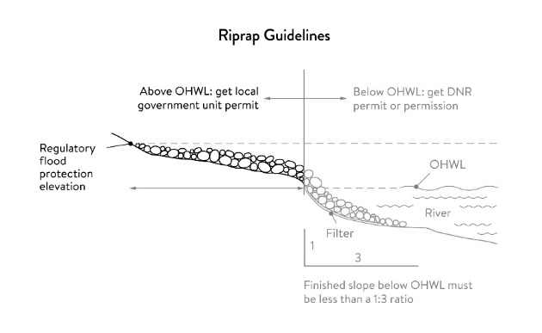
10.32 Construction or replacement of rock riprap, retaining walls, and other erosion control structures within the bluff impact zone and the water quality impact zone are allowed with a permit consistent with provisions of Section 10.6 provided that:
- If the project includes work at or below the OHWL, the commissioner has already approved or permitted the project.
- The structures are used only to correct an established erosion problem as determined by the (insert name of LGU and/or resource agency).
- The size and extent of the structures are the minimum necessary to correct the erosion problem and are not larger than the following, unless a professional engineer determines that a larger structure is needed to correct the erosion problem:
- Retaining walls must not exceed five feet in height and must be placed a minimum horizontal distance of ten feet apart; and
- Riprap must not exceed the height of the regulatory flood protection elevation.
10.33 Repair of existing rock riprap, retaining walls, and other erosion control structures above the OHWL does not require a permit provided it does not involve any land alteration.
10.4 Stormwater management.
10.41 In the bluff impact zone, storm water management facilities are prohibited, except by permit if:
- There are no alternatives for storm water treatment outside the bluff impact zone on the subject site;
- The site generating runoff is designed so that the amount of runoff reaching the bluff impact zone is reduced to the greatest extent practicable;
- The construction and operation of the facility does not affect slope stability on the subject property or adjacent properties; and
- Mitigation based on the best available engineering and geological practices is required and applied to eliminate or minimize the risk of slope failure.
10.42 In the water quality impact zone, development that creates new impervious surface, as allowed by exemption in Section 12.0, or fully reconstructs existing impervious surface of more than 10,000 square feet requires a storm water permit . Multipurpose trails and sidewalks are exempt if there is down gradient vegetation or a filter strip that is at least five feet wide.
10.43 In all other areas, storm water runoff must be directed away from the bluff impact zones or unstable areas.
10.5 Development on steep slopes. Construction of structures, impervious surfaces, land alteration, vegetation removal, or other construction activities are allowed on steep slopes if:
10.51 The development can be accomplished without increasing erosion or storm water runoff;
10.52 The soil types and geology are suitable for the proposed development; and
10.53 Vegetation is managed according to the requirements of Section 9.0.
10.6 Conditions of land alteration permit approval.
10.61 Temporary and permanent erosion and sediment control measures retain sediment onsite consistent with best management practices in the Minnesota Stormwater Manual;
10.62 Natural site topography, soil, and vegetation conditions are used to control runoff and reduce erosion and sedimentation;
10.63 Construction activity is phased when possible;
10.64 All erosion and sediment controls are installed before starting any land disturbance activity;
10.65 Erosion and sediment controls are maintained to ensure effective operation;
10.66 The proposed work is consistent with the vegetation standards in Section 9.0; and
10.67 Best management practices for protecting and enhancing ecological and water resources identified in Best Practices for Meeting DNR General Public Waters Work Permit GP 2004-0001.
10.7 Compliance with other plans and programs. All development must:
10.71 Be consistent with Minnesota Statutes, chapter 103B, and local water management plans completed under Minnesota Statutes, chapter 8410;
10.72 Meet or exceed the wetland protection standards under Minnesota Rules, chapter 8420; and
10.73 Meet or exceed the floodplain management standards under Minnesota Rules, sections 6120. 5000 – 6120.6200.

11.0 SUBDIVISION AND LAND DEVELOPMENT STANDARDS
11.1 Purpose.
11.11 To protect and enhance the natural and scenic values of the MRCCA during development or redevelopment of the remaining large sites
11.12 To establish standards for protecting and restoring biological and ecological functions of primary conservation areas on large sites; and
11.13 To encourage restoration of natural vegetation during development or redevelopment of large sites where restoration opportunities have been identified in MRCCA Plans.
11.2 Applicability.
11.21 The design standards in this section apply to subdivisions, planned unit developments and master- planned development and redevelopment of land involving ten or more acres for contiguous parcels that abut the Mississippi River and 20 or more acres for all other parcels, including smaller individual sites within the following developments that are part of a common plan of development that may be constructed at different times:
- Subdivisions;
- Planned unit developments; and
- Master-planned development and redevelopment of land.
11.22 The following activities are exempt from the requirements of this section:
- Minor subdivisions consisting of three or fewer lots;
- Minor boundary line corrections;
- Resolutions of encroachments;
- Additions to existing lots of record;
- Placement of essential services; and
- Activities involving river-dependent commercial and industrial uses.
11.3 Application materials. Project information listed in Section 3.6 must be submitted for all proposed developments.
11.4 Design standards.
11.41 Primary conservation areas, where they exist, must be set aside and designated as protected open space in quantities meeting the following as a percentage of total parcel area:
- CA-ROS District: 50%;
- CA-RN District: 20%;
- CA-RTC, CA-UM, and CA-UC Districts: 10%; and
- CA-SR District: 10% if the parcel includes native plant communities or provides feasible connections to a regional park or trail system, otherwise no requirement.
11.42 If the primary conservation areas exceed the amounts specified in Section 11.41, then protection of native plant communities and natural vegetation in riparian areas shall be prioritized.
11.43 If primary conservation areas exist but do not have natural vegetation (identified as restoration priorities in the MRCCA Plan), then a vegetation assessment must be completed to evaluate the unvegetated primary conservation areas and determine whether vegetation restoration is needed. If restoration is needed, vegetation must be restored according to Section 9.62.
11.44 If primary conservation areas do not exist on the parcel and portions of the parcel have been identified in the MRCCA plan as a restoration area, vegetation must be restored in the identified areas according to Section 9.62 and the area must be set aside and designated as protected open space.
11.45 Storm water treatment areas or other green infrastructure may be used to meet the protected open space requirements if the vegetation provides biological and ecological functions.
11.46 Land dedicated under (insert LGU ordinance citation) for public river access, parks, or other open space or public facilities may be counted toward the protected open space requirement.
11.47 Protected open space areas must connect open space, natural areas, and recreational areas, where present on adjacent parcels, as much as possible to form an interconnected network.
11.5 Permanent protection of designated open space.
11.51 Designated open space areas must be protected through one or more of the following methods:
- Public acquisition by a government entity for conservation purposes;
- A permanent conservation easement, as provided in Minnesota Statutes, chapter 84C;
- A deed restriction; and
- Other arrangements that achieve an equivalent degree of protection.
11.52 Permanent protection methods must ensure the long-term management of vegetation to meet its biological and ecological functions, prohibit structures, and prohibit land alteration, except as needed to provide public recreational facilities and access to the river.
11.6 Alternative design standards.

12.0 EXEMPTIONS
12.1 Purpose. To provide exemptions to structure placement, height and other standards for specific river or water access dependent facilities as provided in Minnesota Statutes, section 116G.15 Subd. 4.
12.2 Applicability.
12.21 Uses and activities not specifically exempted must comply with this (section, chapter, or article). Uses and activities exempted under shore impact zone and bluff impact zone must comply with the vegetation management and land alteration standards in Sections 9 and 10.
12.22 Uses and activities in Section 12.3 are categorized as:
- Exempt – E. This means that the use or activity is allowed;
- Exempt if no alternative - (E). This means that the use or activity is allowed only if no alternatives exist; and
- Not exempt - N. This means that a use or activity is not exempt and must meet the standards of this ordinance.
12.3 Use and activity exemptions classification.
12.31 General uses and activities.
Use or Activity | Set backs | Height Limits | SIZ | BIZ | Applicable standards with which the use or activity must comply
Industrial and utility structures requiring greater height for operational reasons (such as elevators, refineries and railroad signaling towers) | N | E | N | N | Structure design and placement must minimize interference with public river corridor views.
Barns, silos, and farm structures | N | E | N | N
Bridges and bridge approach roadways | E | E | E | (E) | Section 8
Wireless communication towers | E | E | N | N | Section 5.26
Chimneys, church spires, flag poles, public monuments, and mechanical stacks and equipment | N | E | N | N
Historic properties and contributing properties in historic districts | E | E | E | E | Exemptions do not apply to additions or site alterations
Buildings and structures on the face of or abutting the bluff in the CA-UC district of St. Paul, between Chestnut Street and Highway 52. | E | n/a | n/a | E | Height in CA-UC district is governed by underlying zoning

12.32 Public utilities.
Use or Activity | Set backs | Height Limits | SIZ | BIZ | Applicable standards with which the use or activity must comply
Electrical power facilities | E | E | E | (E) | Section 8
Essential services (other than storm water facilities) | E | E | E | (E) | Section 8
Storm water facilities | E | N | E | (E) | Section 10
Wastewater treatment | E | N | E | N | Section 8
Public transportation facilities | E | N | (E) | (E) | Section 8

12.33 Public recreational facilities.
Use or Activity | Set backs | Height Limits | SIZ | BIZ | Applicable standards with which the use or activity must comply
Accessory structures, such as monuments, flagpoles, light standards, and similar park features | E | E | (E) | (E) | Section 8; within BIZ, only on slopes averaging less than 30%. Exemptions do not apply to principal structures.
Picnic shelters and other open-sided structures | E | N | (E) | N | Section 8
Parking lots | (E) | N | (E) | (E) | Section 8; within BIZ, only within 20 feet of toe of bluff; not on face of bluff; and must not affect stability of bluff
Roads and driveways | (E) | N | (E) | (E) | Section 8
Natural-surfaced trails, access paths, and viewing areas | E | N | E | E | Section 8
Hard-surfaced trails and viewing platforms | E | N | E | (E) | Section 8; within BIZ, only on slopes averaging less than 30%
Water access ramps | E | N | E | (E) | Section 8
Public signs and kiosks for interpretive or directional purposes | E | N | E | (E) | Section 8

12.34 River-dependent uses.
Use or Activity | Set backs | Height Limits | SIZ | BIZ | Applicable standards with which the use or activity must comply
Shoreline facilities | E | N | E | (E) | Section 5.25. Exemptions do not apply to buildings, structures, and parking areas that are not part of a shoreline facility
Private roads and conveyance structures serving river-dependent uses | E | N¹ | E | (E) | Section 5.25

12.35 Private residential and commercial water access and use facilities.
Use or Activity | Set backs | Height Limits | SIZ | BIZ | Applicable standards with which the use or activity must comply
Private roads serving 3 or more lots | (E) | N | N | (E) | Section 7; in BIZ, only on slopes averaging less than 30%. Exemption does not apply to private roads serving fewer 3 lots or to private driveways and parking areas
Access paths | E | N | E | E | Section 7
Water access ramps | E | N | E | N | Section 7
Stairways, lifts, and landings | E | N | E | E | Section 7
Water-oriented accessory structures | E | N | E | N | Section 7
Patios and decks | E | N | N | N | Section 7.5
Directional signs for watercraft (private) | E | N | E | N | Section 7.6; exemption does not apply to off-premise advertising signs
Temporary storage of docks, boats, and other equipment during the winter months | E | N | E | N
Erosion control structures, such as rock riprap and retaining walls | E | N | E | (E) | Sections 10.3, 10.5 and 10.6
Flood control structures | E | N | E | (E) | Section 10

River-dependent commercial, industrial, and utility structures are exempt from height limits only if greater height is required for operational reasons.

