LGUs may use this DNR-created template to create their own land alteration permit guidance documents. Content may be modified and used as a stand-alone document or integrated into other existing documents. This template and all land alteration permit companion template documents contain text consistent with the optional higher standards in the MRCCA model ordinance. LGUs should edit the content of these documents to be consistent with the local adopted MRCCA ordinance. Replace DNR logo with the LGU logo and contact info. These template documents are updated periodically, check DNR’s webpage for most recent version.

Property Owner Guidance for Land Alteration Permits in the Mississippi River Corridor Critical Area (MRCCA)

In riparian areas and on bluffs, land alteration disturbs and removes natural soils and vegetation, destroying animal habitat and increasing pollution risks to surface waters from sediment pollution. Construction of riprap, retaining walls, and other erosion control structures in these areas also blocks the movement of wildlife in critical movement corridors and changes the character of natural and scenic areas.
The MRCCA is a corridor of land along each side of the Mississippi River in the Twin Cities Metro Area with coordinated state, regional and local land use planning and zoning. Vegetation removal is regulated through a local permit to protect the corridor’s scenic, natural, and recreational features.
The purpose of the permit is to help property owners alter land in a manner that sustains natural character, stabilizes slopes and protects water quality.
To minimize these negative impacts to riparian areas and bluffs, certain land alteration activities require a permit. The permit ensures that higher risk land alteration activities are managed to limit impacts. This guidance explains when to apply for a permit and how to complete the permit application.

Where is a permit required?
A permit is required for land alteration activities in:
- The bluff impact zone (BIZ). A bluff and land within 20 feet of a bluff. A bluff is a natural feature with a minimum 25 ft. height and an average slope exceeding 18%, and
- The following riparian areas (these riparian areas are defined as the water quality impact zone (WQIZ) in the ordinance):

 | Riparian Areas
MRCCA District | Mississippi and Major Tributaries | Wetlands and Public Water Basins | Natural Drainage Routes and Public Watercourses
CA-ROS | 100’ from Mississippi River.  75‘ from the Minnesota & Vermillion Rivers. | 50’ from edge | 50’ from edge or OWHL
CA-RN CA-RTC CA-SR CA-UM | 50’ from the Mississippi, Crow, Rum and Vermillion Rivers

You can find out if your property contains a bluff impact zone or any of these riparian areas with the DNR’s online PCA mapper. Use the DNR’s online MRCCA District mapper to find out the MRCCA District in which your property is located. Type your address into the mapping applications to zoom to your property. Use the legend in each mapping application to identify your district and these riparian areas.

What activities require a permit?
- In riparian areas, land disturbance of more than 10 cubic yards or an area greater than 1,000 square feet.
- In riparian areas AND bluff impact zones, construction or replacement of riprap, retaining walls and other erosion control structures. (Repair of existing riprap, retaining walls or other erosion control structures above the OHWL does not require a permit, as long as the repair project does not disturb or alter land.)
- In the bluff impact zone:
  - Erosion control projects developed under a plan approved by the local government or a resource agency.
  - Access paths, stairways, lifts, landings, and other development allowed as an exemption under Section 12 (of the model ordinance, insert local ordinance reference) of the (name of ordinance).
  - Repair and replacement of existing buildings and facilities.
  - All other activities in the bluff impact zone are prohibited.

How can I best manage an erosion problem?
Riprap, retaining walls and other hard armoring methods are popular approaches for protecting land against erosion. However, these approaches have significant negative impacts to shoreline vegetation and animal habitat, and can worsen erosion problems downstream. Because of these negative impacts, these structures are only allowed to fix an existing erosion problem in riparian areas and in bluff impact zones. They are not allowed for aesthetic landscaping purposes. If intensive vegetation clearing is needed to install riprap, retaining walls or other hard armoring structures, a vegetation permit and vegetation restoration will also be required.
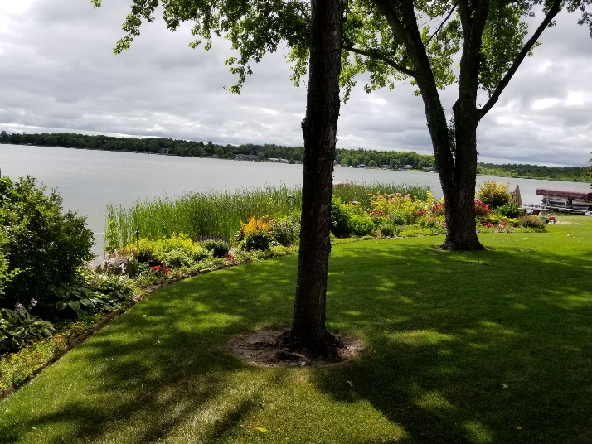
Shoreline stabilization using vegetation. Jake Snyder.
Fortunately, there are alternative methods for stabilizing riverbanks and steep slopes that can be effective in many situations and that have far less negative impacts. These alternative “bio-engineering” methods use vegetation and natural engineering methods to hold soil in place. Please see the Anoka Conservation District technical publication, Riverbank Stabilization, to understand causes of erosion and methods for stabilizing soils. The University of Minnesota Extension also provides guidance for stabilizing shoreland and bluffs.

What are the permit application submittal requirements?
A complete permit application includes:
- A brief project description
- An aerial photo and/or site plan showing:
- Property boundaries
- Location and label of the bluff impact zone and riparian areas
- Location of the proposed land alteration area, including the outer grading limits

Note: You may use the DNR’s online PCA mapper to determine if your proposed land alteration activity will occur in any riparian areas or in the bluff impact zone. Aerial photos from this online mapper can be printed to show property boundaries and the location of riparian areas and bluff impact zones. Hand drawings on aerial photos printed from DNR’s online mappers may be used to show the project location.
Applications to construct or replace riprap, retaining walls or other hard armoring structures will also need to submit the following:
- Photos showing that an established erosion problem exists.
- Explanation that the proposed erosion control structures are the minimum necessary to correct the problem.
- Construction plans showing consistency with the following design standards:
  - For retaining walls, the walls are no higher than five feet and are at least 10 feet apart.
  - For shoreline riprap, the height must be not higher than the regulatory flood protection elevation (RFPE). The RFPE is typically defined as an elevation of one foot above the 100-year flood elevation. Riprap installed to this elevation provides protection from erosion due to flooding. Check with your local government for the RFPE. Please consult DNR’s riprap design standards for installing riprap.
- For retaining walls and riprap exceeding these design standards, applicants must submit design drawings and a statement by a professional engineer testifying that a larger structure is needed to correct the erosion problem.
- For erosion control projects developed under a plan approved by the local government or a resource agency, applicants must submit the approved plan.
- For projects involving work below the OHWL, applicants must submit an email or permit from the DNR documenting approval of work below the OHWL is consistent with DNR’s riprap design standards. Contact your DNR Area Hydrologist for more information.

What happens when I submit my permit application?
Planning staff will review the application to make sure it is complete and that all required information is shown on an aerial photo and/or site plan, and that specific performance standards have been met.
If the permit application is complete and meets the performance standards, the permit will be approved subject to the following general conditions of approval and any project specific conditions:

- Temporary and permanent erosion and sediment control measures retain sediment onsite consistent with best management practices in the Minnesota Stormwater Manual;
- Natural site topography, soil, and vegetation conditions are used to control runoff and reduce erosion and sedimentation;
- Construction activity is phased when possible;
- All erosion and sediment controls are installed before starting any land disturbance activity;
- Erosion and sediment controls are maintained to ensure effective operation;
- The proposed work is consistent with the vegetation standards in Section 9.0 (insert local ordinance reference) of the (name of ordinance); and
- Best management practices for protecting and enhancing ecological and water resources identified in Best Practices for Meeting DNR General Public Waters Work Permit GP 2004-0001.

