Photo/Graphic Placeholder

Project Title
Author’s Name
Date

Project Number
NOAA Award Number
This [report/video/workshop/brochure/etc.] was prepared by [recipient name] using Federal funds under award [number] from the Coastal Zone Management Act of 1972, as amended, administered by the Office for Coastal Management, National Oceanic and Atmospheric Administration (NOAA), U.S. Department of Commerce provided to the Minnesota Department of Natural Resources (DNR) for Minnesota’s Lake Superior Coastal Program. The statements, findings, conclusions, and recommendations are those of the author(s) and do not necessarily reflect the views of NOAA’s Office of Coastal Management, the U.S. Department of Commerce, or the Minnesota DNR.
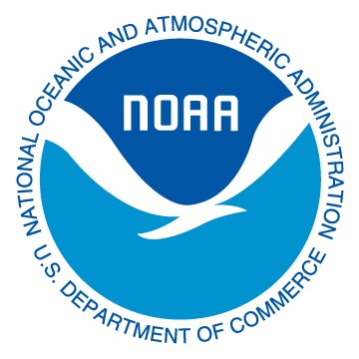

Final Report Template
This template may help in the development of your final report. In order to make the report accessible (Section 508), it is preloaded with headings and formatting. Leave the headings and replace the body text with the narrative of your report.

Introduction
Briefly explain the context and/or need for the project. List the project’s outcomes as stated in the progress reports.

Work Completed
Briefly summarize the work done to complete the project. Outline how the project did or not reach its original goals and were the grant’s outcome(s) met.

Results
Summarize the results or the impact of the project. Describe, if applicable, how the products will be used in the future, who will benefit, or how the project has resulted in an improvement to the conditions of coastal resources or their management. Include in what way MLSCP made the project possible or more successful.

Partnerships
Explain any collaborative efforts with other organizations that were established or leveraged as you worked on the grant.

Leveraged Dollars
In addition to the grant and match dollars, detail any additional funds that were spent on the project noting the amount and the source of the funding. Include volunteer time.

Conclusions
Summarize any lessons learned, and unexpected challenges or surprises encountered during the project. Describe anything someone doing a similar project might need to know to build on the project’s success. Describe any new opportunities for work or newly identified needs that arose as a result of the completion of the project.

Future Plans
If the project is part of an ongoing program or initiative, briefly explain how the program will be funded when the grant is complete. Describe your plan to further distribute or showcase the results, as well as the ‘bigger picture’ (i.e. how your results will be/may be used by others). Include if your products are made available online (beyond the requirements of the grant), include links.

Photos
Pictures that illustrate the results of the project are encouraged. The Coastal Program may use the images in reports to NOAA or other agencies, or for other outreach and education materials in the future. Pictures should include:
  - a caption that describes the image as it relates to the work of the project
  - the date of the photo
- If people’s faces appear in a photo, the Grantee must obtain a signed photo release that authorizes both the Grantee and MNDNR the unconditional rights to use the name(s) and photographic likeness of said person(s). The DNR may use photographs in reports, articles, or press releases; they would not be used as an endorsement. The photo release form should be submitted to the Grants Specialist along with the photo.
- If the project involves construction, photos are required. Photos should include before, during, and after construction shots. One of the photos must be the required acknowledgement signage posted at the project site.

Appendices
List attachments and appendices.
All final products should be included as appendices so that the final report details the project story and includes all results. If final product can be a stand-alone component (i.e. brochure, technical report), the product must have the correct acknowledgement and be labeled with project title and number.

Additional Information
Examples of helpful additional information include:

Human Interest Story
A “human interest” story that helps explain the success of the project. In what ways has the Coastal Program made the project possible or more successful? If possible, provide a quote for use that describes the success of the project.

Media
Identify, attach, or cite any published articles, media reports, web pages, newsletter articles, brochures or similar materials that resulted from the project.

Other
Correspondence or summaries of comments from people who will use the deliverables or who are affected by the project; and/or summaries of evaluations by participants in workshops or meetings conducted as part of the project.

