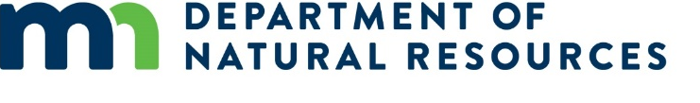

Progress Report Instructions
You must provide quarterly progress reports to the Minnesota Department of Natural Resources regarding your Coastal Program grant funded project. Please read these instructions carefully before writing the report. If you have any questions, contact the grant specialist mlscp.dnr@state.mn.us.
The progress report (next page) uses a mix of form fields and open sections. In the form fields on the top of the report, enter the information from your grant agreement. In the Reporting period, include the month and year of the report.
Project Status: Identify the status of the entire project as “not started”, “in progress”, “not on schedule”, or “completed”. If status is either “not started” or “not on schedule”, please include an explanation and plans to complete the outcome in the Notes.

Project Progress
See the project description in your grant agreement for task outcomes.
- For progress reports due in April and October: Update the Coastal Program of project progress. Briefly describe the activities during the past three months to complete the outcomes and develop the products.
- For progress reports due in January and July: We will include your narrative in our semi-annual performance reports to NOAA. Describe (in more detail) the grant and match activities during the prior six months (January 1 – June 30; July 1 – December 31) to complete the outcomes and develop the products.
Include any problems or concerns encountered during the reporting period; any technical assistance needs you may have and things we should know about your project/progress.

Products
List your products (from the grant agreement).

Training/Education/Coordination
Complete the table for any educational, training, and/or coordination (i.e. community meetings/planning) activities that occurred during this reporting period. Please let me know if you require additional lines.

Submission
Progress reports are due quarterly: April 15, July 15, October 15, and January 15.
Submit the completed progress report to mlscp.dnr@state.mn.us

Progress Report for Coastal Program Grantees
NOAA Award Number:
MLSCP Project Number: Project Title:
Project Start Date:
Person Completing Report (name, title, and email):
Reporting Period: From: To:
Project Status:
Notes:

Project Progress
See instructions for guidance, reference task outcomes as appropriate.

Products
List the products from your grant agreement.

Training/Education/Coordination
Activity | Date | # of attendees | Location | Name of activity/Details

For Minnesota’s Lake Superior Coastal Program Use Only
MNDNR Agreement Number:
Date Received by MLSCP:

