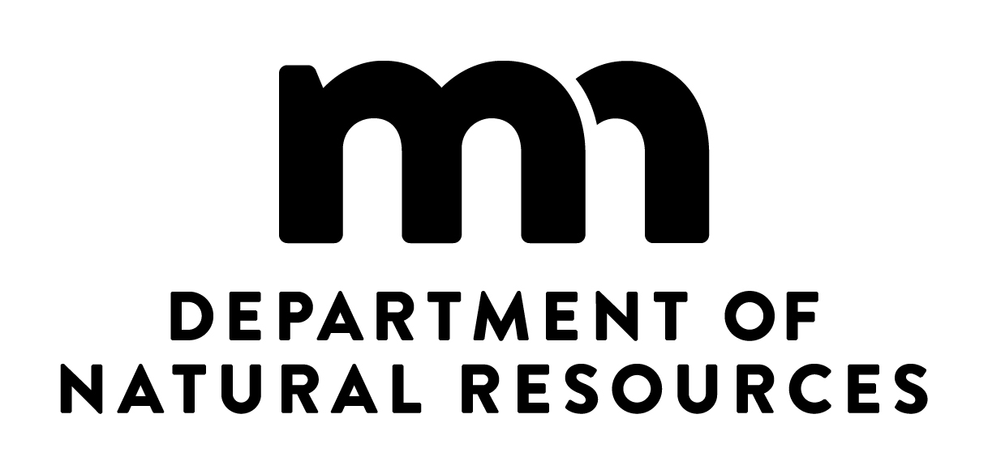
Lake Service Provider Pilot Project Permit

Lake Minnetonka and zebra mussels
  - Minnesota Department of Natural Resources (DNR)
  - Division of Ecological and Water Resources
  - 500 Lafayette Road, Box 25, St. Paul, Minnesota 55155

Who may apply for this permit
You are eligible to apply for this permit and participate in the Lake Minnetonka pilot study (authorized by Minnesota Statutes, 84D.108 Subd. 2a.), if your businesses meets the following requirements:
- Have a current regular lake service provider permit,
- are located within or in a municipality immediately bordering the Lake Minnetonka Conservation District (LMCD) boundaries (Minnetrista, Mound, Spring Park, Orono, Minnetonka Beach, Wayzata, Minnetonka, Woodland, Deephaven, Shorewood, Greenwood, Excelsior, Tonka Bay,Victoria, Independence, Maple Plain, Medina, Long Lake, Plymouth, Medicine Lake, New Hope, Golden Valley, Saint Louis Park, Hopkins, Edina, Eden Prairie, Chanhassen, Chaska, Laketown Township, St. Bonifacious, Waconia, or Watertown, and
- furnish adequate proof of a $50,000 corporate surety bond, as required by Minnesota Statutes, 84D.108 Subd. 2a(d)

How to use this permit
You must sign this permit to make it valid, and keep a copy of this permit with you while doing any activity authorized by this permit. This permit is only valid in conjunction with a valid lake service provider permit.

Permittee information
- Name of lake service provider business owner or manager: _____________________________
- Business phone number: _________________________________
- Name(s) of any other designees authorized to work under this permit – note that all designees must have a current lake service provider employee certificate:

___________________________________

___________________________________

___________________________________

___________________________________

- Address(es) of any business location(s) where you may transport equipment under this permit:

Permit conditions

Definitions
In this permit:
- “You” refers to anyone working under this permit listed as a permittee or designee above.
- “Eligible equipment” is customer-owned water-related equipment that is a watercraft, dock or lift that you remove from Lake Minnetonka (DNR Division of Waters number 27-0133). Eligible equipment must have a place to attach a tag as required by the permit. Equipment owned or used by your businesses, or types of water-related equipment not listed here, are not eligible for this pilot project (without prior approval from the DNR). Equipment that has been transported away from a Lake Minnetonka access without being tagged is no longer eligible equipment.
- “Enrolling” equipment refers to the process of tagging eligible equipment and using a mobile application or a DNR watercraft inspector to document that the equipment has been tagged and to provide additional information about that equipment to the DNR. Equipment must be enrolled at an access of Lake Minnetonka.
- “Enrolled equipment” is eligible equipment that has been tagged and that may be handled according to this permit.

Scope

This permit allows you to return eligible equipment to Lake Minnetonka with zebra mussels attached after the equipment has been serviced, repaired or seasonally stored.

Required actions
- The business owner or manager must successfully complete DNR pilot project training and ensure that any designees listed on this permit have been trained either by DNR or the lake service provider permittee to follow all pilot study requirements and protocols.
- You must transport enrolled equipment with zebra mussels attached directly from Lake Minnetonka to an address specified on this permit when you are removing the equipment from the lake. When you are returning the equipment to the lake, you must transport the equipment from an address on this permit directly to Lake Minnetonka. If you have more than one business location listed on this permit, you may transport enrolled equipment between those addresses.
- You may not transport any enrolled equipment with attached zebra mussels to a water body other than Lake Minnetonka.
- You must use tags, mobile applications or documentation required by DNR for the pilot project.
- You must tag, mark, and/or enroll in a smartphone or tablet application all eligible equipment in accordance with this permit.
  - In the case of docks or other equipment that may be in more than one section, only one section must be tagged but all sections must be stored and transported with the tagged section at all times.
- If, for any reason, enrolled equipment needs to be removed from the pilot project (for example, the equipment is sold, or the equipment is going to be placed into a water body other than Lake Minnetonka), you must
  - remove the tag from the equipment,
  - decontaminate the equipment before leaving your facility, and
  - comply with all state laws.

- Once the tag is removed from the equipment, it is no longer enrolled equipment and this permit no longer applies to that equipment.
- If, for any reason, eligible equipment is not enrolled in the pilot project before leaving an access of Lake Minnetonka, that equipment is not eligible to be enrolled in the pilot project.
- You must comply with invasive species laws that are not covered specifically by this permit, including removing drain plugs from watercraft before transport and removing aquatic plants from equipment at the access.
- You are responsible for placing and removing tags from all equipment.
- Immediately report any lost tags or other concerns to the DNR.

Surety bond
- Your surety bond is payable upon violation of Minnesota Statutes, chapter 84D while acting under this permit. Examples of violations that would require paying the surety bond include:
  - Placing or attempting to place water-related equipment with attached zebra mussels into any water body other than Lake Minnetonka,
  - violating the terms or conditions of this permit,
  - transporting enrolled equipment to a location not listed on this permit, or
  - transporting enrolled equipment to a location that is not on a route between one of the addresses listed on this permit or between one of those addresses and Lake Minnetonka.

Inspections
Your facilities, records related to this permit, and any equipment transported under this permit are subject to inspection at any reasonable time by the Commissioner of Natural Resources or a designated employee.

Revocation
The DNR may revoke this permit if you do not comply with the conditions of this permit or, if necessary to protect the interest of the public, to protect native plant and animal populations in the state, or to otherwise protect the state’s natural resources. Any violation of Minnesota Statutes, chapter 84D may result in revocation of this permit.

Transferability
This permit is not transferable.

Disclaimer of Liability
No liability is assumed by the State or any of its officers, agents, or employees by issuance of this permit, or for any act or omission of the permittee.

Dates valid
This permit is valid from the date issued through December 1, 2019.

If you have questions
If you have questions about this permit, contact April Rust, Aquatic Invasive Species Training Coordinator, at april.rust@state.mn.us or 651-259-5706.

Issued by:
[name of DNR employee signing these permits] Date

I hereby certify that I have read and understand the provisions of this permit and understand
that this permit is not valid unless it is signed by the permittee.

Permittee Signature  \ | Date

cc: Maj. Jackie Glaser, Terri Yearwood, Jeanne Daniels, Ann Pierce, Heidi Wolf, April Rust, Adam Doll, Kelly Pennington [modify list as necessary]

