
Revised October 2025

APPLICATION TO
CONDUCT A FISHING TOURNAMENT
INSTRUCTIONS:
- Complete all information requested below and sign.
- Submit the permit fee, parking plan (if applicable) and a copy of the Tournament Rules with this application.
- Permit applications will be accepted from August 1 for tournaments being held the following year. Complete applications received before the last Friday in September will be eligible for a drawing if more applications are received for a given waterbody than available permits. Other applications will be handled on a first-come, first-serve basis.
- Permit fees are $50 for youth (all participants 18 or younger), $70 for small tournaments (50 or fewer boats or shore-based tournaments), $225 for large tournaments (more than 50 boats), or $135 for ice tournaments. Off-site weigh-in fees are $280 for small tournaments or $560 for large tournaments. Submit fee with this application. See DNR website for details.

Tournament name |  |  |  |  |  |  |  | Format type (choose one)  ☐ Ice fishing ☐ Open water
Name of permittee (must be a Minnesota resident) |  |  |  |  | Daytime telephone number (include area code)
Address of permittee (number and street, RFD, box no., city, state, zip code)
Name of sponsor (organization, firm, or individual) |  |  | Email address of permittee
Name of tournament waters / D.O.W. ID number |  |  |  |  | Acres |  | County
Boat accesses to be used (Note: tournaments may not use more than 50% of parking spaces at state-owned accesses without an approved parking plan)
Tournament fish species
List the tournament limit per angler (if more than one species, list individual species separately)
- Is this an immediate release tournament? ☐ Yes ☐ No  (aka catch - photo- release; this means no central weigh-in of fish)  - Is this a catch and release with weigh-in? ☐ Yes ☐ No  - Is this a catch and keep tournament? ☐ Yes ☐ No |  |  | - Is this a youth (all under 18 years old) tournament? ☐ Yes ☐ No  - Is this a bowfishing or spearing tournament? ☐ Yes ☐ No
List weigh-in location(s) if applicable
Have you conducted a fishing tournament in the past that has required a DNR permit? ☐ Yes ☐ No
If no, you may be required to provide additional financial information, see MN DNR website http://www.dnr.state.mn.us/fishing/tournaments/index.html
If yes, name of tournament: Date of tournament:
Water body name: Permit number (if known):
Have you ever failed to make required prize awards? ☐ Yes ☐ No
Maximum estimated number of entrants | Maximum estimated number of boats | Tournament dates (month-day-year) |  |  |  | Daily fishing hours
 |  | From: |  | To: |  | From: |  |  |  | To:
Entry fee  per individual | Total prize  value | Signature of permittee |  |  |  |  |  |  | Date
$ | $

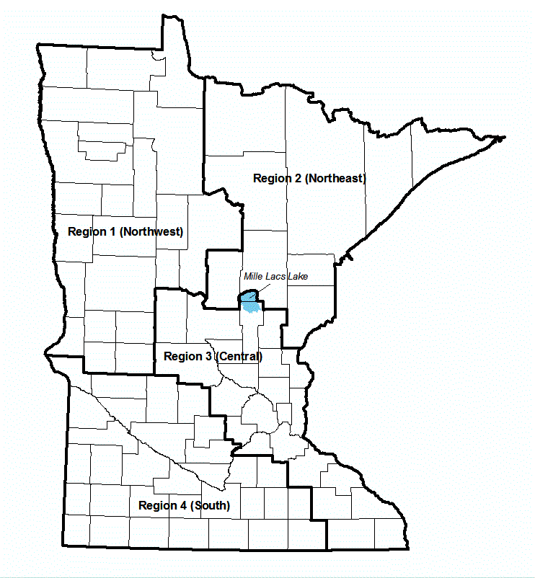

Region 1 (Northwest)
Department of Natural Resources
Regional Fisheries Manager
Attn: Whitney Honstead
whitney.honstead@state.mn.us
2115 Birchmont Beach Road NE
Bemidji, MN 56601
(218) 308-2623

Region 3 (Central) (includes Mille Lacs)
Department of Natural Resources
Regional Fisheries Manager
Attn: Neil Vanderbosch
neil.vanderbosch@state.mn.us
1200 Warner Road
St. Paul, MN 55106
(651) 259-5780
Region 2 (Northeast)
Department of Natural Resources
Regional Fisheries Manager
Attn: Ruth Zaleski
ruth.zaleski@state.mn.us
1601 Minnesota Drive
Brainerd, MN 56401
(218) 203-4342

Region 4 (South)
Department of Natural Resources
Regional Fisheries Manager
Attn: Paula Erickson
paula.erickson@state.mn.us
21371 State Hwy 15
New Ulm, MN 56073
(507) 233-1215

