Zebra mussel picture | Post Card Title
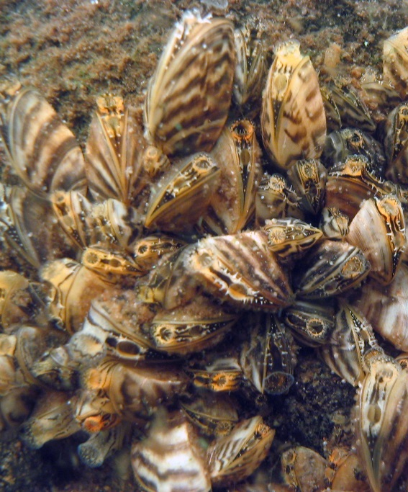 | Zebra  Mussel  Absence  Report  [Insert Organization  Name Here]
blank | blank
Zebra
Mussel
Absence
Report
[Insert Organization
Name Here]
Zebra
Mussel
Absence
Report
[Insert Organization
Name Here]
blank | blank
Zebra
Mussel
Absence
Report
[Insert Organization
Name Here]
Report Data | Mailing Information
LAKE INFORMATION:  Your Name: ___________________  Phone or Email: ________________  County: _______________________  Water Body Name: ______________  DOW#: _______________________  SEARCH INFORMATION:  Location in Water Body: ______________________________  Search Method(s) and Date(s): | This card is for absence reports only. If you think you found a zebra mussel, report it to the DNR immediately.  Thank you for your efforts!
____________________________________________________________________________________________________________________________________________________________________________________ | Organization  Address Line 1  Address Line 2  City, State ZIP Code
Blank | blank
LAKE INFORMATION:  Your Name: ___________________  Phone or Email: ________________  County: _______________________  Water Body Name: ______________  DOW#: _______________________  SEARCH INFORMATION:  Location in Water Body: ______________________________  Search Method(s) and Date(s): | This card is for absence reports only. If you think you found a zebra mussel, report it to the DNR immediately.  Thank you for your efforts!
____________________________________________________________________________________________________________________________________________________________________________________ | Organization  Address Line 1  Address Line 2  City, State ZIP Code

Report Data | Mailing Information
LAKE INFORMATION:  Your Name: ___________________  Phone or Email: ________________  County: _______________________  Water Body Name: ______________  DOW#: _______________________  SEARCH INFORMATION:  Location in Water Body: ______________________________  Search Method(s) and Date(s): | This card is for absence reports only. If you think you found a zebra mussel, report it to the DNR immediately.  Thank you for your efforts!
____________________________________________________________________________________________________________________________________________________________________________________ | Organization  Address Line 1  Address Line 2  City, State ZIP Code
Blank | blank
LAKE INFORMATION:  Your Name: ___________________  Phone or Email: ________________  County: _______________________  Water Body Name: ______________  DOW#: _______________________  SEARCH INFORMATION:  Location in Water Body: ______________________________  Search Method(s) and Date(s): | This card is for absence reports only. If you think you found a zebra mussel, report it to the DNR immediately.  Thank you for your efforts!
____________________________________________________________________________________________________________________________________________________________________________________ | Organization  Address Line 1  Address Line 2  City, State ZIP Code

