[Instruction Page – Delete When Complete]

Metrics Template 2024: Making a Difference with AIS Prevention Aid
The following template list of metrics provides a standardized way for local governments and their partners to voluntarily track and share their Aquatic Invasive Species (AIS) Prevention Aid accomplishments. This tool helps track measurable achievements and success stories to show local residents, stakeholder groups, boards and elected officials the impact of your AIS program in your communities. While providing information in this template is not required by Statute 477A.19 (AIS Prevention Aid), more participation makes the dataset more robust and beneficial for everyone.

The following categories and metrics highlight common AIS prevention and management activities. Fill in what is applicable to your program this calendar year. This template is not all-inclusive and there are no required fields. Fill in as many metrics as you see fit. You may also include additional metrics that were tracked by your program.

When you are done filing out this template, delete the following: this first page, non-applicable metrics and purple instruction text. Then, you will have a clean report ready for sharing!

Ideally, once complete, you can:
- Share with your community to showcase your program’s hard work.
- Share with the Minnesota Department of Natural Resources, so that data from all counties can be compiled and shared annually, to showcase the statewide impact of these local AIS prevention programs. Individual county metric reports will be posted with permission on a file-sharing site for all counties to access.
  - Each of the 83 counties receiving aid is an important piece to the puzzle – we need all the pieces to get a complete picture. Please consider contributing to this statewide effort! There were 53 counties that submitted in 2023 – let’s keep trending higher! Don’t be left out.
  - Metrics summaries from past years can be found on the AIS Prevention Aid webpage.
A completed template might look something like this:
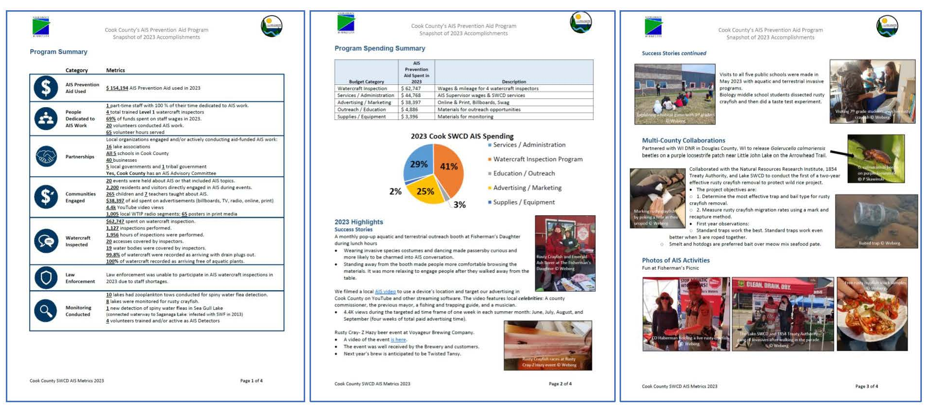

[Instructions (delete purple text when complete):
These numbers should reflect activities accomplished in calendar year 2024 using AIS Prevention Aid.
- Fill in your county name.
- Provide an overview of your program.
- Fill in applicable metrics below by double-clicking and entering numbers to replace the grey highlighted areas.
  - Add metrics and categories as desired.
- Delete the metrics and categories that are not applicable to your program, or write “N/A” or “0.”
  - The “watercraft inspected” category could be replaced or supplemented by including your Watercraft Inspection End of Season Report as an appendix to this document.
- Provide an overview of your program spending.
- Describe your plans for next year.
- Share stories and photos of success, accomplishments, and impacts because those stories can be just as powerful as numbers, if not more so!]

________________ County’s AIS Prevention Aid Program:

A Snapshot of Accomplishments in 2024

Program Summary
[Instructions (delete when complete): Provide a short description about your county’s AIS program here, such as program oversight, funds, priorities, goals, strategies, capacity (staff/time dedicated to AIS work), partners, etc.]
 | Category | Metrics
 | AIS Prevention Aid Used | $ ____ AIS Prevention Aid used this calendar year  $ ____ AIS Prevention Aid received this calendar year  $ ____ AIS Prevention Aid saved for ___ (describe what the funds are saved for here) ___ (Examples: contingency, rollover, large purchase, response, etc.)
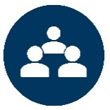 | People Dedicated to AIS Work | _____ full-time staff with ____ % of their time dedicated to AIS work  (Staff that work 40 hours a week; provide average % if more than 1 staff person or list out separately. Do not include inspectors, they are counted below.)  _____ part-time and seasonal staff with ____ % of their time dedicated to AIS work (Staff other than inspectors that work less than 40 hours a week or seasonally; provide average % if more than 1 staff person or list out separately. Do not include inspectors here. They are counted below.)  _____ total authorized watercraft inspectors, including:  ____ trained as Level 1 and ____ trained as Level 2  $____ total spent on staff wages, including:  $____ in AIS Prevention Aid  $____ in other funds leveraged from __ (list organizations if applicable) __ (Leveraged funds are additional funds (local, state, federal) provided by organizations that directly support staff who work on aid-funded activities.)  _____ volunteers conducted AIS work supporting aid-funded activities  _____ volunteer hours served supporting aid-funded activities (If applicable, add “@ $__/hr they contributed a total of $__”)
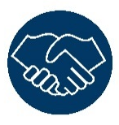 | Partnerships Created and Maintained | Local organizations engaged and/or actively conducting aid-funded activities:  _____ lake associations  _____ conservation nonprofits and/or outdoor groups (e.g., angling, hunting, paddling, sailing, etc.)  _____ schools and/or youth organizations  _____ businesses  _____ local governments  _____ tribal governments  _____ other groups such as __ (list organizations if applicable) __  County AIS Task Force or Committee established in __ (insert year or N/A) ___
 | Funds Distributed, Contributed and Leveraged | $____ of AIS Prevention Aid awarded as grants to other organizations  _____ organizations awarded grants  $____ in funds contributed by other organizations that directly supported all aid-funded activities in the county (aka leveraged funds) (e.g., matching for: grants, watercraft inspections, invasive aquatic plant management, education, etc.)  _____ organizations contributing additional funds
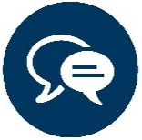 | Communities Engaged | _____ events held about AIS or that included AIS topics  _____ residents and visitors directly contacted/engaged about AIS during events  _____ children/students and _____ teachers taught about AIS  _____ commitments gathered  $____ of aid spent on advertisements (billboards, TV, radio, newspaper, social media, etc.)  __ (describe social media and/or advertising reach here) __ (Examples: number of ads, posts, followers, shares, impressions, etc.)
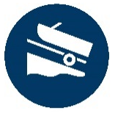 | Watercraft Inspected | $____ spent on watercraft inspection (If applicable, add “decontamination”) including:  $____ in AIS Prevention Aid  $____ in other funds leveraged from __ (list organizations if applicable) __  (Leveraged funds are additional funds (local, state, federal) provided by organizations that directly support aid-funded inspection activities.)  ____ inspections performed  _____ hours of inspections performed  _____ accesses covered by inspectors  _____ water bodies covered by inspectors  ____% of watercraft recorded as arriving with drain plugs out  ____% of watercraft recorded as arriving free of aquatic plants  _____ decontamination units (hot water, high pressure) operated by Level 2 inspectors  _____ decontaminations performed  _____ boaters engaged by AIS Volunteers/Ambassadors at water accesses  _____ water bodies with cleaning tool stations maintained at _____ water accesses (If applicable: ____ total tool uses)
 | Law Enforcement Supported | $____ in aid provided to local law enforcement officers to enforce AIS laws  _____ local law enforcement officers trained this year on AIS laws  _____ local law enforcement officers conducted AIS work  _____ boaters contacted by local law enforcement  _____ AIS warnings and citations written by local law enforcement
 | Monitoring Conducted | _____ total lakes and rivers surveyed for AIS. Surveys included:  _____ early detection searches on _____ water bodies  _____ zebra mussel settling plates deployed on _____ water bodies  _____ veliger tows taken on _____ water bodies  _____ aquatic plant surveys conducted on _____ water bodies  _____ invasive common carp surveys conducted on _____ water bodies  _____ __ [list additional survey method(s) and species if applicable]__ conducted on _____ water bodies  _____ new detections in the county (new AIS discovered in a water body)  _____ volunteers trained and/or active as AIS Detectors  _____ people participated in the University of Minnesota Extension and Minnesota AIS Research Center’s “Starry Trek” event  List of species targeted for monitoring or surveys: __ (list species if applicable) __
 | New Infestation Response Planned | _____ coordinated response(s) to a new AIS population(s) (Response can be control, inspection, education, monitoring, etc.)  _____ sites controlled/managed  __ (describe your county’s response plans here) __ (Examples: A response plan developed in 20XX, follows the state’s response plan, county does not have a response plan, etc.)
 | AIS Controlled | $____ spent on in-lake/river control of AIS, including:  $____ in AIS Prevention Aid  $____ in other funds leveraged from _____ organizations.  (Leveraged funds are additional funds (local, state, federal) provided by organizations that directly support aid-funded control/treatment activities.)  _____ groups involved or conducting aid-funded control activities  _____ total water bodies/sites with aid-funded control activities, including:  _____ water bodies with invasive aquatic plant management  _____ water bodies with invasive common carp management (If applicable, include number/pounds of carp removed)  _____ sites with purple loosestrife management where _____ biocontrol beetles were released  _____ sites with non-native Phragmites management covered _____ acres  _____ water bodies/sites with __ (list additional species if applicable) __ management  List of species controlled: __ (list species if applicable) __

Program Spending Summary
[Instructions (delete when complete): In the table below, list the estimated dollar amount of AIS Prevention Aid funds going to specific activity categories this year, or delete this section. Provide a description for each category. Include any staff wages as part of each applicable budget category or create a new category if staff time is not tracked by category. If your county had a local grant program, separate aid funds spent by the county in the second column and aid funds awarded/spent by other local organizations in the third column. In most cases, dollar amounts below should match the dollar amounts provided in the summary table above. For example, the sum of columns two and three should equal the total amount of aid funds spent this year.
Budget Category | AIS Prevention Aid Spent by the County in 2024 | (if applicable)  AIS Prevention Spent by Local Grantees in 2024 | (if applicable)  In-Kind Funds Contributed in 2024 | Description
Public Outreach and Education | $ | $ | $
Watercraft Inspection | $ | $ | $
Enforcement | $ | $ | $
Monitoring | $ | $ | $
New Infestation Response | $ | $ | $
AIS Control | $ | $ | $
(insert additional categories as needed) | $ | $ | $
Totals | $ | $ | $

Plans for 2025
[Instructions (delete when complete): Briefly describe how your program may change and what will remain the same for next year (2025). Are there metrics, performance measures, or goals you wish to maintain or improve upon? Are there new AIS pathways (e.g., live bait, water garden and aquarium pets or plants, biological supply, seafood, docks/lifts, etc.) or audiences you plan to reach?]

2024 Highlights
[Instructions (delete when complete): Programs are more than just numbers. The following sections provide a space for you to highlight and celebrate initiatives your program and your partners have accomplished through the aid in more detail. Fill in, add or delete sections as you see fit.]

Success Stories
- [Instructions: Insert a success story or two here. Example: a watercraft inspector prevented a boat covered in zebra mussels from launching into an uninfested lake; a stakeholder was trained to identify AIS and then detected a new infestation. Consider reporting efforts that reflect greatest accomplishments or impacts.]

Engaging Diverse Audiences
- [Instructions: Diversity, equity, accessibility, and inclusion are core values of the State of Minnesota. How does your AIS programming consider aspects including race, ethnicity, nationality, religion, socioeconomic status, education, marital status, language, age, gender, sexual orientation, mental or physical ability, life experience, ideas, knowledge, learning styles, etc.? Provide examples of what has been done or ideas you may pursue.]

Multi-County Collaborations
- [Instructions: Highlight any initiatives that involve multiple counties and list those counties involved. Again, consider reporting efforts that reflect greatest accomplishments or impacts.]

Reports and Products
- [Instructions: Insert a list of reports (rapid response, lake assessments, research, surveys, etc.) and/or products (brochures, fliers, giveaways, etc.) created using AIS Prevention Aid. Consider reporting about a particular product or effort that would serve as models elsewhere. Beyond the mentioned reports and products, the DNR and researchers are especially interested in the following:
  - List of inspection hours by access and water body (name and DOW number). Reminder: Include this in your Watercraft Inspection End of Season Report, too.
  - List of water bodies monitored for AIS, the survey method(s) used, an estimate of total survey effort (e.g. number of settling plates, tows, rake tosses, water samples, hours spent, distance/areas searched, etc.) and species searched for.
  - List of water bodies where monitoring/early detection activities were funded.
  - List of water bodies where invasive aquatic plant management activities were funded.
  - List of water bodies where invasive carp control was implemented and the control method(s) used.]

Photo(s) of AIS Activities
- [Instructions: Insert photo(s) and caption(s) of AIS activities here. Photo tips, be sure to always: Obtain permission from people before taking their photograph; Obtain permission from parents/guardians before taking a minor’s photograph; Obtain permission from the photographer before using their photo anywhere; Provide photographer credit for every photo used. Finally, follow any additional photo policies as directed by your organization.]

