[Instruction Page – Delete When Complete]

Metrics Template 2022: Making a Difference with AIS Prevention Aid
The following template list of metrics provides a standardized way for local governments and their partners to voluntarily track their Aquatic Invasive Species (AIS) Prevention Aid accomplishments*. This tool helps track measurable achievements and success stories to show local residents, stakeholder groups, boards and elected officials the impact of your AIS program in your communities.
*Providing information in this template is not required by Statute 477A.19 (AIS Prevention Aid).
The following categories and metrics highlight common AIS prevention and management activities. Fill in what is applicable to your program this calendar year. This template is not all-inclusive and there are no required fields. Fill in as many metrics as you see fit. You may also include additional metrics that were tracked by your program.

When you are done filing out this template, delete the following: this first page, non-applicable metrics and purple instruction text. Then you will have a clean report ready for sharing!

Ideally, once complete, you can:
- Share with your community to showcase your program’s hard work.
- Share with the Minnesota Department of Natural Resources, so that data from all counties can be compiled and shared annually, to showcase the statewide impact of these local AIS prevention programs.
  - Each of the 83 counties receiving aid is an important piece to the puzzle – we need all the pieces to get a complete picture. Please consider contributing to this statewide effort! There were 52 counties that submitted in 2021 – let’s keep trending higher!
  - Metrics summaries from past years can be found on the AIS Prevention Aid webpage.
A completed template might look something like this:
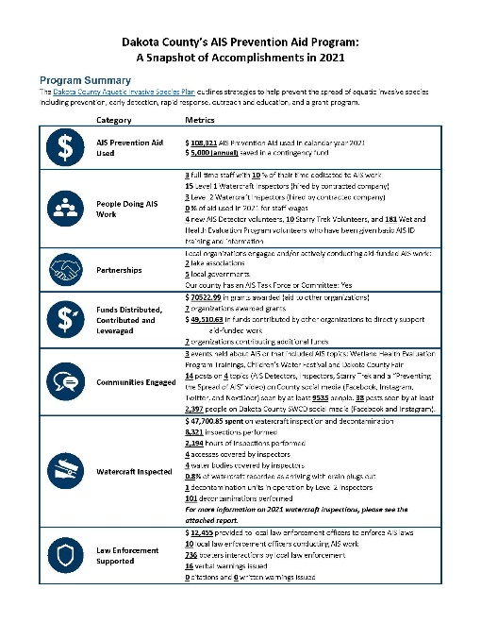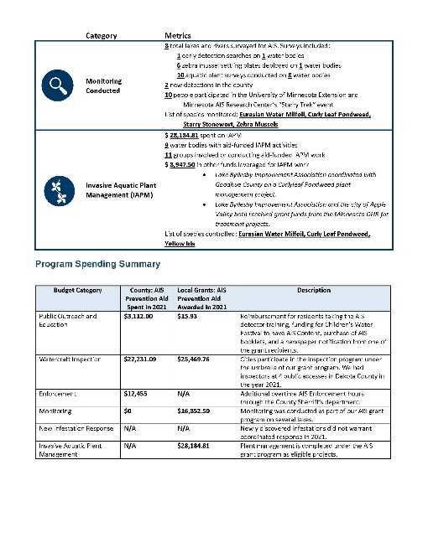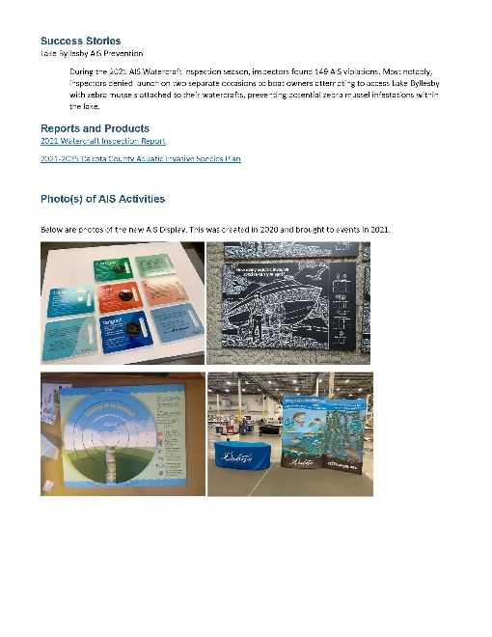
[Instructions (delete purple text when complete):
These numbers should reflect activities accomplished in calendar year 2022 using AIS Prevention Aid.
- Fill in your county name.
- Provide an overview of your program.
- Fill in applicable metrics below by double-clicking and entering numbers to replace the grey highlighted areas.
  - Add metrics and categories as desired.
- Delete the metrics and categories that are not applicable to your program, or write “N/A” or “0.”
  - The “watercraft inspected” category could be replaced or supplemented by including your Watercraft Inspection End of Season Report as an appendix to this document.
- Provide an overview of your program spending.
- Describe your plans for next year.
- Share stories and photos of success, because stories can be just as powerful as numbers, if not more so!]

________________ County’s AIS Prevention Aid Program:

A Snapshot of Accomplishments in 2022

Program Summary
[Instructions (delete when complete): Provide a short description about your county’s AIS program here, such as program oversight, funds, priorities, goals, strategies, capacity (staff/time dedicated to AIS work), partners, etc.]
Icon | Category | Metrics
 | AIS Prevention Aid Used | $ ____ AIS Prevention Aid used this calendar year  $ ____ saved in a contingency fund
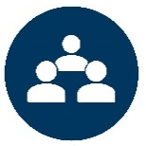 | People Doing AIS Work | _____ full-time staff with ____ % of their time dedicated to AIS work  (Staff that work 40 hours a week; provide average % if more than 1 staff person)  _____ part-time and seasonal staff with ____ % of their time dedicated to AIS work (Staff other than inspectors that work less than 40 hours a week or seasonally; provide average % if more than 1 staff person)  _____ Level 1 Watercraft Inspectors  _____ Level 2 Watercraft Inspectors (operate decontamination units)  _____ % of aid used this year for staff wages  _____ volunteers conducting AIS work  _____ volunteer hours served
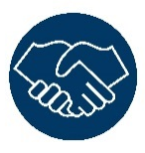 | Partnerships | Local organizations engaged and/or actively conducting aid-funded AIS work:  _____ lake associations  _____ conservation nonprofits and/or outdoor groups (angling, hunting, paddling, sailing, etc.)  _____ schools and/or youth organizations  _____ businesses  _____ local governments  _____ other groups such as _____ (please describe)  Our county has an AIS Task Force or Committee: [Select: Yes or No]
 | Funds Distributed, Contributed and Leveraged | $____ in grants awarded (aid to other organizations)  _____ organizations awarded grants  $____ in funds contributed by other organizations to directly support aid-funded work (e.g. matching for: grants, watercraft inspections, invasive aquatic plant management, education, etc.)  _____ organizations contributing additional funds  $____ in other funds leveraged from _____ (please describe)
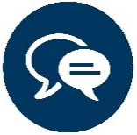 | Communities Engaged | _____ events held about AIS or that included AIS topics  _____ residents and visitors directly contacted/engaged about AIS during events  _____ posts on social media seen by _____ followers  _____ children taught about AIS  _____ commitments gathered  $____ spent on paid advertisements (billboards, TV, radio, newspaper, social media, etc.)
 | Watercraft Inspected | $____ spent on watercraft inspection (If applicable, add “and decontamination”)  _____ inspections performed  _____ hours of inspections performed  _____ accesses covered by inspectors  _____ water bodies covered by inspectors  ____% of watercraft recorded as arriving with drain plugs out  _____ decontamination units in operation by Level 2 Inspectors  _____ decontaminations performed  _____ boaters engaged by AIS Volunteers/Ambassadors at water accesses  This category can be replaced or supplemented by your Watercraft Inspection End of Season Report.
 | Law Enforcement Supported | $____ provided to local law enforcement officers to enforce AIS laws  _____ local law enforcement officers trained this year on AIS laws  _____ local law enforcement officers conducting AIS work  _____ boaters contacted by local law enforcement
 | Monitoring Conducted | _____ total lakes and rivers surveyed for AIS. Surveys included:  _____ early detection searches on _____ water bodies  _____ zebra mussel settling plates deployed on _____ water bodies  _____ veliger tows taken on _____ water bodies  _____ aquatic plant surveys conducted on _____ water bodies  _____ invasive carp surveys conducted on _____ water bodies  _____ new detections in the county (new AIS discovered in a water body)  _____ volunteers trained and/or active as AIS Detectors  _____ people participated in the University of Minnesota Extension and Minnesota AIS Research Center’s “Starry Trek” event  List of species targeted for monitoring or surveys: ________
 | New Infestation Response Planning | _____ response(s) to new AIS populations coordinated  Our county has a new infestation response plan: [Select: Yes or No]
 | Invasive Aquatic Plant Management (IAPM) + Control of Other Invasive Species | $____ spent on IAPM  _____ water bodies with aid-funded IAPM activities  _____ groups involved or conducting aid-funded IAPM work  $____ in other funds leveraged for IAPM work from _____ (please describe)  _____ purple loosestrife sites where biocontrol beetles were released  _____ pounds of invasive carp removed from _____ water bodies  List of species controlled: _______

Program Spending Summary
[Instructions (delete when complete): In the table below, list the estimated dollar amount of AIS Prevention Aid funds going to specific activity categories this year, or delete this section. Include any staff wages as part of each applicable budget category. If your county had a grant program, separate aid funds spent by the county in the second column and aid funds awarded/spent by other local organizations in the third column. In most cases, the totals of both columns here should equal the total amount of aid funds spent this year.]
Budget Category | County: AIS Prevention Aid Spent in 2022 | (if applicable)  Local Grants: AIS Prevention Aid Awarded in 2022 | Description
Public Outreach and Education | $ | $
Watercraft Inspection | $ | $
Enforcement | $ | $
Monitoring | $ | $
New Infestation Response | $ | $
Invasive Aquatic Plant Management | $ | $
Other | $ | $

Plans for 2023
[Instructions (delete when complete): Briefly describe how your program may change and what will remain the same for next year (2023). Are there metrics, performance measures, or goals you wish to maintain or improve upon?]

2022 Highlights
[Instructions (delete when complete): Programs are more than just numbers. The following sections provide a space for you to highlight and celebrate initiatives your program and your partners have accomplished through the aid in more detail. Fill in, add or delete sections as you see fit.]

Success Stories
- [Instructions: Insert a story or two of success here. Example: a watercraft inspector prevented a boat covered in zebra mussels from launching into an uninfested lake; a stakeholder was trained to identify AIS and then detected a new infestation.]

Multi-County Collaborations
- [Instructions: Highlight any initiatives that involve multiple counties and list those counties involved.]

Reports and Products
- [Instructions: Insert a list of reports (rapid response, lake assessments, research, surveys, etc.) and/or products (brochures, fliers, giveaways, etc.) created using AIS Prevention Aid. Beyond the mentioned reports and products, the DNR and researchers are especially interested in the following:
  - List of inspection hours by access and water body (name and DOW number). Reminder: Include this in your Watercraft Inspection End of Season Report too.
  - List of water bodies monitored for AIS, the survey method(s) used, an estimate of total survey effort (e.g. number of settling plates, tows, rake tosses, water samples, hours spent, distance/areas searched, etc.) and species searched for.
  - List of water bodies where IAPM activities were funded.
  - List of water bodies where invasive carp control was implemented and the control method(s) used.]

Photo(s) of AIS Activities
- [Instructions: Insert photo(s) and caption(s) of AIS activities here. Photo tips, be sure to always: Obtain permission from people before taking their photograph; Obtain permission from the photographer before using their photo anywhere; Provide photographer credit for every photo used.]

