School Forest Application
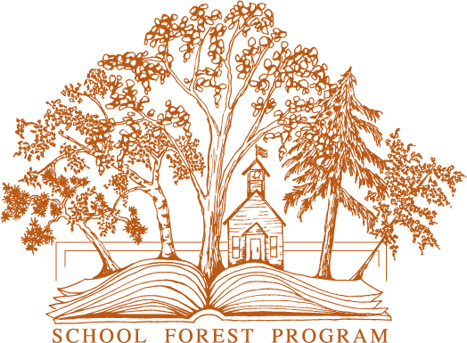
Minnesota Department of Natural Resources

Date: ________________________

School Information
School Name:__________________________________________________________________________
School Type (public, magnet, charter, private, other): ____________________ School District No.: _____
School Address (include city, state, zip): ____________________________________________________
_____________________________________________________________________________________
School Phone: _________________________________________________________________________
Additional schools or organizations that may use the School Forest:_______________________________
_____________________________________________________________________________________

School Forest Information
Name of School Forest: _________________________________________________________________
Number of Acres: ___________ County: ___________________
Distance to School Forest from your school: _______________________

Site Coordinator/Contact Person
Name: ________________________________________ Title: __________________________________
School/work email: ____________________________________________________________________
School/work phone: ____________________________________________________________________
Personal/summer email: ________________________________________________________________
Personal/summer phone: _______________________________________________________________

Required Attachments
___ Copy of property deed
___ Legal description (if not on property deed)
___ Map of site, plat map, or other
___ School Board Resolution declaring site as a School Forest (copy of meeting minutes)
___ Joint Powers Agreement or Management Agreement (if parcel is not owned by school district)

Questions? Contact the School Forest program
schoolforest.dnr@state.mn.us, 651-259-5272

Potential School Forest Committee Members
These are members of the school, community or county that might be interested in participating in planning or organizing the School Forest. Examples include parents, students, teachers, administrators, local or state government staff, business members, foresters, gardeners, community members, etc.

names position/titles
__________________________________________________________________________________________
__________________________________________________________________________________________
__________________________________________________________________________________________
__________________________________________________________________________________________
__________________________________________________________________________________________
__________________________________________________________________________________________
__________________________________________________________________________________________
__________________________________________________________________________________________
__________________________________________________________________________________________
__________________________________________________________________________________________
__________________________________________________________________________________________
__________________________________________________________________________________________

Have you contacted your local DNR Forester? __ No __ Yes, who?_________________________________

Have you consulted with any other foresters? __ No __ Yes, who? ________________________________

What help from the School Forest program could benefit your site?
__________________________________________________________________________________________
__________________________________________________________________________________________
__________________________________________________________________________________________
__________________________________________________________________________________________
__________________________________________________________________________________________
__________________________________________________________________________________________
__________________________________________________________________________________________
__________________________________________________________________________________________
__________________________________________________________________________________________

Once we receive your application, the School Forest staff will contact your site coordinator with more information and determine the next steps to best achieve your site’s needs.

Please send this completed application and all required attachments to:
schoolforest.dnr@state.mn.us (preferred)
School Forest Program
MN-DNR Forestry, 500 Lafayette Road, St. Paul, MN 55155-4044
www.mndnr.gov/schoolforest
651-259-5272

