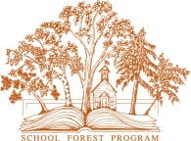
www.mndnr.gov/schoolforest

Minnesota School Forest Program

Twig Observation – Match Game
This is a good activity to refresh students’ observation skills at any age. I’ve used it as an icebreaker with adults and with students a way to teach science observation or using a dichotomous key (grade 5 and up). Best, you don’t have to know the names of the trees! -Laura Duffey, Minnesota PLT and School Forest
Grade(s): K-12, adult
Materials: Pairs or groups of twigs. Each student needs one twig.
Objective(s): Students will explore properties of tree branches and then match their twig with another student’s twig.
Procedure:
- Before class, go outside and collect enough woody twigs so that each student gets a twig. Twigs should be at least 6 inches long and contain 4 or more buds or marks where leaves are attached. Collect from different species of trees and shrubs. Flag the tree and shrubs that supplied the twigs. Make sure to collect at least 2 samples of each species. Students will form pair matches.

Use a small lopper to harvest twigs from living trees or shrubs. Don’t remove the leader branch, which is the topmost twig on a sapling. Remove any leaves. Removing twigs when trees are dormant should not harm the tree.

For younger grades (K-3) select fewer species. This will make matching easier and they can form larger groups of matches.

- Put all the twigs on a table. Let each student choose one twig.

- Tell students to observe their twig closely using as many senses as possible—touch, smell, sight.

- Ask: What do they observe? Write responses on the board.

  - List adjectives on one side of the board.
  - On the other half of the board draw a sample twig. When students identify observations of twig parts such as buds, bud scars, lenticels, hairs, etc., label the twig and build vocabulary.

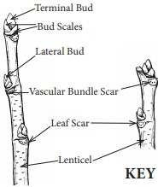 | Image from Wisconsin LEAF

- Ask: What patterns do they observe? If no one mentions bud placement, explain what opposite and alternate branching or buds look like. Draw and label examples of opposite and alternate branching on the board.

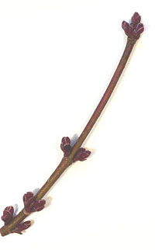 | Example of a twig with opposite branching
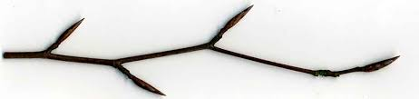 | Example of a twig with alternate branching

- Test for understanding. Ask students who have opposite branching to lift their twigs in the air. Do the same for alternate branching.

- Ask, Does your twig look like your neighbor’s twig? Give them a moment to compare.

- Have each student find a person in the room who has a twig with similar features. Can they find each other?

- If you have time, take students outside to the flagged trees where you harvested the twigs. Challenge students to find the tree that their twig came from. If it’s age-appropriate, provide tree ID books and let each small group try to figure out what species of twig they have. (Using dichotomous keys is grade 7 Minn. science standard.)
Notes: Removing the leaves replicates the typical leaf-off conditions of deciduous trees during a typical Minnesota school year and gives participants a little more confidence identifying trees without relying on leaf shape.
If there are not a lot of tree species in your area, it’s ok to provide more than one pair of each species and let groups of 4 or 6 find each other.

Can you label the parts of your twig?
