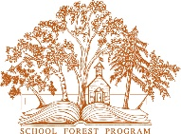

www.mndnr.gov/schoolforest

Minnesota School Forest Program

Lesson Title: GPS Review

By Jamie Madson/Bonnie Wilts/Amy Sarne, madsonj@rockford.k12.mn.us , Rockford Middle School Forest

Grade(s): 5-8

ISTE Standards

- Technology operations and concepts. Students demonstrate a sound understanding of technology concepts, systems, and operations.
- Understand and use technology systems.
- Select and use applications effectively and productively.
- Troubleshoot systems and applications.
- Transfer current knowledge to learning of new technologies.

- Critical thinking, problem solving, and decision-making. Students use critical thinking skills to plan and conduct research, manage projects, solve problems, and make informed decisions using appropriate digital tools and resources.
- Identify and define authentic problems and significant questions for investigation.
- Plan and manage activities to develop a solution or complete a project.
- Collect and analyze data to identify solutions and/or make informed decisions.
- Use multiple processes and diverse perspectives to explore alternative solutions.

Materials:
GPSRs, laminated question sheets, string

Objective:
Use a GPSr to locate predetermined coordinates around the school campus. Once located, the students will answer a review question for an upcoming Minnesota History test.

Procedure:
            - Spend day one building some basic GPS skills. Students should have a basic understanding of GPS technology focusing on what factors affect performance and accuracy.

VOCAB: satellite triangulation: "locking on": accuracy of consumer GPS devices: latitude and longitude: entering coordinates

            - The class will spend the bulk of the first day getting to know the GPSr and locating a few waypoints as a group. Students should pay close attention to make sure they enter coordinates correctly. One number off could affect their chances of success significantly.
            - On Day two students will apply their knowledge to locate waypoints around the campus. At each waypoint, they will find a short reading selection and review question. Once they answer the question, the students should enter the coordinates for the next waypoint located at the bottom of the sheet. They should also check in with the teacher to have their answers checked in between each waypoint.
Name
Class hour
Coordinates | Questions | Answers | Mrs. Wilts’  initials to move onto the next  question
Station lA N45° 05'.467  W93° 44'.242 | 1. What created the large scratches in the rock?
Station 2A | 2. What animals are included in the  Jeffers Petroglyphs?
Station 3A | 3. What is an archaeologist?
Station 4A | 4. What is oral history?
Station 5A | 5. What is an artifact?

Station 1A
About halfway between today's towns of Jeffers and Comfrey is a place where history is written in stone. A 23- mile-long ridge of red rock rises above the surrounding prairie and farmland. Long ago, deposits of sand and mud collected in the area. Slowly, the deposits compressed
first into soft rock (sandstone) and then into hard stone (quartzite). Much of the stone remains hidden from view under layers of soil and water. At several places on the ridge, it looks as if a giant has scratched the rock with its fingernails. The rock has, in fact, been scratched, but not by a giant. The scratches were caused by heavy ice sheets called glaciers as they inched across the ground. Glaciers have covered what is now Minnesota many times.

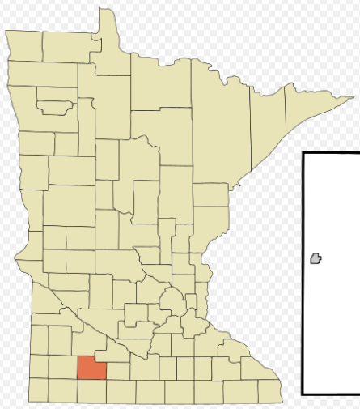

Coordinates for next location:
JN4S0 os'.495 Jw93° 44'.277

Station 2A
The Jeffers Petroglyphs Historic Site is one of the most important collections of ancient rock carvings in North America. These carvings, called petroglyphs, can tell us much about the people who made them, how they lived, and what they may have believed. These images include animals (such as bison, bears, wolves, turtles, elk) and human stick figures.
Some of the humans seem to be holding weapons called atlatls. Others appear to be wearing headdresses with horns. Many carvings, however, are difficult to recognize and we may never know exactly what each symbol means. Many American Indian elders believe that Jeffers is a sacred place to which people have come for thousands of years. For some, the site still provides guidance and healing. To the elders, the symbols on the rocks speak not only of the past, but also of the present and future.

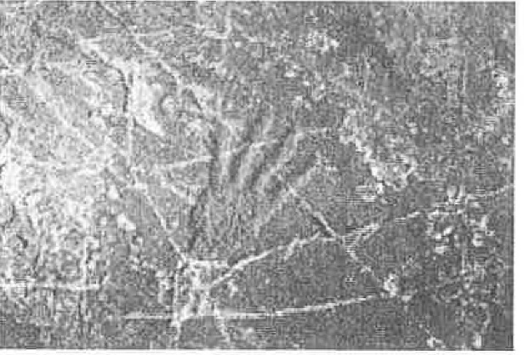

Coordinates for next location:
IN45° os'.437 IW93° 44'.326

Station 3A
Another way to understand the Jeffers Petroglyphs carvings is to ask a type of scientist called an archaeologist.
Archaeologists study human history by looking at the evidence people left behind. (Archaeologists do not study dinosaurs. Paleontologists do.) The petroglyphs at Jeffers are examples of that evidence. Archaeologists argue carvings like those at Jeffers reveal important information about the people who made them, and about the time and place in which they were made.

Archaeologist: a scientist who studies past human life and activities by examining physical evidence such as tools, fire pits, and ruins from dwellings.

Coordinates for next location:
IN45° os'.372 IW93° 44'.299

Station 4A
When people examine historical objects, they interpret them based on their perspective. People's experiences affect how they think about the world, both past and present. Everyone looks at things differently based on their education, culture, time period, and home. Recognizing how perspectives differ is an important part of understanding history. For many centuries, the native people of North America have kept their history alive through oral history. Sometimes these stories tell of events that happened long ago. Sometimes they are legends that teach lessons or explain why things are the way they are. Sometimes the stories warn what might happen in the future if young people don't listen to their elders. Oral history connects people to each other and to the past.
Oral history: the purposeful retelling of stories about the past events and legends of a group to teach about the group's culture.

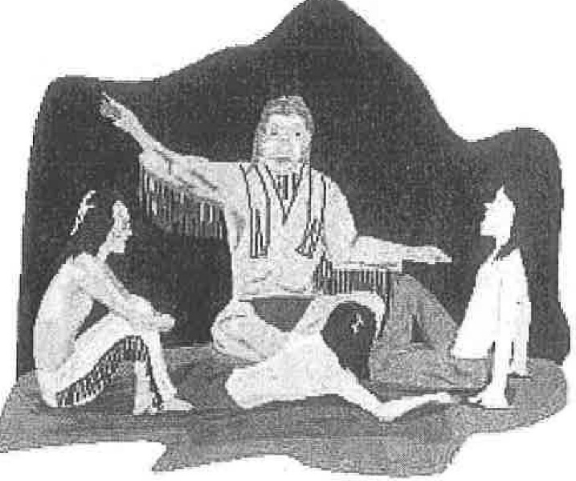

Coordinates for next location:
jN45° os•.414 jw93° 44'.266

Station 5A
The oral histories of many different American Indian nations include stories that can help us understand the meaning of the petroglyphs found at Jeffers. Some stories are told by native people such as the Dakota, who live in Minnesota today and whose ancestors may have made carvings at Jeffers. Others are told by native people who live far away in other parts of North America.
Archaeologists study many types of physical evidence, or artifacts. One type is petroglyphs, like the ones found at Jeffers. To an archaeologist, the Jeffers carvings contain information that can help answer questions such as: Who made the carvings? Where did the people who made them come from? Depending on the questions they have,
archaeologists use different methods to uncover information.
Artifact: any object made, used, or altered by humans.
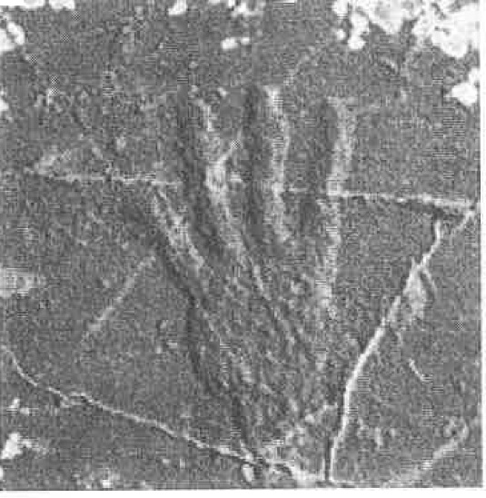
Coordinates for next location:
IN45° 05'.467 IW93° 44'.242

