Leaf Characteristics

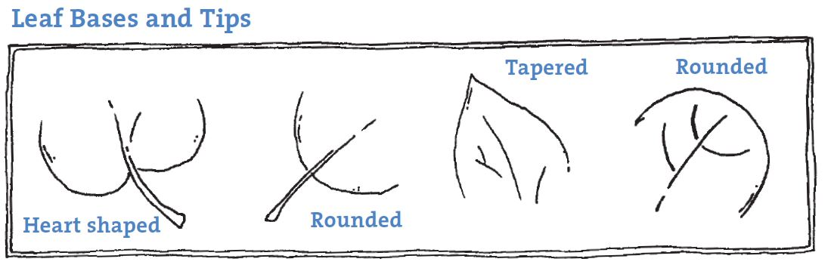

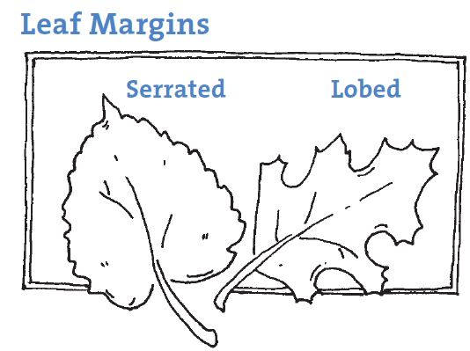

Leaf Fractions

- What fraction of your leaves are red?
- What fraction of your leaves are not heart-shaped on the bottom?

- What fraction of your leaves have rounded tips?
- What fraction of your leaves are not lobed?

List characteristics of your leaves
Attach or draw leaf one and leaf two in the left and right portions of the Venn diagram. List their characteristics. Then list any characteristic shared by BOTH leaves in the middle part of the diagram.
Leaf One

Both Leaves
Leaf Two

