Student Page: Minnesota Life on the Edge

A species is considered:
Endangered if the species is threatened with extinction throughout all or a significant portion of its range.
Threatened if the species is likely to become endangered within the foreseeable future throughout all or a significant portion of its range.
Of special concern if, although the species is not endangered or threatened, it is extremely uncommon in Minnesota, or has unique or highly specific habitat requirements and deserves careful monitoring of its status. Species on the edge of their range that are not listed as threatened may be included in this category along with those species that were once threatened or endangered but now have increasing or protected, stable populations.
Instructions: Choose a plant or animal from the list on the next page. Then answer the questions below. Research the Minnesota Department of Natural Resources website to find more information about your plant or animal.
Species Common Name: __________________________________________________________________
Species Latin Name: ______________________________________________________________________

- What is its status? (threatened/endangered/special concern)

- Where is its range within the state?

- Which biome(s) does it live in? (coniferous forest/deciduous forest/prairie/tallgrass aspen parkland)

- What is its preferred habitat? (ex: wetland, forest, etc.)

- What happens to it in the winter?

- Describe some of its characteristics.

- Why is it rare, threatened, or endangered?

- Are people taking any actions to improve its chances of survival?

- What are some ways that people can help this species?

- What other species depend on it for food or shelter?

- Give at least three reasons why it important that this species survives.

Minnesota Endangered Species
ANIMALS  Mammals  Canada lynx  Gray wolf  Moose  Tri-colored bat  Northern bog lemming  Least weasel  Eastern spotted skunk  Birds  Piping plover  Loggerhead shrike  Horned grebe  Boreal owl  Purple martin  Amphibians  Spotted salamander  Great Plains Toad  Reptiles  Blandings turtle  Plains hognose snake  Common five-lined skink  Insects  Karner blue butterfly  Poweshiek skipperling  Rusty-patched bumblebee  Quebec emerald  Mussels  Purple cat's paw pearlymussel  Winged mapleleaf  Fish  Lake sturgeon  Paddlefish | 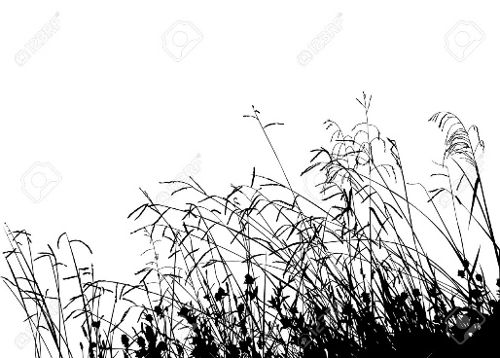  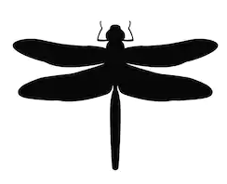 | PLANTS  Minnesota dwarf trout lily  Leedy’s roseroot  Prairie bush clover  Western prairie fringed orchid  Prairie shooting star  English Sundew  Rattlesnake master  Hudson Bay eyebright  Small white water-lily  Plains prickly pear  Snow trillium  Blanket flower  White wild indigo  OTHER  Concentric ring lichen  Pixie foam lichen  Luminous Moss

