March 1, 2012

Representative Dean Urdahl, Chair Senator Bill Ingebrigtsen, Chair
Legacy Funding Division Environment and Natural Resources Committee
571 State Office Building 303 Capitol Building, Room 303
Saint Paul, Minnesota 55155 75 Rev. Martin Luther King Jr. Blvd Saint Paul, Minnesota 55155

Representative Denny McNamara, Chair
Environment, Energy, and Natural Resources
Policy and Finance Committee
100 Rev. Dr. Martin Luther King Jr. Blvd.
Saint Paul, Minnesota 55155

Enclosed is the report entitled, “La Salle Lake State Recreation Area Management Options for the Resort Area,” pursuant to the Laws of Minnesota 2011, First Special Session, Chapter 6, Article 3, Section 9. Submittal of the report is required by March 1st, 2012 and copies have been sent to the Legislative Reference Library.

The Report meets the requirements of the 2011 Legislature that directed the commissioner of the DNR to evaluate “options for the management of the resort within the LaSalle Lake State Recreation Area, including the option to lease the resort to a nonstate entity” and to evaluate the “potential financial arrangements or mechanisms that would make the equivalent of local taxes or payments in lieu of taxes the responsibility of the nonstate entity.”

If you have questions regarding preparation of the report, please contact Casey Nelson, Division of Parks and Trails
at 651-259-5261 or Casey.Nelson@state.mn.us.

Sincerely,
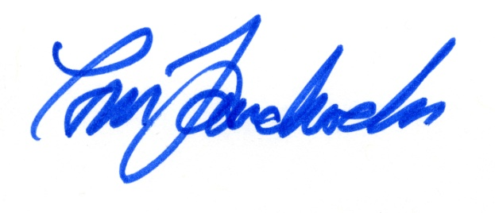
Tom Landwehr
Commissioner

Attachment

c/ Bob Meier, DNR; Erika Rivers, DNR, Courtland Nelson, DNR; Legislative Reference Library

