Dear Visitor to [insert name of resort or campground],

[Your logo here]

Minnesota is renowned for its clean water, good fishing, and remarkable recreational opportunities – and we want to keep it that way for future visitors and future generations.

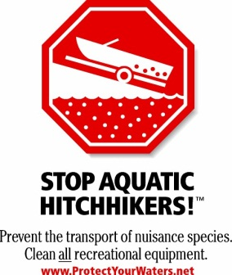
Unfortunately, some invasive species can harm Minnesota’s lakes, rivers, and forests. Aquatic invasive species such as Eurasian watermilfoil, zebra mussel, and spiny waterflea can harm fish habitats and disrupt water recreation activities. These plants, animals, and other unwanted species may “hitch a ride” in water, on boats, in firewood, or on other gear that people move into and around the state.

To help protect Minnesota’s precious water and woodlands and to comply with state law, please take the following precautions before you leave home to visit [insert name of resort or campground] and before transporting watercraft and firewood in the state.

Before traveling to Minnesota every boater must:
- Clean all aquatic plants, zebra mussels, and other prohibited invasive species from boats and trailers. You may not transport aquatic plants or prohibited invasive species in the state, even if they are dead.
- Drain water-related equipment (boat, ballast tanks, portable bait containers, and motor) and
drain bilge, livewell, and baitwell by removing drain plugs. Keep drain plugs out and
water-draining devices open while transporting watercraft. You may not transport water, or arrive at a water access with the drain plug in place, in Minnesota.
- Dispose of unwanted bait, including minnows, leeches, worms and fish parts in the trash. If you want to keep live bait, drain bait containers and refill with bottled or tap water. It is illegal in Minnesota to release bait in the water or to release worms on the ground.
Additional recommended precautions:
Some aquatic invasive species can survive more than two weeks out of water, and they are often small and difficult to see at the access. To remove or kill them, take one or more of the following precautions before moving boats and equipment to another water body, especially after leaving waters infested with zebra mussels or spiny waterfleas:
- Spray with high-pressure water
- Rinse with very hot water (at least 120 degrees F)
- Dry for at least 5 days

Burn local or certified firewood. Rather than bringing firewood to your campground or cabin, buy firewood at the campground or in the town you’ll be visiting. Check the label for “DNR Approved” or the state shield indicating the wood has been certified pest free by the Minnesota Department of Agriculture.

Clean mud, seeds, and plant parts from your OHVs, ATVs, bikes, boots, pets and camping gear before you transport your gear to prevent the spread of weeds and other invasive species.
We are looking forward to your visit. We are sharing this information to help you comply with Minnesota regulations and protect the lakes and forests you come to visit.

For more information, visit www.mndnr.gov/invasives.

[Owner/Manager]

