Humus Types

Three humus types, mor, moder, and mull form in upland forests under aerobic conditions.

Mor humus
A thick mat of undecomposed to partially decomposed litter that is not significantly incorporated into the mineral soil, present in coniferous forests. Decomposition is accomplished primarily by fungi. It is characterized by the presence of a thick litter (L)* layer with thin or no fermentation (F)* and humus (H) * layers. Mor humus is characteristic of the Fire-Dependent forest/Woodland System.

Moder humus
Undecomposed and partially decomposed remains of broad-leaved deciduous forest litter that is shallowly incorporated into the mineral soil. Decomposition is accomplished by bacteria and invertebrates. It is characterized by the presence of litter (L) *, fermentation (F) *, and humus (H) * layers. The humus layer gradually grades into the mineral topsoil. Moder humus is characteristic of the Mesic Hardwood Forest System without worms.

Mull humus
Well-decomposed organic matter that is mixed deeply into the mineral soil. It is characterized by the presence of a thin litter (L) * layer comprised only of remnants from the previous fall and a thick topsoil layer. In Minnesota this happens in two ways. In some deciduous forests, worms are responsible for mixing leaves and humus into the topsoil. In prairies and open wetlands, grasses and sedges produce copious amounts of roots which die and rot in place to create organic-rich topsoil.

Muck humus
Highly decomposed organic matter in which the original plant parts are not recognizable. It contains more mineral matter, is darker in color than peat, and is characterized by the presence of a thick humus (H)* layer. Muck is physically and chemically distinct from the humus of upland communities in its ability to absorb water, adsorb metals toxic to plants, and release nutrients. Muck humus is characteristic of the Wet Forest System where the hydrologic regime fluctuates annually between aerobic and anaerobic conditions.

* Footnote:
L, F, H are organic horizons with differing degrees of decomposition. They develop primarily from the accumulation of leaves, needles, twigs, and woody materials with or without a minor component of mosses. They are usually not saturated for prolonged periods.

L (litter): original vegetation structures (leaves, needles, twigs, etc) are easily discernible.
F (fermentation): some of the original structures are difficult to recognize.
H (humus): the original structures are indiscernible.
From: Field Manual for Describing Soils; Ontario Institute of Pedology, 1985
Three peat humus types sapric, hemic, and fibric form in wetlands with continuous water saturation. Organic matter (peat) accumulates because anaerobic conditions and low temperatures prevent decomposition.

Sapric Peat
The most decomposed class of peat characterized by less than 1/3 recognizable plant fibers (compare to hemic and fibric peat).

Hemic peat
A moderately decomposed class of peat characterized by 1/3 to 2/3 recognizable plant fibers (compare to sapric and fibric peat). The source of organic matter is mosses, sedges, or grasses.

Fibric peat
The least decomposed class of peat characterized by more than 2/3 recognizable plant fibers (compare to hemic and sapric peat). The source of organic matter is sphagnum moss and woody plant debris.

Adapted from:
Field Guide to the Native Plant Communities of Minnesota: The Laurentian Mixed Forest Province
Minnesota Department of Natural Resources, 2003

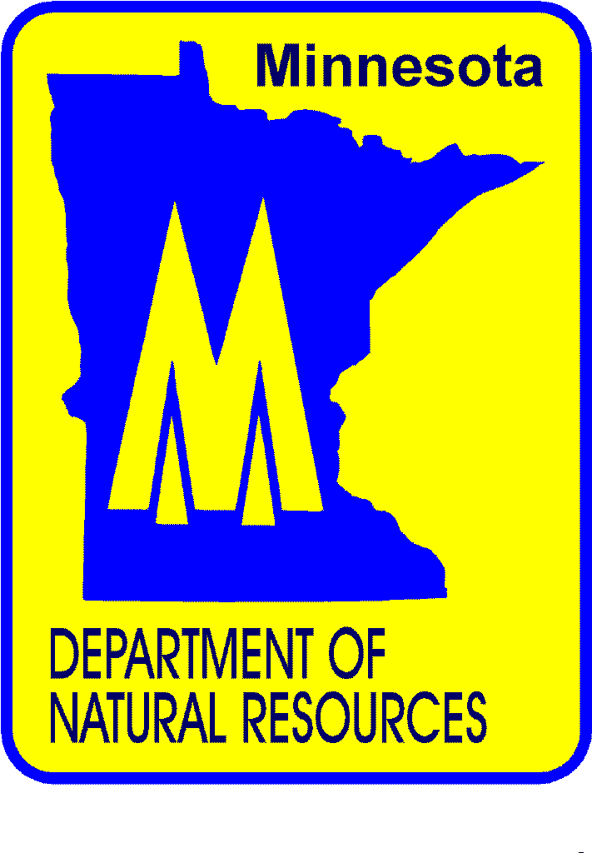
Ecological Land Classification Program
Division of Forestry
MN Department of Natural Resources
Version 1.0 - September, 2005

