
In accordance with Minnesota Statutes 626.553, the Commissioner of Natural Resources has prepared this report form. To comply with M.S. 626.553, officers investigating any accidental shooting or gunshot wound that was caused by an action connected with the activity of hunting or shooting, will complete this form. Information compiled from this form is used to curb and reduce accidental shootings and deaths. This report and supplemental investigative reports shall be mailed within 48 hours of the incident. Questions should be directed to the Education Coordinator at 1-800-366-8917.

Hunting FORWARD REPORT TO:
MN Department of Natural Resources Enforcement – Safety Training Section
15011 Hwy 115
Little Falls, MN 56345-4173
Self-Inflicted
Non-Hunting
Other

Department/Agency |  | Investigating Officer & Badge #
Address (Street, box #, City, State, Zip) |  | Telephone:  Email:
Date of Incident (mm/dd/yyyy) | Time of Incident (military) | Type of Casualty  Fatal Non-Fatal | County
Location of Incident  Private Land/waters  Public Land/waters | GPS Coordinates (If known)  Lat _______________________  Long ____________________________ | Dept./Agency ICR Number | Photos taken of:  Scene Victim Firearm
Shooter Information
Full Legal Name (Last, First, Middle) |  | Address (Street, box #, City, State, Zip) |  |  |  | Age
DL# | Date of Birth(mm/dd/yyyy)  / / |  | Years of Firearms experience |  | Gender  Male   Female
DNR Firearms Safety Certification  No      Yes - Year taken:_______________  Advanced Hunter Ed | Education Level  Did not graduate  GED/High School  College |  | Color of clothing worn (description)  Hat: ______________________ Coat/Vest: ___________________  Trousers: ______________________________  Examples: Blaze Orange/Blaze Orange-Camo/Camo/Drab/Red/Blue/Brown
Type of activity shooter was involved in:  Hunting Target Practice  Supervised Unsupervised  Sporting clays Skeet/trap  Training  Unknown  Other: _____________________ | Type of activity victim was involved in:  Hunting Target Practice  Supervised Unsupervised  Sporting clays Skeet/trap  Training  Unknown  Other: ________________________ |  |  | Incident involved Alcohol?  No  Yes  BAC: _________  Pending  Unknown | Incident involved Drugs?  No  Yes  Illegal drug  Type: __________________  Unknown
Firearm Information
Type of Firearm
Rim fire rifle Shotgun Handgun Center fire rifle Pellet/BB gun Inline Muzzleloader Side lock Muzzleloader Other:__________________

Action Type:
Bolt Lever Semi Auto Pump Revolver Slide Single Hinge Other :______________________

Brand/Make | Model | Serial Number |  | Caliber/Gauge
Ammunition was:  Factory Load  Reload  Unknown | Projectile type:  Shot Size: _________  Shotgun Slug  Bullet  Other:_______________  | Projectile is a:  Fine Shot:___________  Sabot  Other: ______________ | Safety position at the time of discharge was:  On  Off  Defective  Unknown

Victim Information
Full Legal Name (Last, First, Middle) |  | Address (Street, box #, City, State, Zip) |  |  |  | Age
DL# | Date of Birth (mm/dd/yyyy) / / |  | Years of Firearms experience |  | Gender  Male   Female
DNR Firearms Safety Certification  No  Yes - Year taken:___________  Advanced Hunter Ed | Education Level  None  GED/High School  College |  | Color of clothing worn (description)  Hat: ________________ Coat/Vest: _________________  Trousers: ___________________________________  Examples: Blaze Orange/Blaze Orange-Camo/Camo/Drab/Red/Blue/Brown
Victim was in:  Dense cover/vegetation  Wooded  Standing crop  Open field  Vehicle  Elevated Position  Ground Blind  Other: __________________ | Victim out of sight from shooter?  No   Yes  Unknown |  | Victim hospitalized as:  In- patient  Out-patient |  | Incident involved Drugs?  No Yes  Illegal drug  Type: ___________  Unknown
Incident involved Alcohol?
No Yes
BAC: ___________
Pending
Unknown
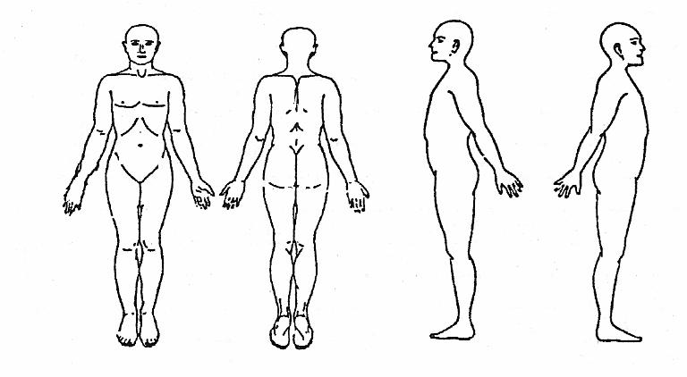  Front Back Left side Right side  Mark approximate entrance/exit wounds location(s) on the diagram. Include cuts, bruising, and amputation locations. Describe in victim injuries box. |  |  |  | Victim injuries (describe):
Incident Information
Weather:  Sunny Cloudy Rain Ice  Light Snow Heavy Snow Fog  Temperature (f): __________  Wind mph: _______________  Wind direction: _______________ |  | Type of Terrain:  Wooded Open field  Wetland Lake  Standing Crops Hillside  Other: _______________ | Distance shooter from Victim in yards:  1-5 6-9  10-15 16-20  21 or more: ______________
Light Conditions:  Dawn  Daylight  Dusk  Nighttime | Legal times:  Sunrise: ______________  Sunset: _______________  Sunrise/Sunset tables available in hunting regulations handbook | Incident occurred on:  Water – river, stream, lake, marsh  Road right-of-way  Railroad right-of-way  Other: __________ | Criminal Charges:  No  Yes  Unknown | Property damage:  No  Yes  Describe: _________

Hunting Information
Were they members of a hunting party?  Shooter  Yes No  Victim  Yes No | Members of same hunting party?  Yes  No | Number in party?  Shooter _______  Victim _______ | Animal hunted by shooter:  Deer Bear Moose Turkey  Grouse Pheasant Dove Waterfowl  Squirrel Rabbit Fox Raccoon  Crow Coyote Skunk Woodchuck  Other: ________________________
Contributing Factors
Most important contributing factor(s) - List most important factor as “1” in box and 2nd factor if present as “2”:

Victim moved in line of fire Drop firearm
Dog (foot/paw discharged firearm) Heart Failure
Careless/reckless handling of firearm Discharge firearm from in/on a vehicle
“Horse play” - Didn’t know it was loaded Removing firearm from or placing in vehicle
Failure to check beyond target Quick Draw
Victim covered by shooter swinging on game Riding in vehicle with loaded firearm
Improper crossing of obstacle with loaded firearm Clubbing game with firearm
Victim out of sight of shooter Cleaning firearm
Victim in line of fire Firearm fell from insecure rest
Loading firearm Fall from Elevated Stand
Failure to identify target (Mistaken for game) Ricochet
Unloading firearm Hypothermia
Shooter stumbled and fell Shooting across/from roadway
Defective firearm ammunition Obstruction of barrel
Run with loaded firearm Other:
Defective firearm Ascending Elevated stand - please complete page 4
Trigger caught on brush or other object Descending Elevated stand - please complete page 4
Improper ammunition used/wrong caliber or gauge

Describe incident in detail explaining cause: Incident Report attached

*Complete next page only if incident involved ELEVATED STAND
Elevated Stand Incident Only
Disregard this page if incident does not involve elevated stand

Incident Information
Fall while climbing into or out of elevated position (check all that apply):  Not applicable  Safety harness not in use  Lost balance of footing Slipped  Equipment failure Step Broke Ladder/climber failed  Other:_____________________________ |  |  | Fall while in stand (check all that apply):  Not applicable  Ascending Descending  Safety harness not in use  Moving/repositioning/loss balance Fell asleep  Stand component piece failure (See stand component failed section)  Other: _________________________________________
Type of Safety Harness worn (check all that apply):  Single Belt  Chest  Full body  None  Use of a haul line? No Yes | Approximate # of feet of fall:  1-5 6-9  10-15 16-20  21- 30  31or more: ___________________ |  |  | Harness Failure (check all that apply):  Not applicable  Malfunction of buckle/strap  Improper fit/size Directions not followed  Stitching/material broke Frayed  Other:________________________________

Type of Elevated Stand
Elevated stand type (check all that apply):  Manufactured tripod  Brand/model: _______________________  Manufactured climbing  Brand/model: _______________________  Manufactured lock on (chain or fabric strap anchors)  Brand/model: _______________________  Homemade climbing  Homemade lock on  Lock on  Tripod  Metal Wood Plastic |  | Elevated stand type (check all that apply):  Manufactured ladder  Brand/model: ___________________  Homemade ladder  Metal Plastic Wood  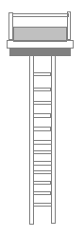  Ladder Stand |  |  | Elevated stand type (check all that apply):  Manufactured Permanent  Brand/model: ________________________  Homemade permanent  Wood Metal Plastic  Built on tree Platform Enclosed (4 sided)  Built on independent structure/tripod  Other:_______________________________  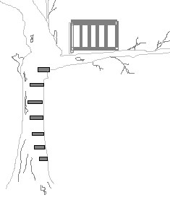  Permanent type
Stand component failed due to:  Metal Fatigue/bent  Fastener(s) broke/pulled out  Wood decayed  Other:________________________________  Attachment straps failed:  Yes No |  | Stand component failed due to:  Metal Fatigue/bent  Fastener(s) broke/pulled out  Wood decayed  Other:__________________________  Attachment straps failed:  Yes No |  |  | Stand component failed due to: Wood decayed  Fasteners broke/pulled out  Wood broke on platform/rails  Wood broke on steps  Improper construction  Other:________________________________
Other related equipment/component failure:

