Sample Workshop Agenda

Workshop Title

Date, Location, Start/End times

Workshop goals (list 1-3): At the end of this workshop, participants will…
 | header
Arrival time | Sign in, make a name tag, get tea/coffee, pick up agenda/handouts.
Beginning | State workshop goals.  State logistics (break, lunch, dismissal time, when you plan to go outside, what to bring outside, bathrooms)  Allow time for short introductions/icebreaker, esp. if participants don’t know each other.
Workshop time | * Give out activity guides  Show how to use the guides  * Login with YOUR www.plt.org/login account and show dashboard, free curriculum, resources.  * Have everyone create an account on www.plt.org/login  - Have each person write their username/password in their books.  - Have each person go to their dashboard and enter “Workshop Participation Information” for National PLT.  * Do activities. Choose activities based on your audience composition and needs. After each activity, lead a short discussion on how participants might use or adapt the lesson with their students.  - Plan for bathroom breaks (at least 1 every 2-3 hours)  - Plan for transition time to go outside  * Absorption time: Educators appreciate time to reflect, search through the guide, and integrate activities into their curricula.  * Show other resources (e.g. DNR posters, books, etc.)  * Present in-depth information on a natural resource topic with guest speaker (optional)

Lunch
Workshop time | Continue from above
Wrap-up | Summarize all the lessons you did today/ask for overall feedback.  Have participants fill out the PLT Workshop Participation Information form from their PLT login account.  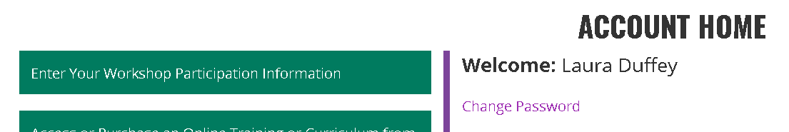  Evaluation forms Give participants at least 5 minutes of reflective time. Collect forms BEFORE handing out CEU certificates.
Your contact information here www.mndnr.gov/plt

