Minnesota

Snowmobile Trails Assistance Program

CAPITAL IMPROVEMENT MANUAL

Minnesota Department of Natural Resources



I. Introduction

A. Definitions Page 3
B. Trails and Waterways Regional and Area Boundaries Map Page 4
C. Program Summary Page 5
D. Responsibilities and Roles of Stakeholders Page 6

II. aPPLICATION PROCESS AND PROGRAM PROCEDURES
A. Eligibility Guidelines Page 7
B. Environmental Review Considerations Page 8
C. Procedures Page 8
D. Project Priorities Page 10
E. Selection Process Page 10

III. FINANCIAL MANAGEMENT
A. Allowable Costs and Charges Page 11
B. Reimbursement Procedure Page 14
C. Accounting and Audit Page 15

IV. Program Forms
A. Description of Forms Page 16
Capital Improvement Application Page 17
Sample Agreement Between Sponsor and State Page 19
Request for Reimbursement Page 20
Sample Work Log Page 24
Sample Trail Permit Page 25
Elements of a Sponsor Resolution Page 26

Appendix A: Elements of a Successful Trail Page 27
Appendix B: Trail Planning, Design, and Development Guidelines Page 31
APPENDIX C: Federal Recreational Trail Program Page 39
Appendix D: DNR GIA Trail Proposal Review Process Page 10
Appendix E: Minnesota Environmental Quality Board
Rules Relating to Trails Page 41

A. DEFINITIONS

AUTHORIZED REPRESENTATIVE - Person responsible for the administration of the contract for either the Sponsor or the Department of Natural Resources.

GROOMING - Snow grooming is the process of loosening or breaking up heavily compacted or icy snow and placing the snow back down in an equally compacted smooth condition.

CAPITAL IMPROVEMENT - Capital improvements as they relates to the Minnesota Snowmobile Trails Assistance Program are infrastructure developments, acquisitions, or repairs of a Snowmobile Grant-in-Aid Trail that is above and beyond the responsibilities to maintain that trail as defined by the terms of the established Maintenance and Grooming grant. These responsibilities are defined in the Snowmobile Trails Assistance Program Maintenance and Grooming Manual.

LOCAL UNIT OF GOVERNMENT (LUG) - The political subdivision that has agreed to work with the snowmobile club in the development and maintenance of a trail. This can be a county, city, township, or village.

RESOLUTION - Official record of the LUG where they agree to sponsor a snowmobile or trail club and/or trail, certify that the various benchmarks have been met, and administer the grant from the DNR.

SNOWMOBILE CLUB -A formal organization that has contracted with a LUG to maintain and operate a local snowmobile trail.

SPONSOR - The local unit of government that has agreed to work with the snowmobile club.

SUFFICIENT RECORDS: Records that are necessary to verify that the club and sponsor have completed certain benchmarks. These will include at a minimum:
- Invoices of repairs/significant expenditures;
- Liability insurance evidence (as required);
- Log of volunteers and man-hours spent on the various trail activities. This log should include date, number of people working on the trail, number of hours, equipment used, type of work done, and section of trail worked on; (an example is included in the Program Forms Sectiion) signed by a club representative;

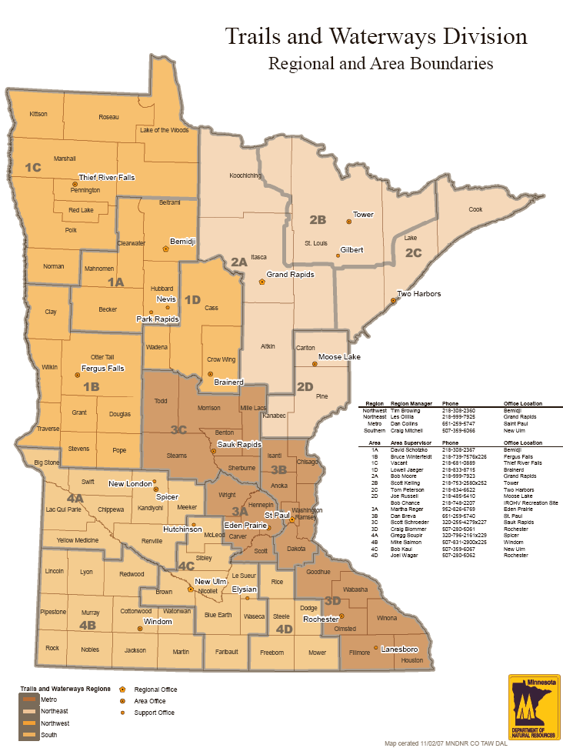

C. PROGRAM SUMMARY

PROGRAM BACKGROUND

In 1973 the Minnesota Legislature delegated the responsibility of administering a cost-sharing program for the development and maintenance of snowmobile trails to the Department of Natural Resources (DNR). The goal of this program was the creation and maintenance of locally initiated trails that were financially assisted by the state. This program was named the "Minnesota Trails Assistance Program," and is popularly known as the grants-in-aid program or simply the GIA program. The DNR has been delegated the responsibility of administering the funds appropriated by the legislature for the GIA program. The Legislature has subsequently provided programs to cover cross-country skiing, off-highway 4x4 trucks, off-road motorcycles, and all- terrain vehicles.
The DNR central office in Saint Paul sets program policy and guidelines, budgets for program funding and provides for auditing of grants. Department of Natural Resources Regional Trails and Waterways Managers and Area Trails and Waterways Supervisors are responsible for reviewing and processing necessary program forms, providing technical assistance when requested, monitoring trails for actual performance of disbursed activities, and conducting informational meetings with local organizations. The Area Trails and Waterways Supervisors are the main contact for local organizations.

CAPITAL IMPROVEMENTS AND DEVELOPMENT OF GRANT-IN-AID TRAILS

While the majority of grant-in-aid funding is dedicated to maintaining the existing GIA Trails throughout Minnesota, grants-in-aid for capital improvements and development are also available. These grants are reimbursement based where eligible costs are matched at up to 65 percent. The application deadline for improvement grants is February 28. A guideline for project eligibility is that the total cost of the project should be approximately 20 percent or more of the existing maintenance and grooming grant. See eligibility section for more information.

D. RESPONSIBILITIES AND ROLES OF STAKEHOLDERS

Snowmobile Clubs:
- Secure a local unit of government as a sponsor.
- Enter into an agreement with the sponsor to physically perform the development work identified in the application.
- Complete tasks in a timely way and submit documentation to the sponsor as required for them to be reimbursed for development activities.
- Maintain sufficient records as defined under the Definition of Terms within this instruction Manual to satisfy the auditing needs of the trail sponsor and DNR.
- Adhere to the guidelines contained in this instruction manual.
- The Department of Natural Resources very strongly recommends that clubs partially shield their volunteers from the consequences of injury by securing appropriate insurance coverage. Obtain sufficient insurance if necessary and required by the sponsor to protect the interests of the club as well as the local unit of government sponsor.
- Obtain sufficient permission from each landowner on which the snowmobile trail is located.
- Clubs may incorporate to protect themselves further.

Local Unit of Government/Sponsor:
- Pass a resolution to serve as the sponsor and submit that to the DNR along with the application form.
- Be responsible for certifying to the DNR completion of the approved capital improvements necessary to initiate payments and provide a quality snowmobile trail.
- Work with DNR to verify that the local club is adhering to the various guidelines contained in this instruction manual.
- The DNR strongly urges the sponsors to similarly enter into contracts with their snowmobile clubs. These contracts will provide your unit of government with safeguards in the event that monies will have to be reclaimed by the State.

State/Department of Natural Resources:
- Initiate application process and respond to submitted applications
- Provide the Grant Agreement for the sponsoring local unit of government.
- Disburse funds for development upon receipt of appropriate reimbursement requests from the sponsor.
- Conduct random program and fiscal reviews to evaluate performance in coordination with sponsors and clubs and to evaluate appropriate accounting procedures and compile needed information for future statewide or system-wide audits (see page 9).

A. ELIGIBLITY GUIDELINES

Eligible projects for the capital improvement program must be above and beyond the responsibilities of the existing maintenance and grooming grant. A project that meets this criterion is generally defined as having a total cost of approximately 20 percent or more of the existing maintenance and grooming grant. Capital improvement grants include the following types of projects:

- Major Reroute Projects
  - Major reroutes includes rerouting an existing trail to preserve trail continuity.
  - Major reroute projects are generally a result of the following:
    - Landowner permission changes
    - Development issues on the trails existing corridor area
    - Safety issues

- Major Rehabilitation Projects
  - Emergency Rehabilitation: rehabilitation needs resulting from unforeseen events that disrupt the continuity of an existing trail. Emergency grants may be awarded at any time throughout the year depending on need. Emergency grants are generally a result of the following events:
    - Storms
    - Washouts
    - Blow downs
    - Unexpected effects on an existing trail
  - Major Rehabilitation: major rehabilitation projects are generally a result of the need to do the following:
    - Improve trail safety
    - Widen trails
    - Improve trail surface
    - Improve trailhead facilities

- Bridge Projects
  - New placement of a bridge on an existing trail that currently has no existing bridge.
  - Replacement of a bridge because of deficiencies.

- Acquisition Projects
  - Acquisition projects are proposals to acquire existing trail routes.
  - Acquisition projects may also include proposals to acquire new trails and/or facilities.

- New Development and Additions to the GIA System
  - New development projects include projects to add new or existing trails or facilities to the GIA system, including alignments.
  - The DNR annually determines if new development projects will be funded. The eligibility of new development projects will be officially communicated through a formal letter and posted on the Snowmobile GIA website.
B. ENVIRONMENTAL REVIEW CONSIDERATIONS

Many new development projects and some trail relocation initiatives will require some level of environmental review. Sponsors and related clubs should work with Trails and Waterways Area Supervisors on determining which requirements they will need to address as they move forward with their projects. Attached as Appendix E are the rules adopted by the Environmental Quality Board relating to recreational trail development. These rules outline the requirements and exemptions relating to whether or not an environmental review may or may not be needed. Also attached as Appendix D, is the process and general timeline in which the DNR conducts these environmental reviews.

C. PROCEDURES

You must adhere to the following procedures if you are applying for Minnesota Cross-Country Ski Trails Assistance Program funding on a trail system that is presently enrolled within the grant-in-aid trail system.

NOTE: UNDER NO CONDITION CAN CONSTRUCTION TAKE PLACE ON ANY PARCEL OF LAND, PRIVATE OR PUBLIC, UNLESS A SIGNED PERMIT HAS BEEN SECURED IN THE NAME OF THE SPONSOR.

The Minnesota Trails Assistance Application projects must comply with the following procedures:

- Trail user organizations/clubs must submit application forms to the sponsor.
a. One (1) copy with original signatures.
b. One (1) copy trail validation map of the existing trail system and proposed development (assistance provided by DNR). The map must identify the following:
- Where new bridges, rest areas and parking lots are located or will be located
- Where new connections or relationships to other trails, if any
- Minor and major relocation areas showing old and new alignments

2. The sponsor will submit the above items, along with a supporting resolution, to the DNR Area Trails and Waterways Supervisor for review.

Application forms must be received by February 28. Projects may require an environmental review. Please see Appendices C and D for environmental review information.

3. Upon approval of the application, the Area Trails and Waterways Supervisor will submit a contract agreement to the sponsor. The sponsor will then process four (4) copies of the contract agreement with original signatures on each copy and return all copies to the Area Trails and Waterways Supervisor.

4. The DNR will notify the sponsor, in writing that the agreement has been executed.

NOTE: Do not begin any work on your capital improvement project that you expect reimbursement until your area supervisor has notified you to do so and you have a fully signed contract with the State of Minnesota in front of you.

5. Timetable: The schedule set below is designed to help all parties involved in the program in planning trail work and setting up funds so work can proceed.

A. Application: These forms must be received by the DNR regional office by February 28.

B. Requests for Reimbursement:

i. Requests for Reimbursement for summer and fall construction or maintenance are due no later than December 31.
ii. Subsequent Requests for Reimbursement may be submitted monthly by the calendar months.
iii. ALL Requests for Reimbursement must be received by the DNR no later than May 30 for that year's work.
iv. Payment of Requests for Reimbursement: If Requests for Reimbursement are executed properly and all necessary signatures and invoices are included in the request, the DNR will pay the requests. Requests submitted improperly will be returned for proper execution.

D. PROJECT PRIORITIES

The first priority for funding any grant-in-aid will be maintaining existing trails that are receiving acceptable use and do not require rerouting. The following order of priorities is used in determining funding of a capital improvement project.

- Major Reroute Projects

- Major Rehabilitation Projects

- Bridge Projects

- Acquisition Projects

- New Development and Additions to the GIA System

  - To ensure a fair statewide distribution of grants, regional factors will be considered in funding new development. These factors include existing use per mile of trail, existing trail mileage, ability to hold snow, and tourism considerations.

  - The DNR annually determines if acquisition and/or development will be funded. The eligibility of new development will be officially communicated through a formal letter and posted on the Snowmobile Grant-in-Aid website.

E. SELECTION PROCESS

Capital Improvement Project Applications are submitted to Trails and Waterways Area/Region officials. The following outlines the process for selecting and approving capital improvement grants-in-aid.

- Trails and Waterways Area/Region staff identify regional priority projects. Those that meet the above priorities and also meet regional priorities are recommended for funding to the DNR Central Office.

- The DNR Central Office review Trails and Waterways Area/Region recommendations and then approve or deny the requests for project funding based on the above priorities, statewide distribution, and funding availability.

A. ALLOWABLE COSTS AND CHARGES

Allowable Charges

All the charges listed below must be directly related to the acquisition, rehabilitation, and development of the GIA trail system outlined in the application. No other charges will be accepted without prior approval from your Area Trails and Waterways Supervisor.

Administration Charges (65% Reimbursable)
(No More Than 15 Percent Of Total Grant)

1. Mileage and Labor: These charges may be reimbursed for preparing the paperwork and forms for the program, bookkeeping, paying invoices, attending necessary county board or DNR meetings, and obtaining bids for equipment rentals.

2. Stamps: The cost of mailing necessary DNR forms, billings, bid requests, or maps. It is suggested that a list of mailings and materials mailed be kept on file.

3. Telephone Calls: Long distance calls directly related to trail administration to vendors, the sponsoring agency, landowners, and the DNR will be accepted. It is suggested that a list of calls be kept on file.

4. Office Supplies: The purchase of materials needed to fulfill the programs administration such as writing, typing, and copying materials are acceptable. Office space rental is not an acceptable charge.

5. Maps Used to Administer Grants: The cost of county maps that are to be submitted to the DNR as required by the program are reimbursable.

6. Meeting: The DNR allows charges for essential personnel to attend meetings directly related to the program. The general rule will be not more than four (4) people for a trail committee meeting and not more than two (2) people for a governmental meeting. Club meetings are not acceptable as chargeable meetings. Rental of meeting rooms is not an acceptable charge.

7. Computer Time: The cost of using computers shall be reimbursed as part of the administrative portion of the grant. The origin of cost, such as number of hours, or equipment rental, or materials (such as floppy disks) should be described on the worksheet. The Allowable Cost for figuring reimbursement shall be $7.80 per hour (65% reimbursable).

Land Acquisition Charges (65% Reimbursable)

1. Mileage and Labor: These charges are acceptable for alignment work, checking ownership records, and landowner contacts.

2. Maps: The cost of securing maps necessary for aligning trail routes is reimbursable. County highway maps and topographic maps are acceptable -- aerial photography maps should receive DNR approval since costs can be extremely high.

3. Permits and Easements: The program has done extremely well to date with landowner cooperation and low permit or easement costs. Costs incurred are reimbursable.

Development And Charges (65% reimbursable)

1. Mileage and Labor: These charges are reimbursable for construction and rehabilitation of the trail system. A worksheet must be filled out for reimbursement identifying hours and dates work was performed.

2. Equipment Rentals:
A. Heavy equipment work is reimbursable as needed for construction. The operator or vendor of the heavy equipment must be identified and an invoice submitted to the DNR for payment.
B. Bids: When equipment cannot be rented at the allowable costs, bids must be let to secure the necessary equipment. Three (3) hourly bids must be secured from vendors in your area. If three (3) bids cannot be secured, list the vendors contacted, date contacted, and vendor's response. When the bids have been secured, the Area TAW Supervisor must be contacted and approve the bids. After approval, the equipment can be hired. The bids are then submitted with the Request for Reimbursement. NOTE: Before any equipment rental or work is done, the rental costs must be within the allowable limits. If these limits cannot be met, bid procedures must be strictly adhered to or the billing will not be processed.
C. Hand power equipment rental is reimbursable. The operator or owner of the equipment must be identified on the worksheet for payment.

3. Material: Charges may be submitted for materials used directly on the trail system. Materials may include, but are not limited to lumber, paint, signs, gates, posts, fencing, culverts, fill, grass seed, bolts or other hardware, etc. If you have a question on any materials, it is best to contact your Area TAW Supervisor.

4. Contracted Work: Work that is contracted to complete the development work is reimbursable subject to going through the proper bidding procedure. In addition, all bidding most also follow regular standards established by the Sponsor.

Allowable Costs
(65% Reimbursable)
Total Cost
Labor $ 14.00/hour
Computer $ 11.00/hour
Mileage
Snowmobile/ATV/Motorcycle $ .45/mile
Car $ .45/mile
Pickup $ .55/mile
4x4 $ .60/mile
1 - 2 ton $ .80/mile
2 ½ ton & up $ 1.00/mile
Semi-Tractor/ trailer $ 1.40/mile
Power Tools
Chainsaws $ 6.80/hour
Brushsaw $ 7.20/hour
Post Hole Digger $ 6.10/hour
Equipment (Includes Gas, Oil, & Operator)
ATV 6X6, Mule, Ranger, etc. $20.00/hour
Bobcat $46.00/hour
Small Tractor (less than 25hp) $24.00/hour
Tractor (25hp to 70hp) $49.00/hour
Tractor (70+hp) $62.00/hour
Attachments (additional per hour)
Disc $ 6.80/hour
Flail Mower (brush cutter) $ 11.00/hour
Other Equipment (Includes Gas, Oil, & Operator)
Other Power-Take Off Equip. $ 24.00/hour
Backhoe $ 60.00/hour
Skidder $ 60.00/hour
JD-350 $ 60.00/hour
JD-450, JD-8, D-3 Cat $ 76.00/hour
JD-670 Grader $ 82.00/hour
JD-644 Frontend Loader $ 82.00/hour
D-4, JD-550 $ 82.00/hour
D-6, JD-850 $108.00/hour
D-7, D-8 $138.00/hour
Stump Grinder under 40hp $ 54.00/hour
Stump Grinder over 40hp $ 68.00/hour
Hydro Ax $138.00/hour
Hydraulic Excavator $108.00/hour
Brush Cutter $ 54.00/hour
Power Generator $ 20.00/hour
Backhoe Equal 915 Caterpillar $ 116.00/hour
ASV Posi-Trac $ 52.00/hour
(Reimbursement Rates Updated on 8/10/2006)
B. REIMBURSEMENT PROCEDURE

The Reimbursement Form found later in this manual is to be submitted to your Trails and Waterways Area Supervisor from the Sponsor. The Area Supervisor will review and then approve the payment/invoices based on allowable costs and charges referenced above. Trails and Waterways Area/Region offices process and approve all payments and charges defined as eligible by this manual. Only costs accrued after a fully executed agreement between the State of Minnesota and the Local Unit of Government is in place are eligible for reimbursement.

Reimbursement Instructions
The Request for Reimbursement Form must be used to summarize the invoices and costs. Use the Worksheet Form to document the following:
1. Date the work was done.
2. Operator’s or volunteer’s name.
3. Number of hours of labor time.
4. Rate per hour (taken from Allowable Costs page).
5. Total cost of labor (multiply #3 X #4).
6. Name the mode of transportation used (pickup, ATV, etc.) If different types of modes of transportation are used, use a separate line for each type (e.g., pickup truck on one line, ATV the next line).
7. Number of miles being claimed.
8. Rate per mile (taken from Allowable Costs page).
9. Total cost of transportation (multiply #7 X #8).
10. Name of types of heavy equipment or power equipment used. Include make and model for heavy equipment. Use one line for each piece of equipment being used (e.g., bulldozer on one line, backhoe the next line, etc.) See NOTE section below for instructions for entering INVOICES for purchased goods or services.
11. Numbers of hours equipment used.
12. Rate per hour (taken from Allowable Costs page).
13. Total cost of equipment used (multiply #11 X #12).
14. Total Cost (add #5+#9+#13).
15. Fill in the type of work done and the location.
16. Fill in the Expenditure Type (Adm = Administration; Acq = Acquisition; Con = Trail Construction; Reloc = Trail Relocation; Fac = Trail Facilities).
17. Add all costs in boxes #5 to get Grand Total Labor Costs.
18. Add all costs in boxes #9 to get Grand Total Transportation Costs.
19. Add all costs in boxes #13 to get Grand Total Other Equipment Costs.
20. Grand Total for this page (add #17+#18+#19).
21. Trails Administrator’s Signature.
22. Date the worksheet was completed.
Entering Invoices for Purchased Goods/Services Over $100
All Requests For Reimbursement for purchased goods or services over $100 must be accompanied by an invoice. When invoices for purchased goods and services are included please enter:
- “Invoice” and the Invoice Number in Operator’s Name column (#2);
- the invoice amount in the Total Cost Column (#14);
- the explanation for the expense in the Type of Work and Location column (#15); and
- complete Expenditure Type column (#16)

C. ACCOUNTING AND AUDIT
The Sponsor shall maintain books, records, documents, and other evidence relevant to this grant and in such detail that will accurately document all project costs for which payment have been received. The Sponsor shall use generally accepted accounting principles and these records shall be retained for six years after this grant terminates. The State, its representative or the legislative auditor shall have the right to examine this evidence and the Sponsor shall make them available at the office at all reasonable times during the record retention period. Records shall be sufficient, as defined in the Manual to reflect significant costs incurred and volunteer donation of time, equipment, and/or materials in performance of this grant.

A. DESCRIPTION OF FORMS

The following forms have been included to identify the basic paperwork necessary for the Trails Assistance Program. See the DNR’s website at www.dnr.state.mn.us/grants/recreation/gia_snowmobile.html

- Capital Improvement Project Application: This form is the formal application from the Sponsor to the State of Minnesota for the development project.

- Sample Agreement Between Sponsor and State: This form is the formal grant agreement between the local government sponsor and the State/DNR.

- Request for Reimbursement: This form is to be used to request reimbursement for allowable costs related to the development project as outlined in the application.

- Operator’s Work Log: This form should be used to itemize costs and should accompany the Request for Reimbursement.

- Sample Landowner Permission Form: This form is designed to help clubs to obtain private landowner permission for trails.

- Elements of a Sponsor Resolution: This is an explanation of the information a correct Sponsor resolution should contain.

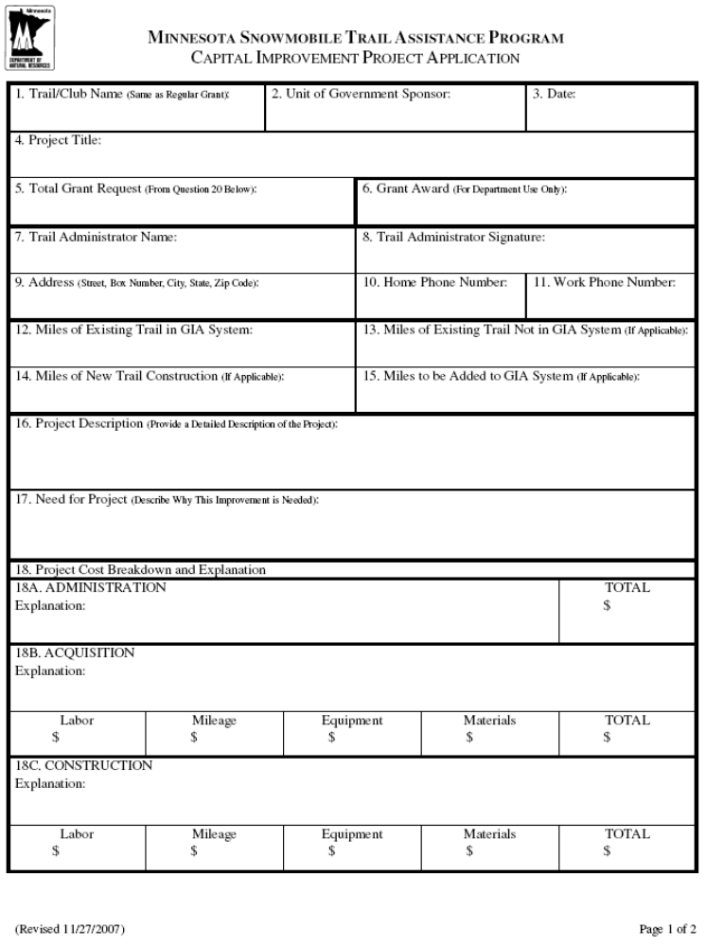
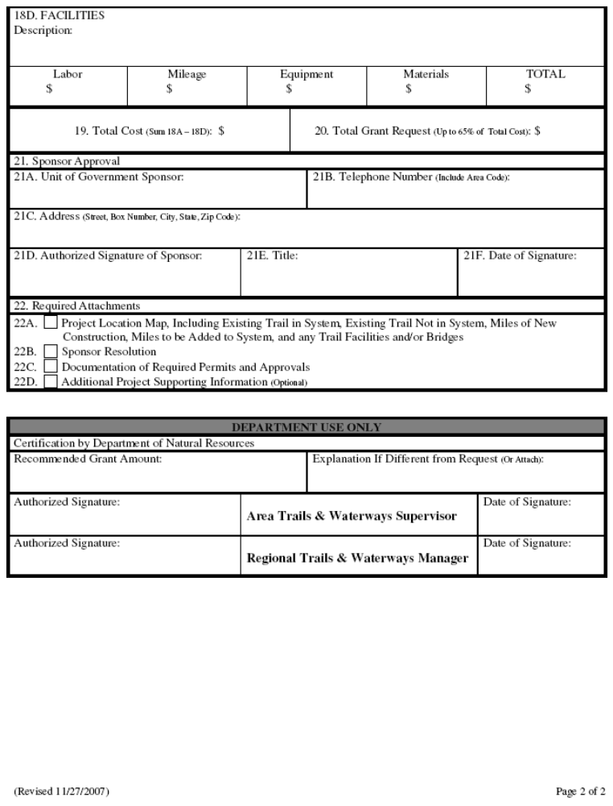
Minnesota Snowmobile Trail Assistance Program
FY 2009 Capital Improvement

Grant Agreement

Local Unit of Government (Sponsor) | Trail/Club Name | Grant Amount

THIS AGREEMENT, is made between the STATE OF MINNESOTA, acting through the Commissioner of Natural Resources, hereinafter referred to as the “State”, and the sponsoring Local Unit of Government specified above, and relates to the establishment of proposed trails specified above.

WHEREAS, the local unit of government desires to establish, construct and rehabilitate public trails; and

WHEREAS, the Minnesota Trails Assistance Program provides grants to local units of government for the construction of recreational trails pursuant to Minnesota Statutes, Chapter 84.83; and
WHEREAS, the local unit of government has applied to the State for a grant for said trails and has submitted the Minnesota Trails Assistance Program’s application form, maps, and resolution of the local unit of government authorizing the proposed trails as outlined in said documents; and said application form, resolution, map or capital improvement proposal are attached hereto as Exhibit “A”.

NOW THEREFORE, it is agreed between the parties as follows:

A. TRAIL OBLIGATION OF THE SPONSOR. The Sponsor agrees to maintain the proposed trails in accordance with the guidelines contained within the current Minnesota Snowmobile Trails Assistance Program Capital Improvement Manual, hereinafter referred to as the "Manual" as accepted or amended by the State. All work will be the responsibility of the Sponsor, it’s employees, or the sponsor’s agent provided the agent is registered as a nonprofit corporation with the State of Minnesota. The Sponsor shall:

1. Proceed to acquire necessary interests in lands on the Trail. The Sponsor must acquire land in fee, easement, lease, permit, or other authorization for said Trail. The term of said interest shall be no less than four (4) months between November 15 of any year and April 1 of the succeeding year. For each parcel of land crossed by the Trail, the Sponsor shall obtain from the owner of said parcel a permit, lease, easement, deed, or other authorization for said crossing in accordance with Minnesota Statutes Chapter 604A. The Sponsor shall certify that the necessary interests in the land have been obtained and are on file with the Sponsor or the sponsor’s agent.

2. Construct, establish, and rehabilitate the trails as outlined in Exhibit A. If the local unit of government fails to expedite establishment and construction of trails, the State may withhold future payments to the local unit of government and/or terminate this agreement.
B. TECHNICAL ASSISTANCE. The State shall give technical assistance to the local unit of government in establishing trails upon request.
C. FUNDING. The state’s sole responsibility under this Agreement is to provide funds to the local unit of government. In the event that state funds become unavailable because of legislative or executive action or restraints the grant amount may be reduced or canceled by the State.

D. REIMBURSEMENT. The state agrees to reimburse the local unit of government 65 percent of the cost of trail acquisition, development, and other capital improvements. All costs shall be in accordance with the allowable charges and costs listed in the Manual. This grant shall not exceed the State Cost as specified above.
E. PAYMENT. The local unit of government must submit a request for reimbursement and attach worksheets furnished by the State for all costs incurred in acquiring, and developing the trail, all in accordance with the Manual. Additionally, the local unit of government must submit original receipts of actual purchases exceeding $100.00. Further, the first request for reimbursement for costs incurred by grooming must be made by January 31, and the last day of every month thereafter while costs are incurred during the grooming season.

1. First Payment: Upon receipt of the request for reimbursement evidencing acceptable trail costs of $500.00 or more for acquisition or development the State agrees to reimburse the local unit of government for approved costs in accordance with the Manual. The State shall not be required to pay for any services provided by the local unit of government which the State determines to be unsatisfactory as determined by the State’s authorized representative.
2. Subsequent Payments: Each thirty (30) successive days after the first payment, the local unit of government may submit invoices evidencing trail costs. Payments shall be made to the extent of authorized reimbursement, or until this agreement is terminated.
3. Trail Segments: It is understood that if the trail system is developed in segments, the local unit of government may submit requests for reimbursement as soon as continuous and workable segments are completed.

F. STATE AUDITS. Under Minnesota Statutes § 16C.05, subd. 5, the Grantee’s books, records, documents, and accounting procedures and practices relevant to this grant contract are subject to examination by the State and/or the State Auditor or Legislative Auditor, as appropriate, for a minimum of six years from the end of this grant contract. Records shall be sufficient, as defined in the Manual to reflect significant costs incurred and volunteer donation of time, equipment, and/or materials in performance of this grant.

G. WORKERS COMPENSATION. The Grantee certifies that it is in compliance with Minnesota Statutes § 176.181, subd. 2, pertaining to workers' compensation insurance coverage. The Grantee's employees and agents will not be considered State employees. Any claims that may arise under the Minnesota Workers' Compensation Act on behalf of these employees and any claims made by any third party as a consequence of any act or omission on the part of these employees are in no way the State's obligation or responsibility.

H. LIABILITY. Each party agrees that it will be responsible for its own acts and the results thereof to the extent authorized by law and shall not be responsible for the acts of the other party and the results thereof. The State’s liability shall be governed by the provisions of the Minnesota Tort Claims Act, Minnesota Statutes § 3.736 and other applicable law. The Sponsor’s liability shall be governed by the provisions of Minnesota political Subdivisions Tort Liability, Minnesota Statutes § 466.02 and other applicable law.
I. TERM.
I.1 Effective date: (INSERT DATE HERE), or the date the State obtains all required signatures under Minnesota Statutes Section 16C.05, subdivision 2, whichever is later. The Grantee must not begin work under this grant contract until this contract is fully executed and the Grantee has been notified by the State’s Authorized Representative to begin the work.
I.2 Expiration date: June 30, 2009, or until all obligations have been satisfactorily fulfilled, whichever is sooner.
J. TERMINATION. This Agreement may be terminated by the State in the event of a default by the Sponsor, the legislature appropriates insufficient monies for the program, or the abandonment of the Trail. It may also be terminated upon mutual agreement by the State and the Sponsor.

K. PUBLICITY AND ENDORSEMENT. Publicity: Any publicity regarding the subject matter of this grant contract must identify the State as the sponsoring agency and must not be released without prior written approval from the State's Authorized Representative. For purposes of this provision, publicity includes notices, informational pamphlets, press releases, research, reports, signs, and similar public notices prepared by or for the Grantee individually or jointly with others, or any subcontractors, with respect to the program, publications, or services provided resulting from this grant contract.
Endorsement: The Grantee must not claim that the State endorses its products or services.

L. ASSIGNMENT OR MODIFICATION. The Sponsor may not assign any of its rights or obligations under this Agreement without the prior written consent of the State. No change or modification of the terms or provisions of this Agreement shall be binding unless such change or modification is in writing and signed by all parties on this Agreement.

M. DATA DISCLOSURE. Under Minnesota Statutes § 270.66, and other applicable law, the Grantee consents to disclosure of its social security number, federal employer tax identification number, and/or Minnesota tax identification number, already provided to the State, to federal and state tax agencies and state personnel involved in the payment of state obligations. These identification numbers may be used in the enforcement of federal and state tax laws which could result in action requiring the Grantee to file state tax returns and pay delinquent state tax liabilities, if any.

N. GOVERNING LAW, JURISDICTION, AND VENUE. Minnesota law, without regard to its choice-of-law provisions, governs this grant contract. Venue for all legal proceedings out of this grant contract, or its breach, must be in the appropriate state or federal court with competent jurisdiction in Ramsey County, Minnesota.

O. AUTHORIZED REPRESENTATIVE. The authorized representative of the sponsor is prohibited from being an officer or bookkeeper/accountant of the club or organization receiving this grant on behalf of the State.

IN WITNESS WHEREOF, the parties hereto have executed this Agreement.
LOCAL UNIT OF GOVERNMENT
(County) (City) (Village) (Town)

Authorized Representative Signature | Title | Date
Authorized Representative Signature | Title | Date

DEPARTMENT OF NATURAL RESOURCES
Individual certifies that funds have been encumbered as required by M.S. § 16A.15 and 16C.05. | State Encumbrance Verification  CFMS #: | Date
Signature (Recommend for Approval) | Trails and Waterways Regional Manager | Date
Authorized Signature | Trails and Waterways Division Director | Date

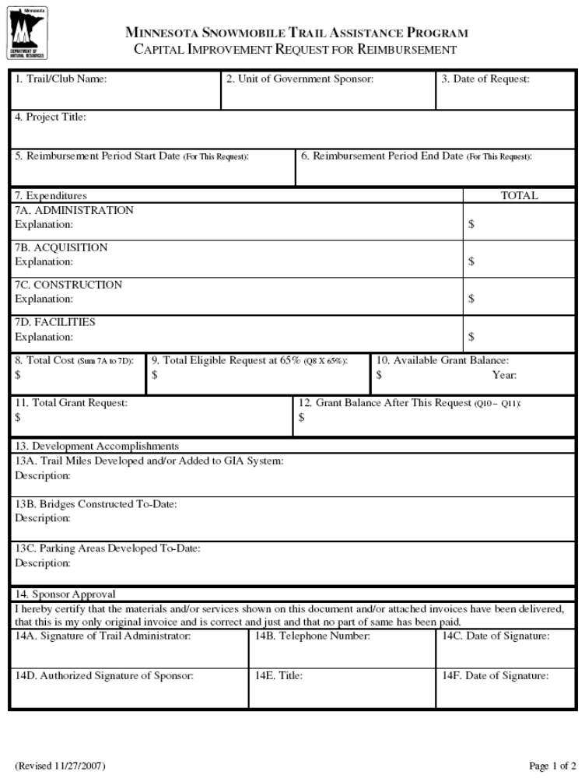
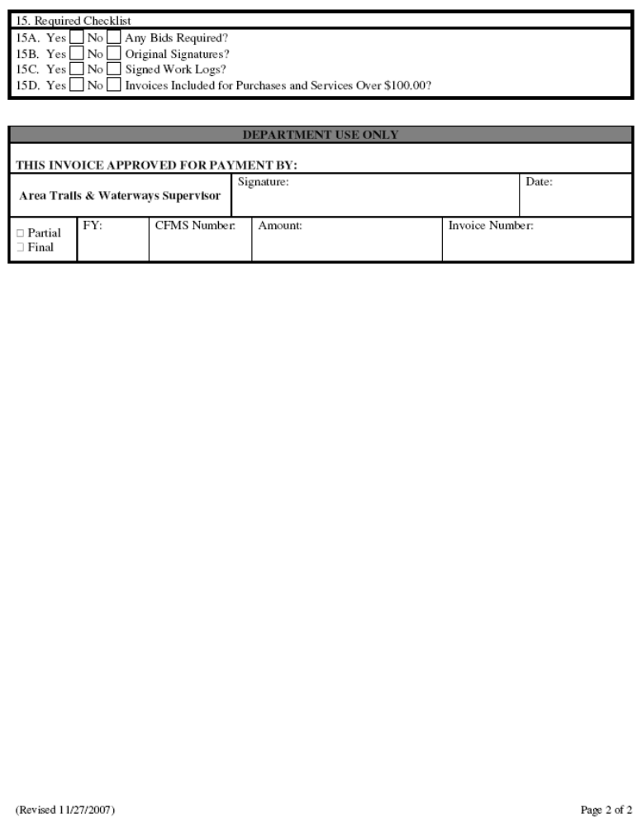

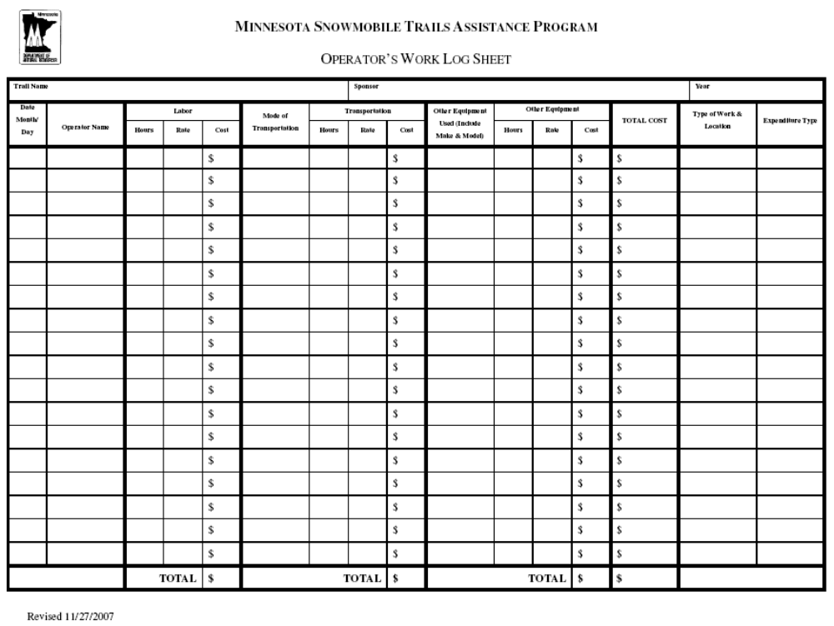

Sample Landowner Permission Form

LANDOWNER PERMISSION

THIS PERMIT is granted on ______________________________, by _________________________ the Landowner(s) to_______________________________ the Sponsor to establish and/or maintain the _________________________________ Snowmobile Trail.

That ______________________________________, the (record owners, contract for deed purchasers, lessees) in consideration of ______________________________________________________, grants this permit over and upon the following described premises situated in the County of __________________, State of Minnesota, to wit: (complete land description)

SUBJECT TO:

1. This permit shall be continuous and will terminate upon sale of the land, or upon notification in writing to the Sponsor six (6) months prior to termination by the Landowner(s).

2. The right-of-way shall be open to the general public for snowmobile use.

3. The Sponsor shall at all times have the right to enter upon said right-of-way for any purpose necessary to the performance of lawful powers and duties.

4. The Landowner(s) shall have the right to close said right-of-way during any emergency, with the approval of the Sponsor.

5. The permit is for a_______foot width over the route to be used.

DATE: __________________________ _________________________________________________
(Landowner Signature)

______________________________
(Address and Phone Number)
______________________________
(Club Representative)

NOTE: All Trail Permits are to be made out to the Sponsor not the club. Permits can be made out to club only if the Sponsor has specifically given written permission and authority to the club, and the club has been incorporated.

Elements of a Sponsor Resolution

A sponsor/local unit of government resolution should include the following information:

- A statement that the local unit of government will act as legal sponsor for an application for the DNR Snowmobile Trails Assistance Program

- A statement that the local unit of government may enter into agreement with the State of Minnesota for the specific grant program mentioned above

- A statement that the local unit of government will comply with all applicable laws and regulations as stated in the agreement

- A statement recognizing an individual (in many cases a local government auditor) who will act as a fiscal agent on behalf of the local unit of government

- Date the resolution is adopted

ELEMENTS OF A SUCCESSFUL TRAIL

Trail User Maps and Public Information Guidelines

Accurate maps of the trail system should be prepared for free distribution to users. They should be available at the trailhead, DNR offices, and other locations convenient to the public and at a minimum should include the following data:
- Trail Name or Names.
- Trail Location -- Give directions on how to get to the trail system parking lot from the nearest town and major highway. A small state map showing the general location within the state could also be useful.
- Trail Length -- Show the number of miles/km for each segment or loop.
- Trail Use -- Identify loops or segments designated for snowmobiling use, as well as trails closed to snowmobiling if the potential for conflict with other users exist, e.g., cross-country skiing.
- Trail Connections -- Identify other trails the trail connects to such as: State Parks and State Forests, State Trails, or other Grants-In-Aid Trails.
- Trail Information -- Give name, address and phone number of an individual who may be contacted for information, contact the local chamber of commerce to identify them as the local contact. The phone number of the local conservation officer may also be helpful.
- Bridges -- Show all bridge crossings.
- Roads -- Identify maintained state forest roads and portions used as trails; also identify roads not maintained, but suitable for snowmobiling.
- Mark on map and/or list locations where the following services would be available:
Gas Repair services
Food Medical facilities
Lodging Law enforcement officers
Nearest DNR office 911 or Zenith
Other helpful information
- Develop a grid system for safety purposes or locating facilities.
- Basic Safety Tips -- Speed limit, driving on lakes/thin ice, frostbite, trail signs, etc. Statements concerning speed and alcohol should be included on the map.
- It is helpful to put a date somewhere (bottom right-hand corner for consistency) on the map so the most current maps are in circulation.
- Identify all roads on map, and have corresponding signs posted on trails to help trail users know where they are at all times.
- Clearly identify all state asphalt paved bike trails where metal studs are prohibited.
County base maps are available from the DNR that show snowmobile trail alignments. These base maps are available for most counties from the Trails and Waterways Unit. Check with the Area Trails and Waterways Supervisor for your county.

Trail Design and Construction Guidelines
Minimum riding surface for one-way trail should be eight (8) feet or a reasonable width based on the conditions.
Minimum riding surface for two-way trail should be ten (10) feet or a reasonable width based on the conditions.
An additional two (2) feet should be cleared outside the trail surface. Minimum turning radius is 100 feet, unless marked.
Branches and obstacles above the trail should be cleared to a height of ten (10) feet.
Reflective signs should be placed on the right side of the trail on posts at reasonable intervals (see Appendix B - Snowmobile Trail Signage Manual).

Signing Suggestions

In general, signing on trails should be designed to provide direction, information, and safety for trail users. Major signing areas are at the trailhead, trail junctions, and in areas where safety of the user is involved. Trailhead and trail junction signs will provide maps showing route designation, distance, traffic flow direction, and location of support facilities. Safety signs will caution users of steep slopes, bridges, or highway crossings, and other hazardous trail conditions.

Signs on all trails should be kept at a minimum and be well placed.

Signs placed out on the trail should include reassuring blazers, caution signs, do not enter signs, stop signs, etc.

Placement of most signs should be on the right-hand side of the trail just off the main treadway but within clearing limits. Signs should be attached to posts placed two (2) to three (3) feet off the treadway and three (3) to four (4) feet above expected snow depth. Attach them securely with lag screws or carriage bolts. Wood or metal posts may be used depending on location and availability.
The directional sign used on the trail should be trail junction blazers, directional blazers and reassuring blazers. Signs should be placed in open areas or in other areas where a trail user might become confused. If uncertain about the effectiveness of signing, invite a non-local trail user to identify where deficiencies may exist.

Suggested Signing Program:
1. Trailhead
The following signs should be located near the parking lot at the start of the trail.
A. Major Information Board Map of trails
Registration Distance of various routes
Interpretive information Rules and regulations
Trail conditions Trail uses permitted and prohibited
Emergency telephone numbers
Address of person in charge of trail operation and maintenance (unit manager)
Where to go and who to see in case of emergency
B. You Are Here -- Should be located at the trailhead and at intersections with other trails.
- if necessary, direction of trail (one-way, two-way)
- trail distances (miles or kilometers)
- location of facilities
- you are here location marker

2. Information
A. Use Designation -- Should be located at all intersections where incompatible users may enter the trail.
B. Interpretive -- Located at points of interest along trail. Consult regional naturalist for recommendations concerning interpretive signs.
C. General Information -- Located and designed to provide information to trail users to assist or improve their ability to safely and enjoyably use the trail.
3. Traffic
A. STOP NRM 8.4.1. Location: every traveled public road or railroad crossing.

B. STOP AHEAD NRM 8.4.2. Location: should appear 300 feet before traveled public road or railroad crossing.

C. DO NOT ENTER NRM 8.4.4A Location: ski or other trail intersections, one-way trails, prohibited areas.

D. YIELD NRM 8.4.3 Location: intersections with other trails in open areas. May also be used at private trail crossing found on railroad grades.

E. CAUTION NRM 8.4.5 Location: should be placed prior to all potentially hazardous areas such as cliff edges, rock falls, steep hills, congested areas, bridges, sharp ditches, sharp curves.

F. REASSURING BLAZER NRM 8.4.7A Location: where needed to reassure trail use is on the right trail, more in open areas, less in thick woods. May also be needed at unused road or trail intersections.

G. DIRECTIONAL AND TRAIL JUNCTIONS
NRM 8.4.8C Location: based on trail junction. Directional arrows should be placed prior to sharp curves and turns; distance will depend on anticipated speed of user. On snowmobile trails, these signs should appear at least 50 feet prior to the turn, curve, or junction.

H. SNOWMOBILE SYMBOL
NRM 8.4.22A Location: start of trail and at trail intersections with other use trails.

I. NO SNOWMOBILING NRM 8.5.14B Location: where needed to restrict snowmobile use.

J. NO MOTORIZED VEHICLE PERMITTED
NRM 8.4.14 Location where necessary to prohibit use, by Motorized vehicles except snowmobiles.

4. Temporary and Special Signs and Decals
A. Trail Closed NRM 8.4.4D Location: at points where users could enter the trail.

B. Handicapped Accessible No number available
Location: trailhead and facilities.

C. Grant-In-Aid NRM 8.5.7 Location: at intersections of DNR and GIA trails, also at GIA trail heads.

D. Mileage Markers (optional) Location: at intervals of miles and/or kilometers. Mileage markers can be very helpful to the trail user and manager. They let trail users know the distance they have traveled or must travel to return to the trailhead. They can help the manager easily identify maintenance problem areas and can also be useful to help locate injured or stranded trail users.
No number available

E. Caution Truck Hauling NRM 8.4.9 Placed to provide warnings where logging or other trucks cross or share trail treadway.

F. Stay on Trail NRM 8.2.20 Placed in areas where trespass from trail or environmental impacts are of concern.

G. Ski Pass Required NRM 8.5.24 Place at all entry points to ski trails supported by state funds.

Snowmobile Trail Section of the “Trail Planning, Design, and Development Guidelines”
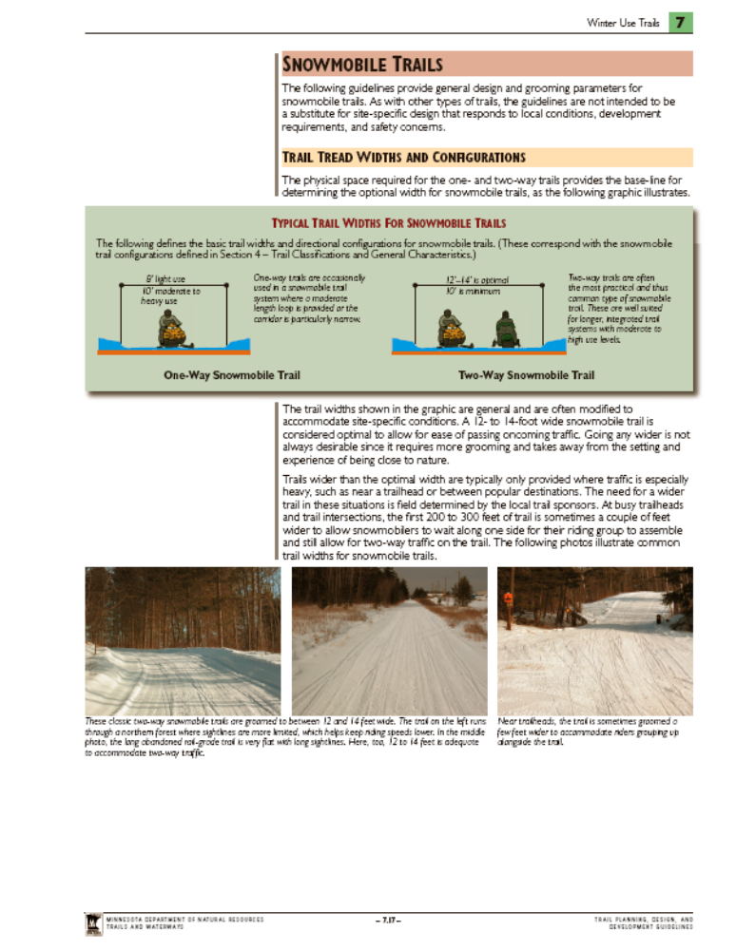

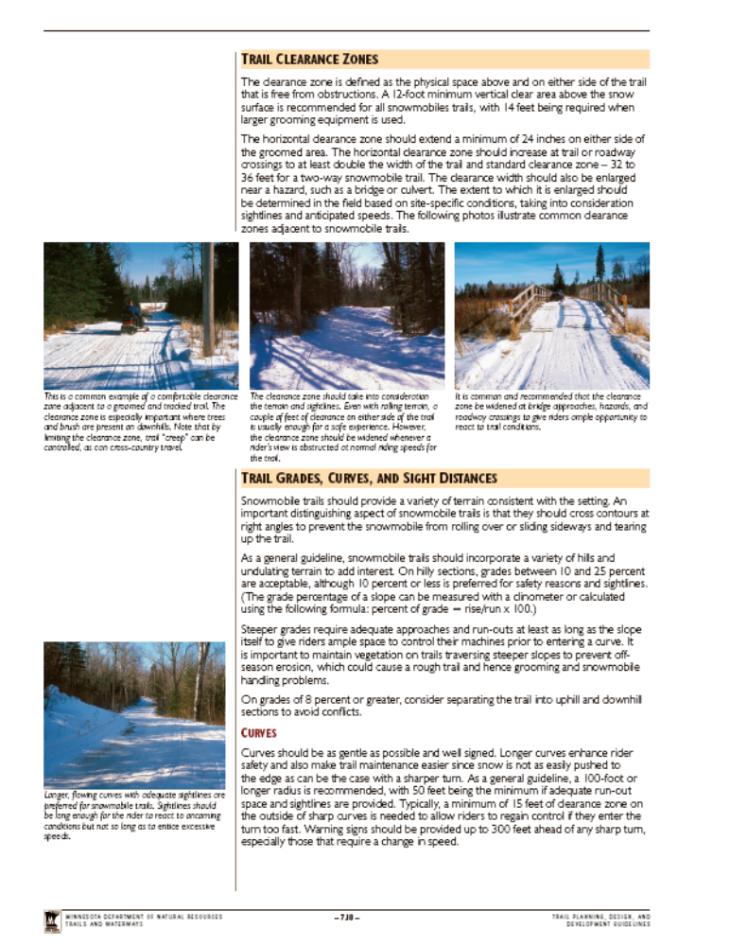

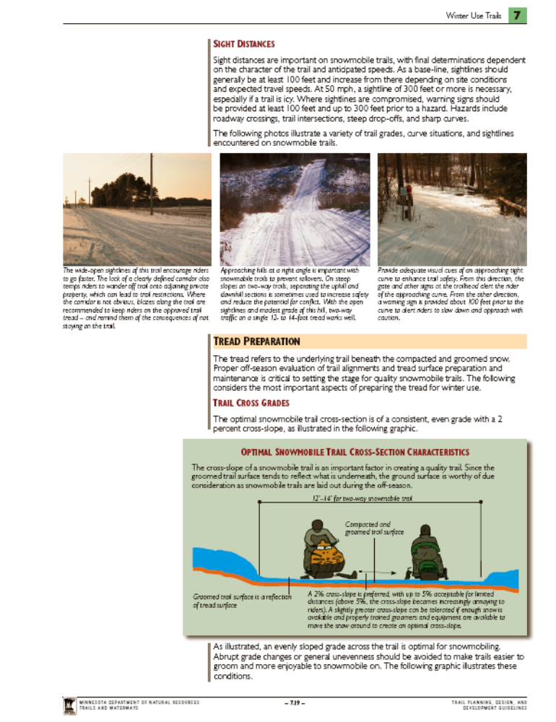

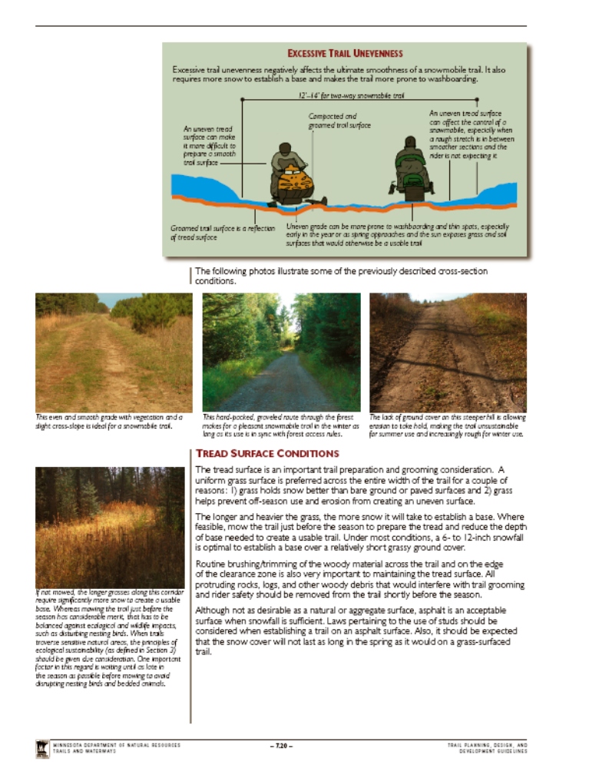

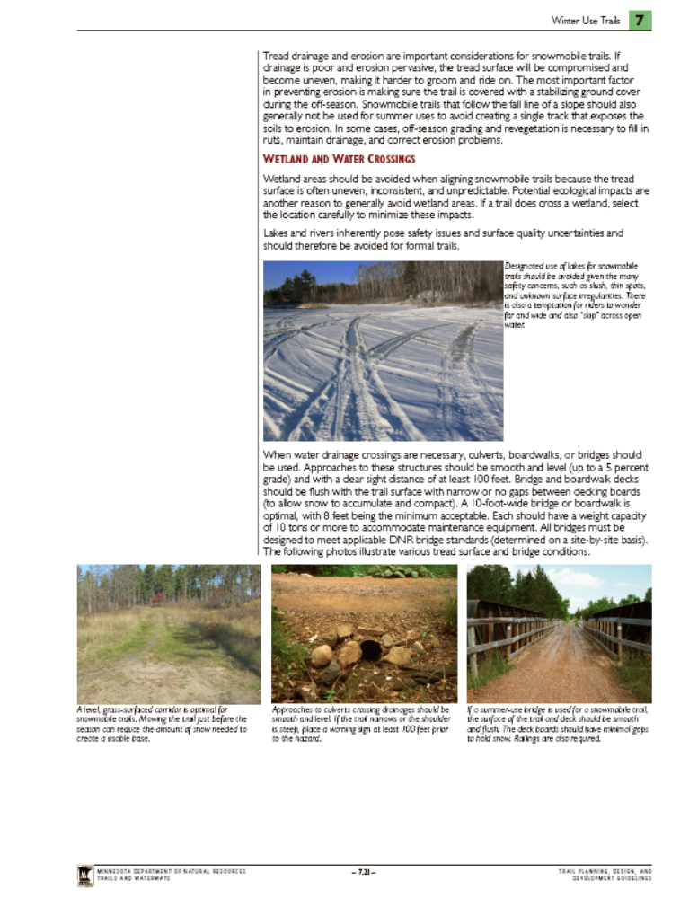

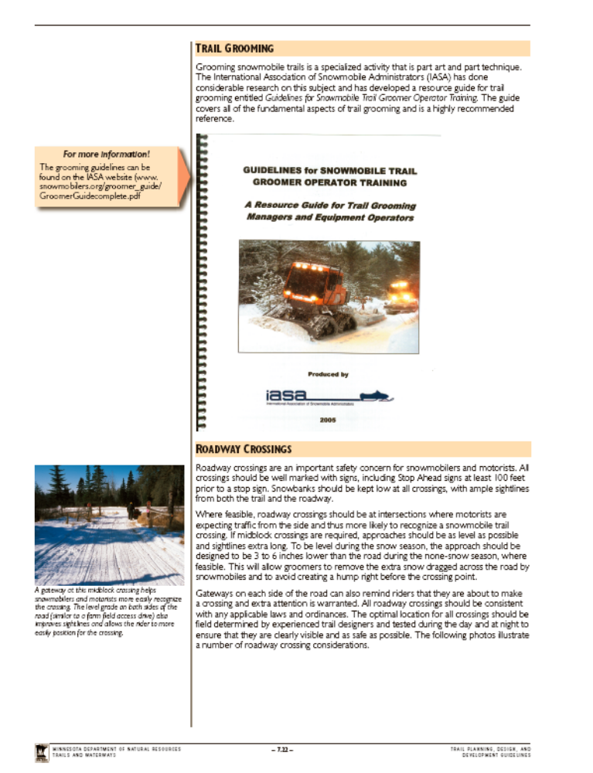

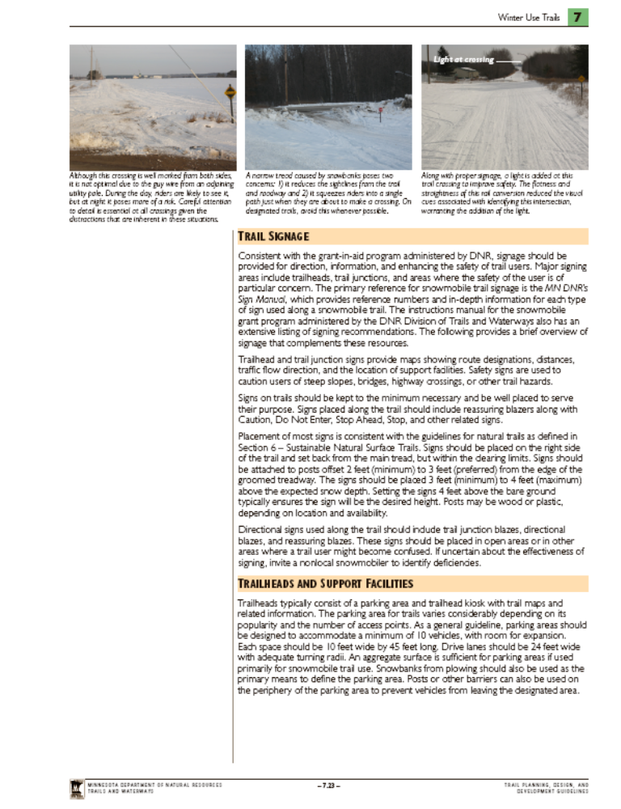

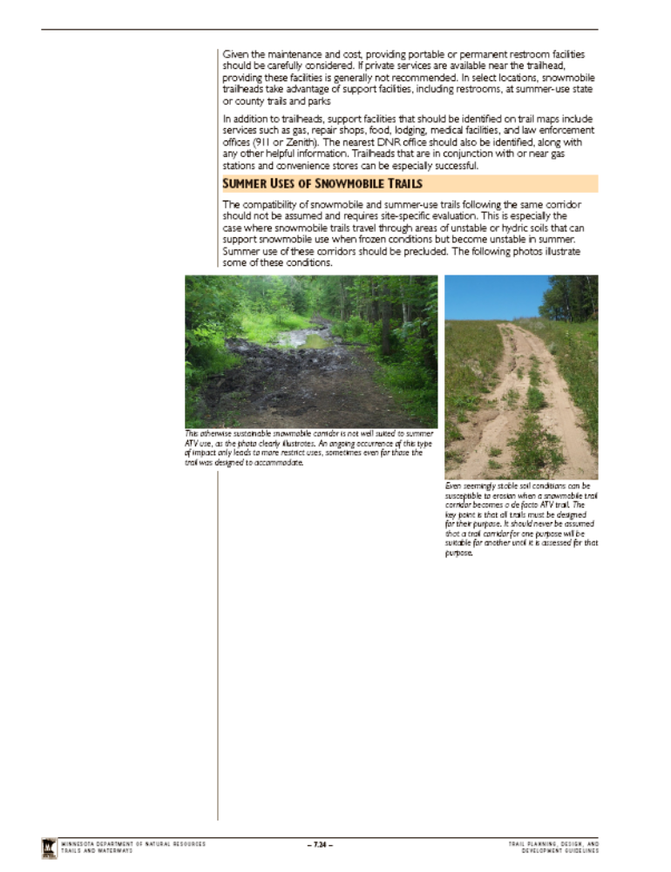

FEDERAL RECREATIONAL TRAILS PROGRAM

An additional source of funding for capital improvements and easement acquisitions could be the Federal Recreational Trail Program. The Safe, Accountable, Flexible, Efficient Transportation Equity Act: A Legacy for Users (SAFETEA-LU) provides for a federal program to provide financial assistance for the development and maintenance of recreational trails and trail-related projects. The Act provides funding from the Federal Highway Trust Fund in acknowledgment of off-road recreational fuel use.

Grants are awarded for nearly any trail related project that is solely located within the state of Minnesota. The priorities for each year are developed by the Minnesota Recreational Trail Users Association (MRTUA) and vary from one grant round to the next. This program is unique in that, legislatively it is specified that the funds must be expended for projects that are strictly motorized as well as projects that are strictly non-motorized, while at the same time encouraging the development of projects that provide for both. The law specifies that 30 percent of the funds must be used for motorized projects, 30 percent for non-motorized, and 40 percent for projects that can be utilized by both.

Private non-profits and other trail organizations are encouraged to work with Federal, State, and local government agencies to develop applications. The goal of the State and MRTUA is to foster cooperative efforts between these groups for long-term development, enhancement and management of recreational trails in Minnesota.

For more information on this program and needed applications, please visit the DNR’s website at: http://www.dnr.state.mn.us/grants/recreation/trails_federal.html

GIA Trail Proposal Review Process (12/1/05 version)
STEP | DNR Review Timeline
STEP | at least | additional
Preliminary project discussions – early coordination w/Trails & Waterways
- Club develops initial concept | Depends on club
- Area T&W Supervisor provides GIA Manual, reviews environmental checklist w/club and checks Natural Heritage ArcView layer | Depends on club
- Club discusses concept w/ key project partners, selected landowners, other interest groups, prepares draft project proposal | Depends on club
1. T&W review of draft project proposal: 1.5 months
- Area T&W Supervisor reviews draft proposal, discussed w/club | 1.5 mo
- Club modifies proposal and secures a local government sponsor | 1.5 mo
- If proposal is a minor* snowmobile or ski trail project with no identified potential impacts, go to Step 5 | 1.5 mo
2. Area Team Screen of Project Proposal: Fast Track possible? 1 month
- Area Team/Reg Eco staff screen proposal for red flag issues (in-office) | 1 mo
- Determine if more in-depth review needed | 1 mo
- Identify additional information DNR staff will need for review | 1 mo
- Review of trail alignment by Natural Heritage Program | 1 mo
- Discuss with club, potentially revise proposal to avoid or mitigate issues | 1 mo
- If no further review needed, go to Public Notification (Step 4a) or EAW (Step 4b) | 1 mo
- If further review needed, go to Step 3 | 1 mo
3. Project Proposal Review: 5 – 10 months (start date depends on RMT assigned schedule)
- Reg T&W Manager prioritizes project proposals. RMT agrees on list/schedule for field review | 1 mo
- Club and T&W gathers additional information needed for field review as identified in Area Team screen (step 2) | 1 mo
- Area Team meets and reviews proposal, complete Rapid Environmental Assessment Checklist, prepare comments | 1.5 mo
- Internal issues resolved by RMT/OHVPC (as needed) |  | 1 - 2 mo
- Area Team meets w/club to discuss comments and suggested changes | 0.5 mo
- Club/T&W solicits additional input from public/interest groups to address issues or increase awareness of proposal (as needed) |  | 1 mo
- Club prepares revised proposal |  | 1 mo+
- RMT reviews proposal & Team comments, meet to accept or deny | 1 mo
- If proposal accepted | 1 mo
- Go to Public Notification (Step 4a), or | 1 mo
- Go to EAW (Step 4b) | 1 mo
4a. Public Notification: 2 month
- 30 day public comment period on final proposal accepted by Department | 2 mo
- Summarize comments, review by Area Team, RMT | 2 mo
- If no further changes needed, go to Grant Application (Step 5) | 2 mo
4b. Prepare EAW: 4 to 6 months
- Prepare draft EAW | 4 mo | 6 mo
- Public comment period | 4 mo | 6 mo
- Determine if EIS is needed | 4 mo | 6 mo
- If so, go to EIS (Step 4c) | 4 mo | 6 mo
- If not, go to Grant Application (Step 5) | 4 mo | 6 mo
4c. Prepare EIS: 1 to 1.5 years | 1 yr
5. Grant Application, Funding Allocation | 2 mo
6. Project Permitting and Construction | 1 yr
7. Monitoring and Enforcement | --

Minnesota Environmental Quality Board
Adopted Permanent Rules Relating to Mandatory EAW Categories and Exemptions
[ NOTE: The final adopted rule was published in the Minnesota State Register (29 SR 571 & 30 SR 319) and took effect Oct. 1, 2005 ]

4410.4300 Mandatory EAW categories
Subp. 37. Recreational trails. If a project listed in items A to F will be built on state-owned land or funded, in whole or part, by grant-in-aid funds administered by the DNR, the DNR is the RGU. For other projects, if a governmental unit is sponsoring the project, in whole or in part, that governmental unit is the RGU. If the project is not sponsored by a unit of government, the RGU is the local governmental unit. For purposes of this subpart, “existing trail” means an established corridor in current legal use.

A. Constructing a trail at least 10 miles long on forested or other naturally-vegetated land for a recreational use other than snowmobiling or cross-country skiing, unless exempted by part 4410.4600, subpart 14, Item D, or constructing a trail at least 20 miles long on forested or other naturally-vegetated land exclusively for snowmobiling or cross-country skiing.
B. Designating at least 25 miles of an existing trail for a new motorized recreational use other than snowmobiling.

In applying items A and B, if a proposed trail will contain segments of newly constructed trail and segments that will follow an existing trail but be designated for a new motorized use, an EAW must be prepared if the sum of the quotients obtained by dividing the length of the new construction by 10 miles and the length of the existing but newly designated trail by 25 miles, equals or exceeds one.

C. Paving 10 or more miles of an existing unpaved trail, unless exempted by part 4410.4600, subpart 27, item B or F. Paving an unpaved trail means to create a hard surface on the trail with a material impervious to water.

D. Constructing an off-highway vehicle recreation area of 80 or more acres, or expanding an off-highway vehicle recreation area by 80 or more acres, on agricultural land or forested or other naturally-vegetated land.

E. Constructing an off-highway vehicle recreation area of 640 or more acres, or expanding an off-highway vehicle recreation area by 640 or more acres, if the land on which the construction or expansion is carried out is not agricultural, is not forested or otherwise naturally-vegetated, or has been significantly disturbed by past human activities such as mineral mining.

F. Some recreation areas for off-highway vehicles may be constructed partially on agricultural naturally-vegetated land and partially on land that is not agricultural, is not forested or otherwise naturally-vegetated, or has been significantly disturbed by past human activities. In that case, an EAW must be prepared if the sum of the quotients obtained by dividing the number of acres of agricultural or naturally-vegetated land by 80 and the number of acres of land that is not agricultural, is not forested or otherwise naturally vegetated, or has been significantly disturbed by past human activities by 640, equals or exceeds one.

4410.4600 EXEMPTIONS
Subp. 27. Recreational trails. The projects listed in items A to F are exempt. For purposes of this subpart, “existing trail” means an established corridor in current legal use.

A. Rerouting less than 1 continuous mile of a recreational trail if the reroute is necessary to avoid sensitive areas or to alleviate safety concerns. Multiple reroutes on the same trail must be treated as independent projects, except that where the cumulative length of currently proposed reroutes exceeds one mile on any five-mile segment of trail, as measured along the rerouted trail, those reroutes are not exempt.

B. Reconstructing, rehabilitating, or maintaining an existing trail involving no changes in designated use.

C. Constructing less than one continuous mile of trail for use by snowmobiles or cross-country skiers.

D. Constructing a trail for winter-only use across agricultural land or across frozen water.

E. Designating an existing trail for use by snowmobiles or cross-country skiers.

F. Constructing or rehabilitating a non-motorized trail within the Twin Cities Metropolitan Regional Park System.
(This Page for Reference Only)

‘EXISTING TRAIL’ - DEFINITION
For purposes of Subpart 37, "existing trail" means an established corridor in current legal use (MR 4410.4300, Subp. 37. Recreational trails). This definition does not apply to designated State Forest Roads which are, by definition, open to vehicular use.

As regards forest classification, motor vehicles (including OHV’s, but not snowmobiles) may be operated on forest roads that are not posted closed in forests classified managed and limited, but not in a forest classified as closed (MR 6100.1950 Motor Vehicles and Snowmobiles, Forest Lands). An ATV may be ridden on a township road or city street unless prohibited by resolution or ordinance, or in the ditch or the outside bank or slope of a trunk, county state-aid, or county highway (MS 84.928 Operation requirements; local regulation.).

4410.4300 MANDATORY EAW CATEGORIES.
Subpart 1. Threshold test. An EAW must be prepared for projects that meet or exceed the threshold of any of subparts 2 to 37, unless the project meets or exceeds any thresholds of part 4410.4400, in which case an EIS must be prepared. If the proposed project is an expansion or additional stage of an existing project, the cumulative total of the proposed project and any
existing stages or components of the existing project must be included when determining if a threshold is met or exceeded if construction was begun within three years before the date of application for a permit or approval from a governmental unit for the expansion or additional stage but after April 21, 1997, except that any existing stage or component that was reviewed under a previously completed EAW or EIS need not be included.

Multiple projects and multiple stages of a single project that are connected actions or phased actions must be considered in total when comparing the project or projects to the thresholds of this part and part 4410.4400.

4410.4600, EXEMPTION CATEGORIES.
Subp 2. Standard Exemptions The following projects are standard exemptions: (any project)
A. projects for which no governmental decisions are required;

B. projects for which all governmental decisions have been made. However, this exemption does not in any way alter the prohibitions on final governmental decisions to approve a project under part 4410.3100;

C. projects for which, and so long as, a governmental unit has denied a required governmental approval;

D. projects for which a substantial portion of the project has been completed and an EIS would not influence remaining implementation or construction; and

E. projects for which environmental review has already been initiated under the prior rules or for which environmental review is being conducted pursuant to part 4410.3600 or 4410.3700.

Subp. 14. Highway Projects. The following projects are exempt: (trail-related excerpt)
D. Roadway landscaping, construction of bicycle and pedestrian lanes, paths, and facilities within existing right-of-way are exempt.

Subp. 22. Land Use. The following projects are exempt: (any project)
A. Individual land use variances, including minor lot line adjustments and side yard and setback variances not resulting in the creation of a new subdivided parcel of land or any change in land use character or density, are exempt.

B. Minor temporary uses of land having negligible or no permanent effect on the environment are exempt.

C. Maintenance of existing landscaping, native growth, and water supply reservoirs, excluding the use of pesticides, is exempt.

[For full text see MN Rules Chapter 4410.0200 – 4410.7500, Rules governing the Minnesota Environmental Review Program]

EQBFINAL.DOC
Rev. 28 Nov 05
FFI: Brian McCann, MN DNR Trails & Waterways, 651/259-5627

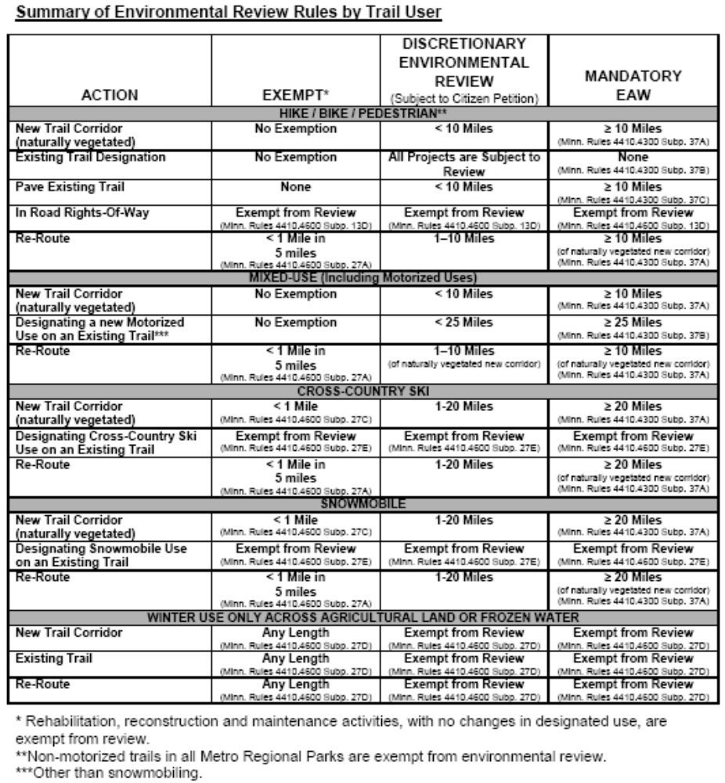

*Less than 1 continuous mile of re-route/5 miles of trail; less than one continuous mile of trail; trails on agricultural land or frozen water; or designating existing trails for use by cross-country skiers or snowmobiles

